Things To Do:

Make completed parts list (Make all parts needed for each leg)

Make detailed assembly guide

Add pictures

What’s needed. How to assemble.

Parts List (Per Leg):

3-D Printed Parts:

Upper Leg Cover

Upper Leg Shell

Middle Leg Cover

Middle Leg Shell

Lower Leg

Transmission_pulley_at3_t30_center (x2)

Transmission_pulley_at3_t30_output (x2)

Transmission Belt Tensioner (x4)

10mm (use this one by default)

10.5mm

11mm

11.5mm

Screws:

M3 x 5 Flat Head Screw (x8 (x4 for each motor))

M3 x 10 Flat Head Screw (x4)

M3 x 16 Phillips Flat Head Screw (x4)

M2.5 x 6 Hex Socket Head (x10)

M2.5 x 10 Hex Socket Head (x14)

M2.5 x 4 Helicoil (x22)

Electronics:

T_Motor Antigravity 4004 300kV (x2)

ODRI Encoder Kit (x2)

Includes:

Motor Shaft Assembly

Center Pulley

Broadcom AEDT-9810-Z00 encoder head

Ribbon wire 1.27mm pitch (5 wire 15 inch x2)

26 AWG Cu Wire (6 color, 50 ft each) (12 inch x6)

Banana Plugs Connector 2mm (x6)

PUDP-30V-S (x2)

Bearings:

Output Bearing (32mm x 25mm x 4mm)

Transmission Bearing (8mm x 4mm x 2mm)

Belt Tensioner Bearing (7mm x 3mm x 3mm)

Other:

Timing Belt:

Timing Belt Conti Synchroflex AT3 GEN III

width: 4mm / length: 150mm / 50 teeth

Timing belt first stage (x2)

Timing Belt Conti Synchroflex AT3 GEN III

width: 6mm / length: 201mm / 67 teeth

Timing belt second stage (x2)

CF-PLA

Pre-assembly preparations

Below is the original documentation for the leg actuators. The current leg actuators are very similar, only difference is found in the shell and cover of the leg. The modified version of the legs have the same internal structure so the placement of all the parts are the same.

# **Details Shell Preparation**

**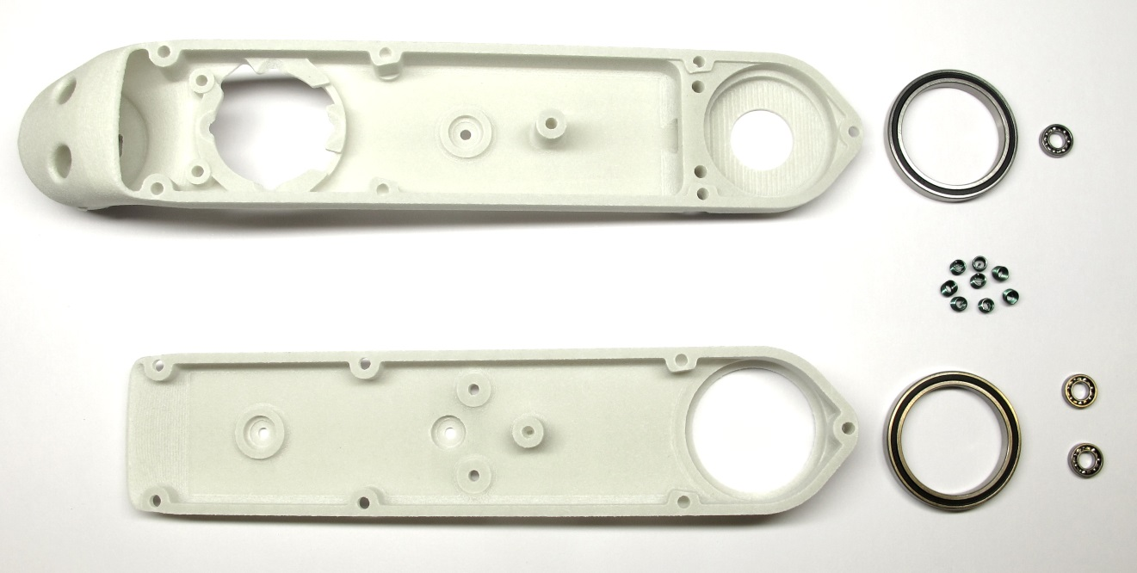***Starting Point: Shell base, shell cover, bearings and helicoil inserts*

*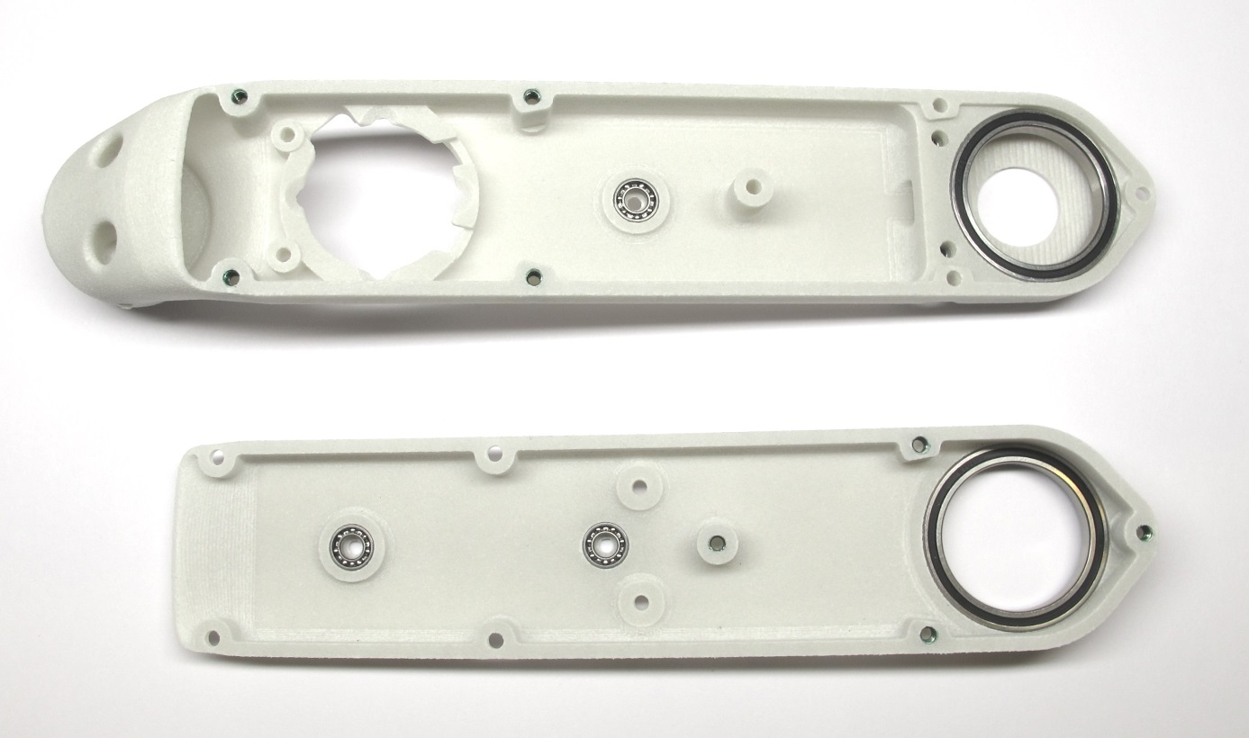  
End Result: Shell base and shell cover prepared for assembly*

## **Description**

* this page describes how to prepare the shells for the brushless actuator modules
* the shell assembly consists of two parts (the shell base and the shell cover) which are connected by eight M2,5 screws
* the flatness of the 3d printed parts and the diameters of the through holes is verified [-> Checking the 3D Printed Shells](https://github.com/open-dynamic-robot-initiative/open_robot_actuator_hardware/blob/master/mechanics/actuator_module_v1/details/details_shell_preparation.md#checking-the-3d-printed-shells)
* the metric threads are cut with a M3 tap [-> Cutting the Metric Threads](https://github.com/open-dynamic-robot-initiative/open_robot_actuator_hardware/blob/master/mechanics/actuator_module_v1/details/details_shell_preparation.md#cutting-the-metric-threads)
* the threaded inserts are installed [-> Installing the Helicoil Inserts](https://github.com/open-dynamic-robot-initiative/open_robot_actuator_hardware/blob/master/mechanics/actuator_module_v1/details/details_shell_preparation.md#installing-the-helicoil-inserts)
* the bearing seats are checked and adjusted if required [-> Adjusting the Bearing Seats](https://github.com/open-dynamic-robot-initiative/open_robot_actuator_hardware/blob/master/mechanics/actuator_module_v1/details/details_shell_preparation.md#adjusting-the-bearing-seats)
* the roller bearings for the output shaft and the transmission shafts are installed [-> Installing the Bearings](https://github.com/open-dynamic-robot-initiative/open_robot_actuator_hardware/blob/master/mechanics/actuator_module_v1/details/details_shell_preparation.md#installing-the-bearings)
* the shell base and shell cover are assembled with eight M2,5 screws [-> Test-Mounting the Shells](https://github.com/open-dynamic-robot-initiative/open_robot_actuator_hardware/blob/master/mechanics/actuator_module_v1/details/details_shell_preparation.md#test-mounting-the-shells)

## **More Information**

* More information on the 3d printing: [Details 3d Printed Parts](https://github.com/open-dynamic-robot-initiative/open_robot_actuator_hardware/blob/master/mechanics/actuator_module_v1/details/details_3d_printed_parts.md#details-3d-printed-parts)

## **Checking the 3D Printed Shells**

**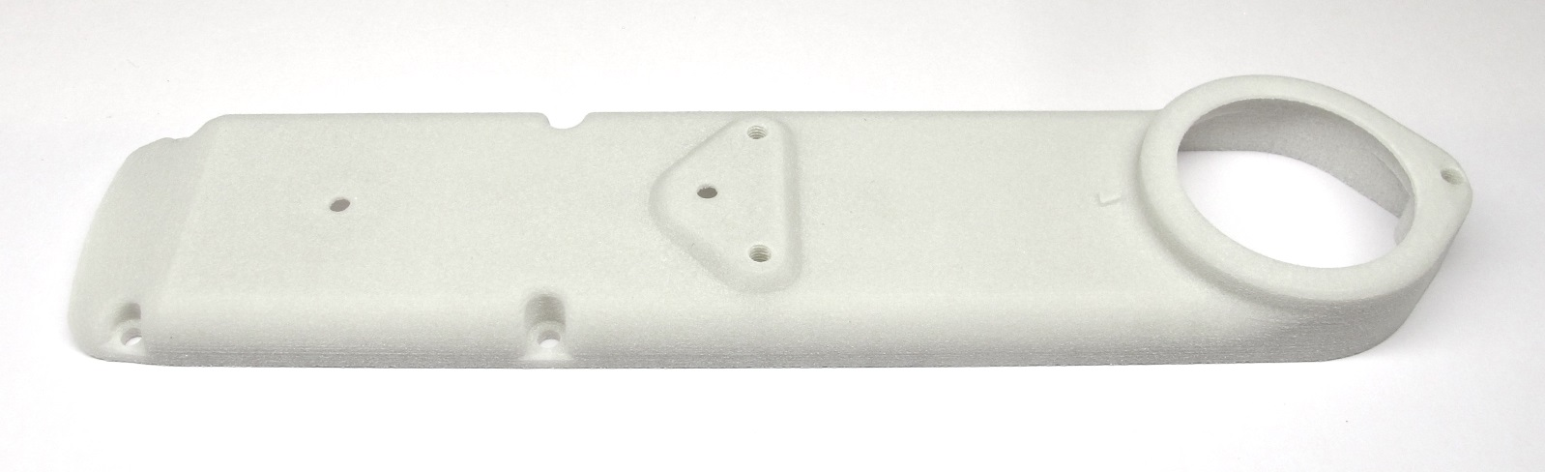***Place the shell cover on a flat surface and visually check the flatness of the part.*

*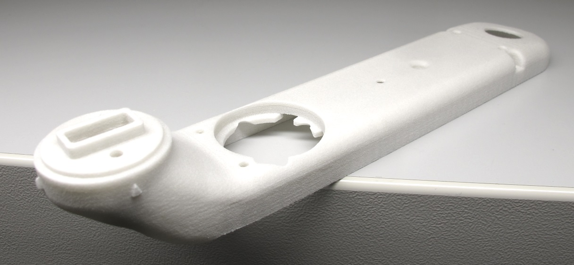  
Place the planar area of the shell base on a flat surface and visually check the flatness of the part.  
If the parts are warped they might not be usable.*

*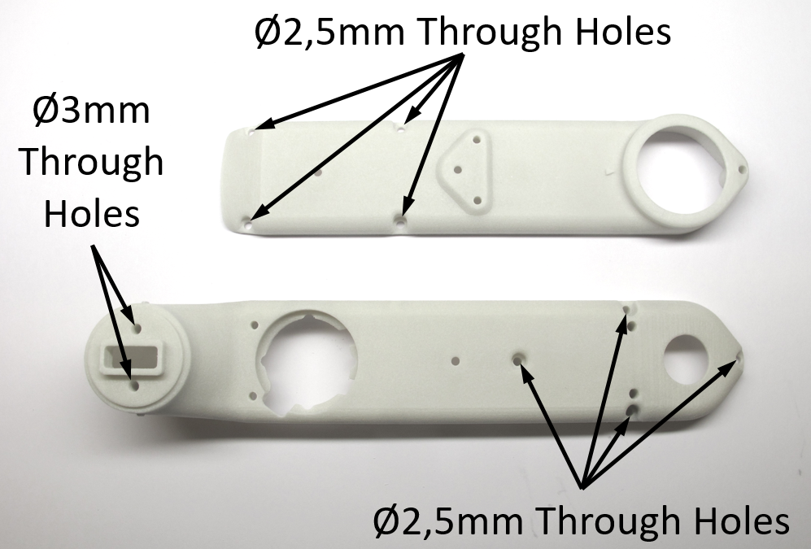  
There are two 3mm and eight 2,5mm through holes in the shell parts.  
Check the diameter of the through holes with a caliper or by inserting a M3 and M2,5 screw.  
If the hole diameters are too small and the screws don't pass through easily increase the hole diameter with a drill.*

## **Cutting the Metric Threads**

**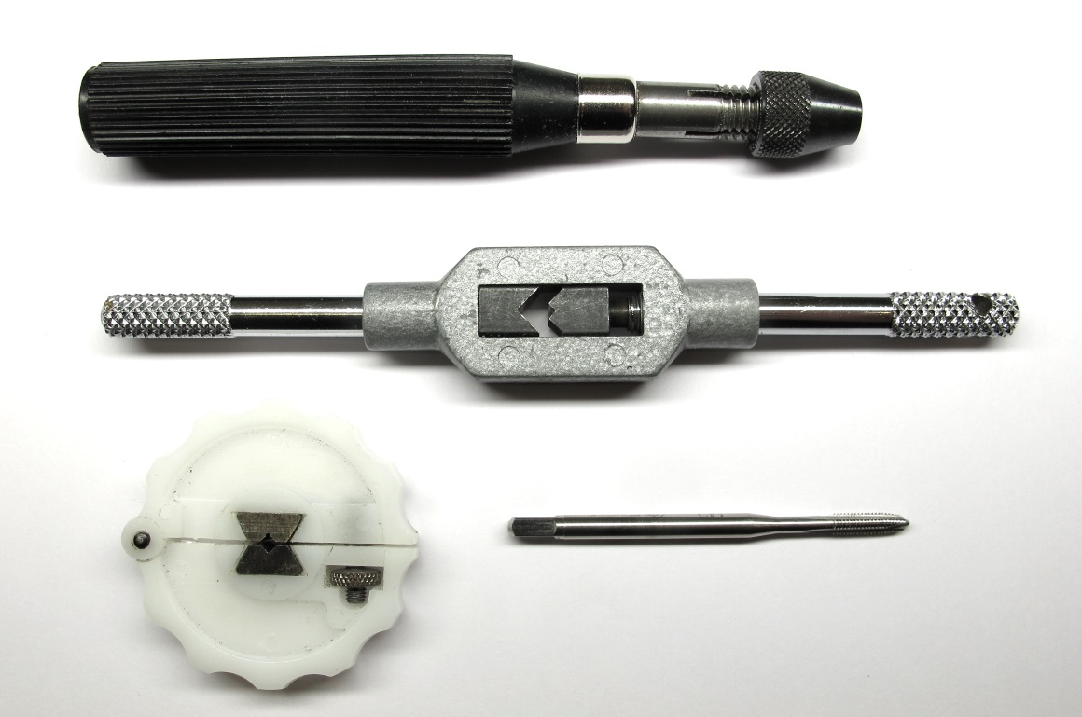***Use a M3 tap to manually cut the threads in the locations shown below.  
The picture shows different tool holders that can be used.*

*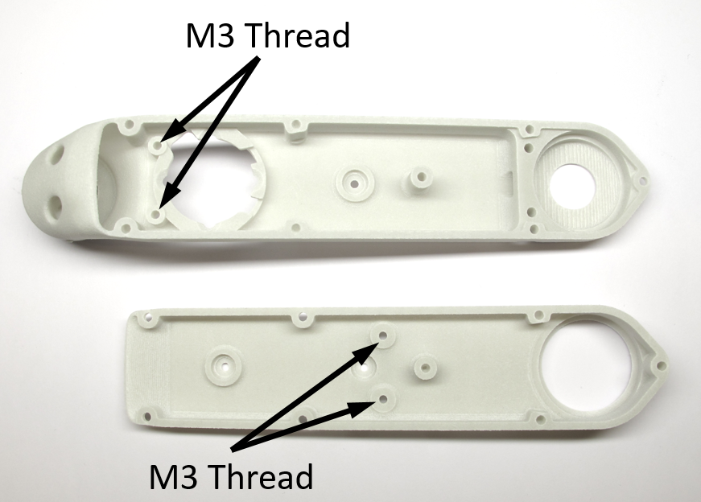  
Use a M3 tap to cut the threads for the encoder mount and the belt tensioners.  
Try to hold the tap as vertical as possible.  
Cut the threads all the way through the shell*

*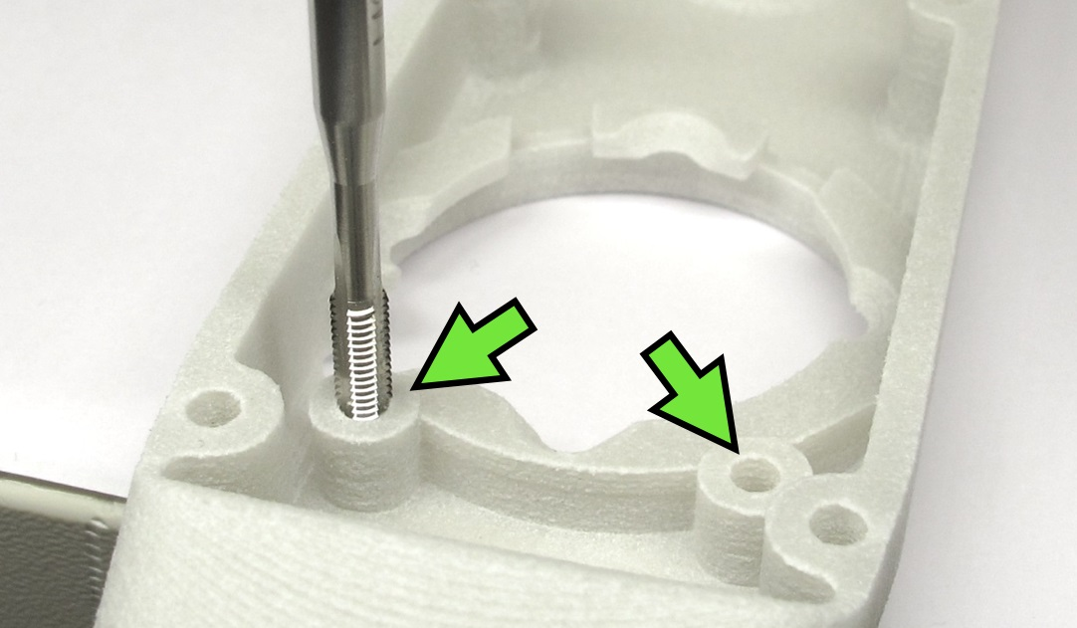  
Use the M3 tap to cut the two threads for the encoder attachment.*

*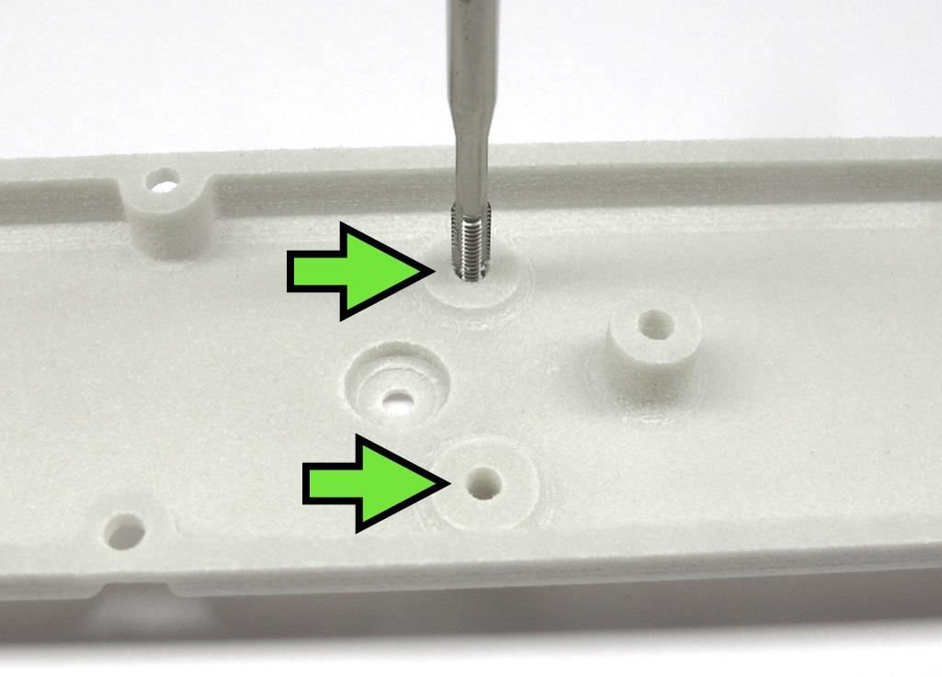  
Use the M3 tap to cut the two threads for the timing belt tensioners.*

## **Installing the Helicoil Inserts**

**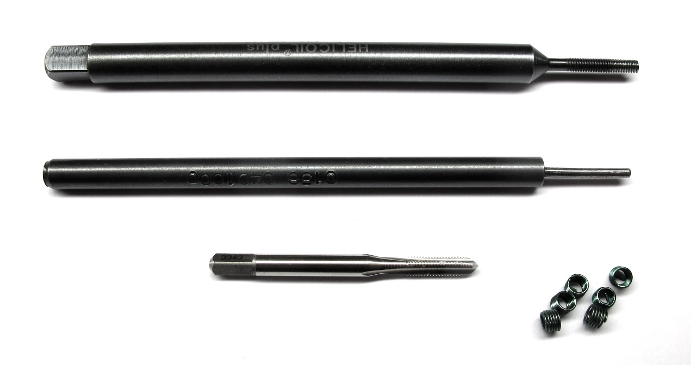***Helicoil Tools M2,5 - Tap, tang-break-off tool and insertion tool*

* we use Helicoil threaded inserts for increased stability
* you need the 3 special Helicoil tools shown in the picture above for each size
* for the actuator modules we use threaded inserts with the sizes M2,5 and M3
* try to hold the tap drill as vertical as possible
* stop tapping when you reach the bottom of the hole and the resistance increases  
  (the threads in the 3d printed parts can strip easily)

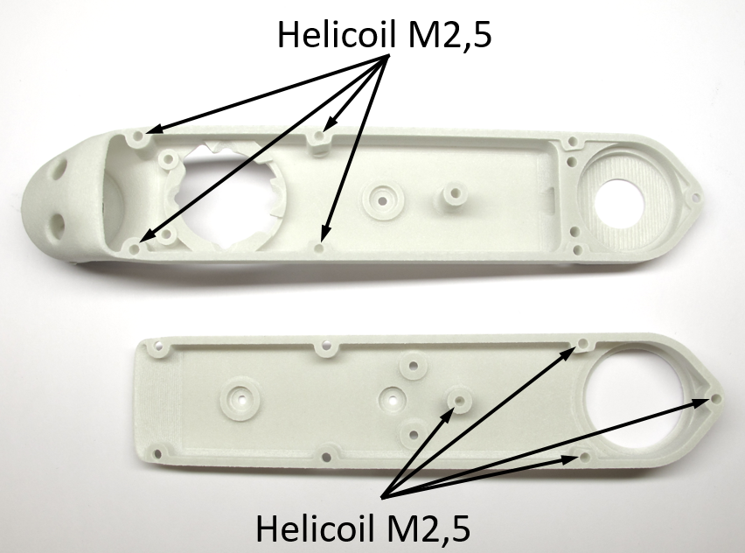  
*In the next step the M2,5 Helicoils are installed in the locations shown above.*

*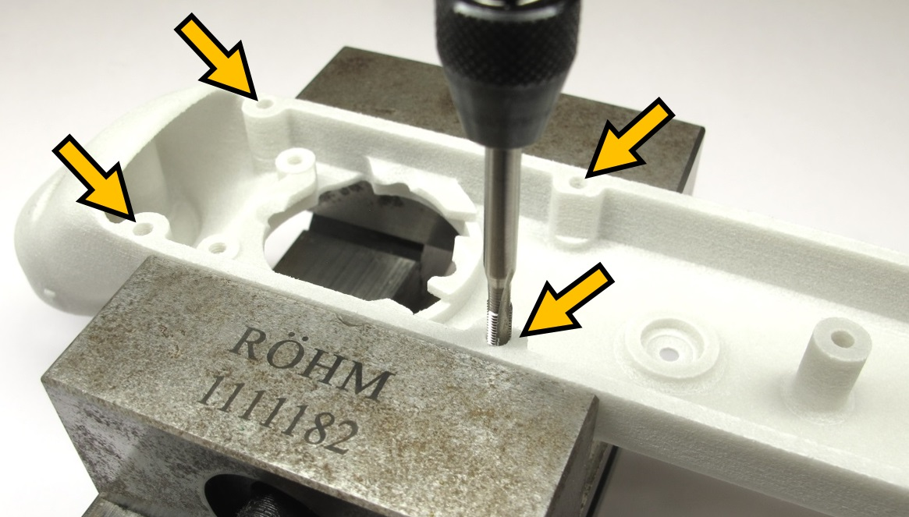  
Shell Base: Tap the 4 holes with the M2,5 Helicoil tap.*

*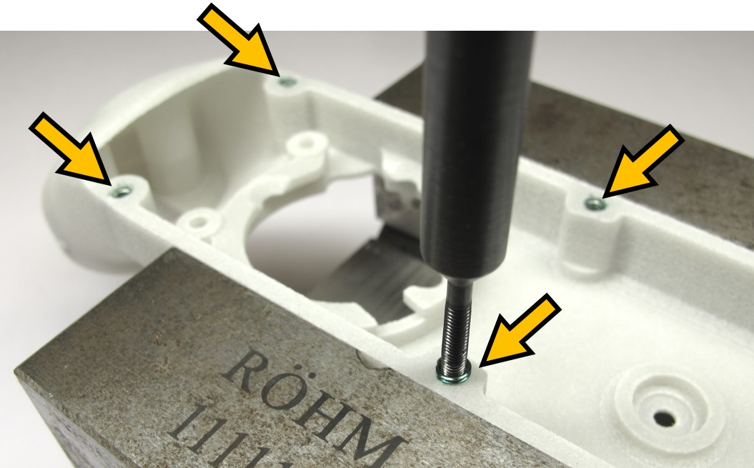  
Shell Base: Install four M2,5 x 3,75mm Helicoils using the installation tool.  
Remove the tangs using the tang break-off tool.  
Make sure that the tangs don't stay inside of the part.*

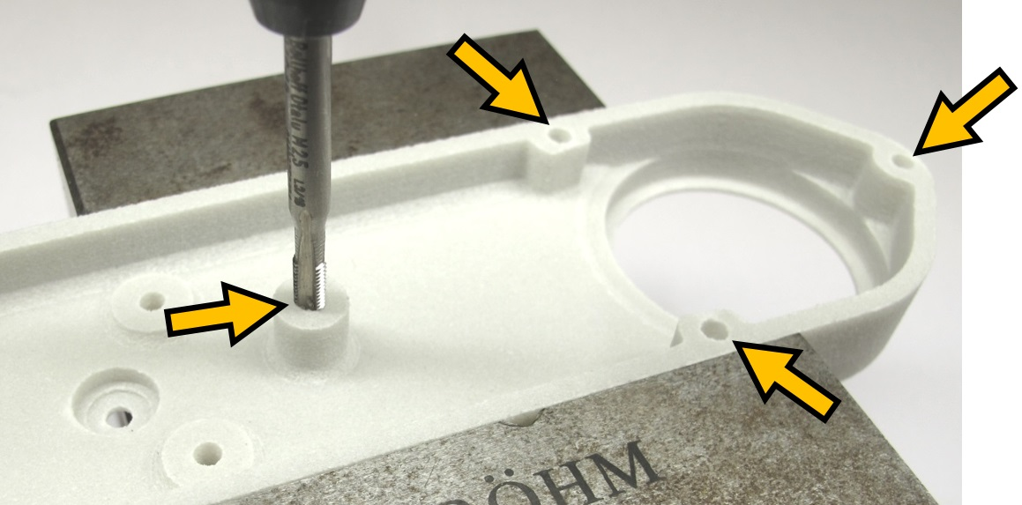  
*Shell Cover: Tap the 4 holes with the M2,5 Helicoil tap.*

*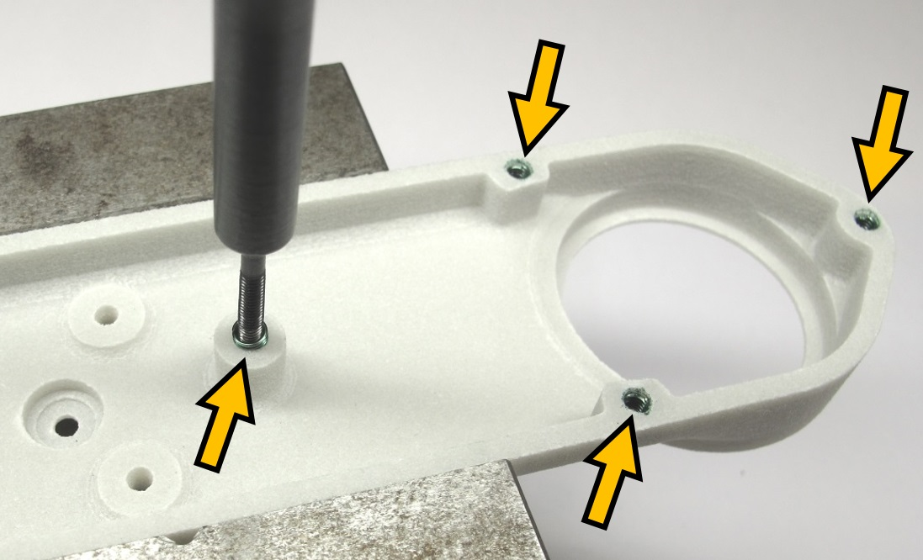  
Shell Cover: Install four M2,5 x 3,75mm Helicoils using the installation tool.  
Remove the tangs using the tang break-off tool.  
Make sure that the tangs don't stay inside of the part.*

*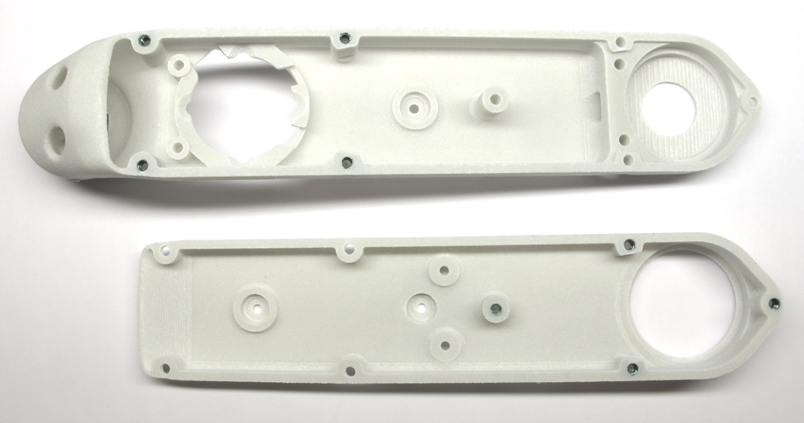  
Shell base and shell cover with the M2,5 Helicoils installed.*

## **2dof Leg - Hip FE Module**

* the Hip FE actuator module for the 2dof legs is an exception
* for all the other actuator modules ignore this step and continue below [-> Adjusting the Bearing Seats](https://github.com/open-dynamic-robot-initiative/open_robot_actuator_hardware/blob/master/mechanics/actuator_module_v1/details/details_shell_preparation.md#adjusting-the-bearing-seats)
* the Hip FE actuator modules for the 2dof leg require two extra M3 helicoil inserts for the second anchor point
* the 2dof leg is used for the [8dof Quadruped Robot](https://github.com/open-dynamic-robot-initiative/open_robot_actuator_hardware/blob/master/mechanics/quadruped_robot_8dof_v1#quadruped-robot-8dof-v1) and the [Leg Test Stand](https://github.com/open-dynamic-robot-initiative/open_robot_actuator_hardware/blob/master/mechanics/leg_test_stand_v1#leg-test-stand-v1)

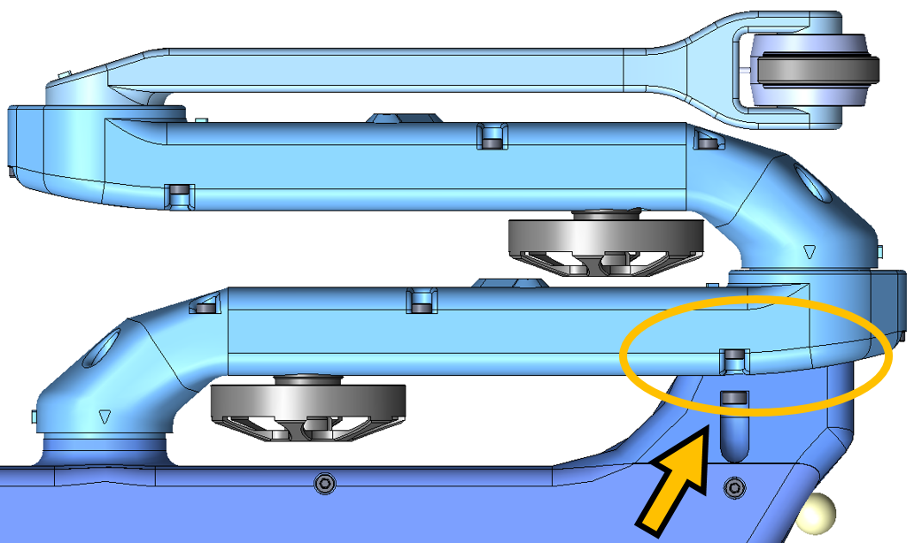  
*Top View 8dof Quadruped: Second Anchor Point*

*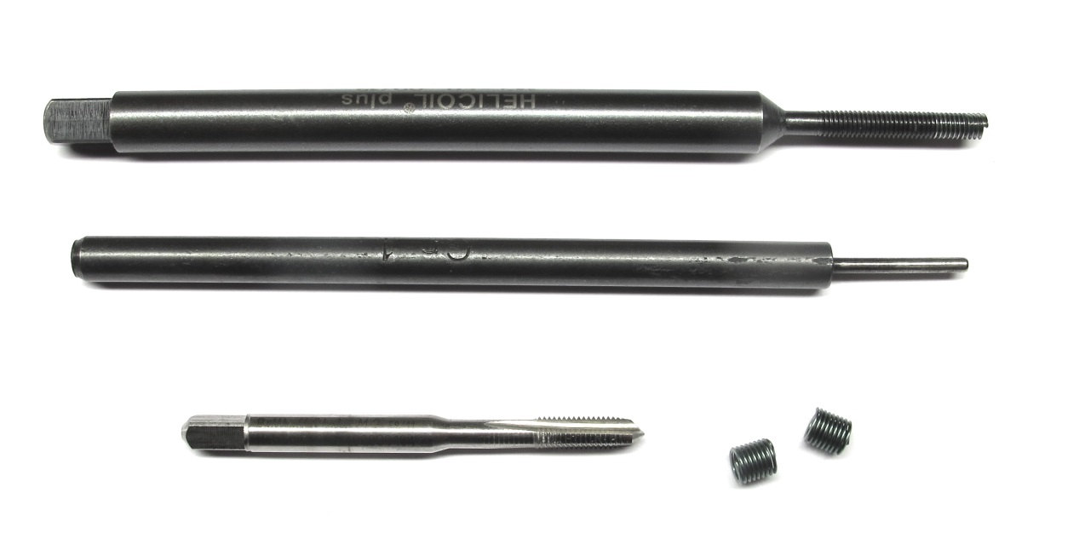  
Helicoil Tools M3 - Tap drill, tang-break-off tool and insertion tool*

*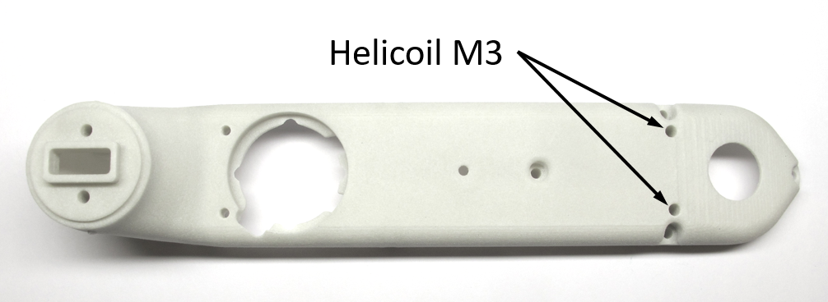  
M3 Helicoil positions for second anchor point.*

*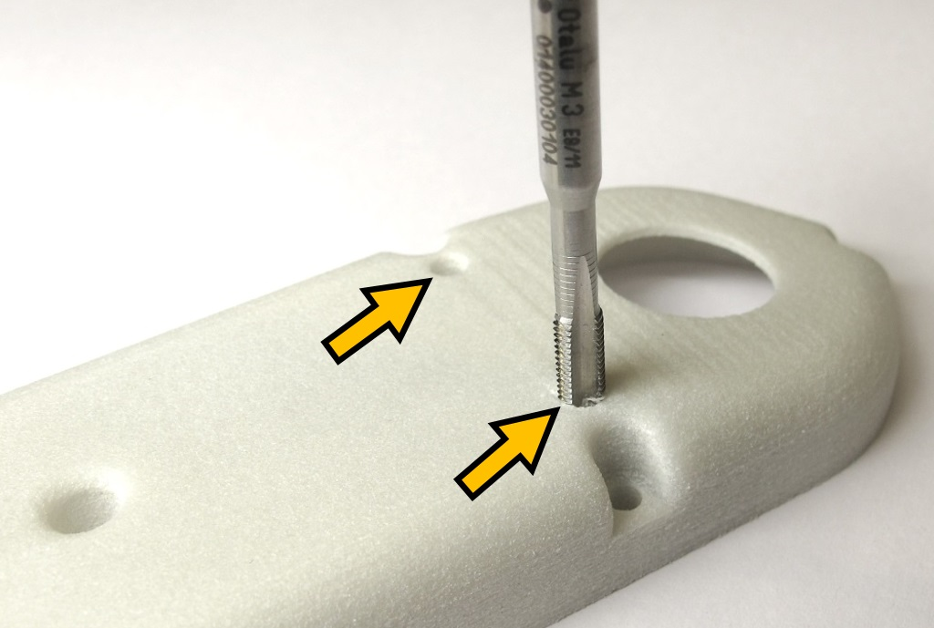  
Tap the two holes with the M3 Helicoil tap.*

*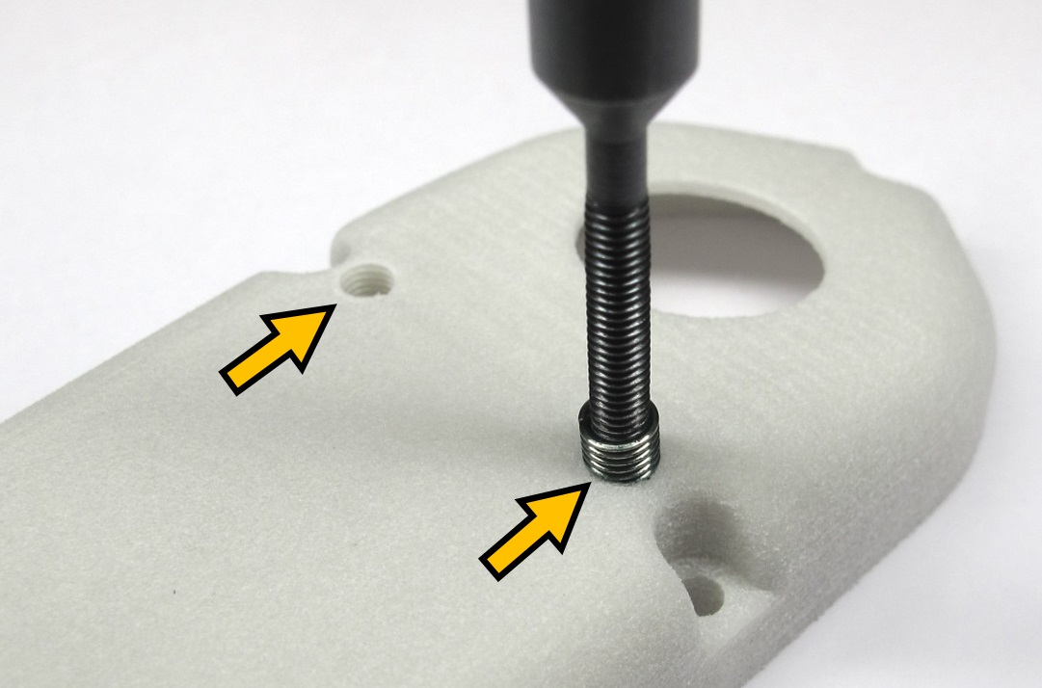  
Install two M3 x 6mm Helicoils using the installation tool.  
Remove the tangs using the tang break-off tool.  
Make sure that the tangs don't stay inside of the part.*

*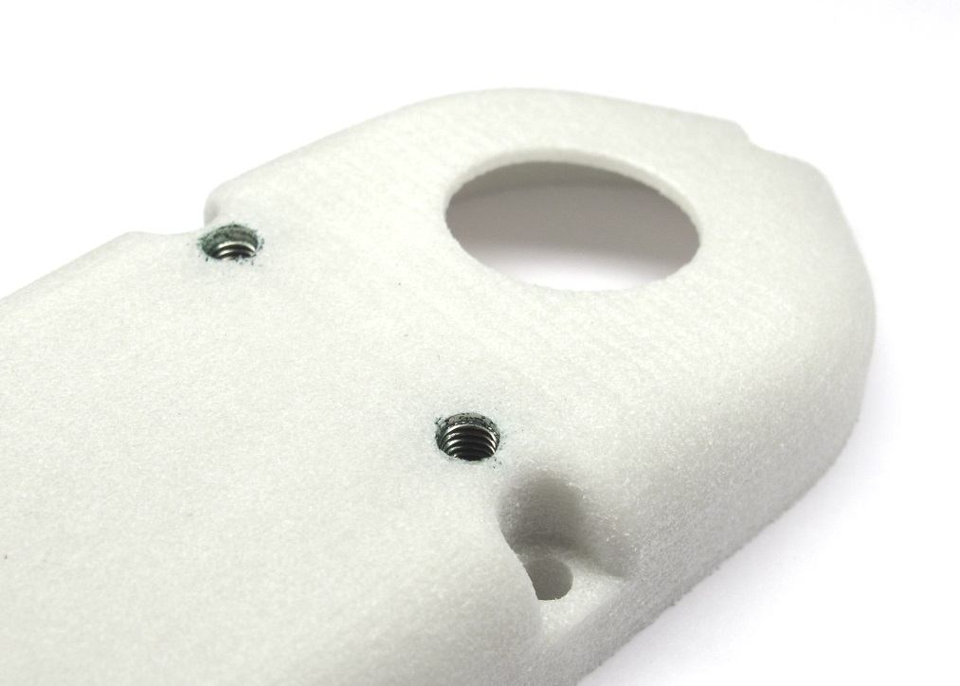  
Shell base with the M3 Helicoils installed.*

## **Adjusting the Bearing Seats**

**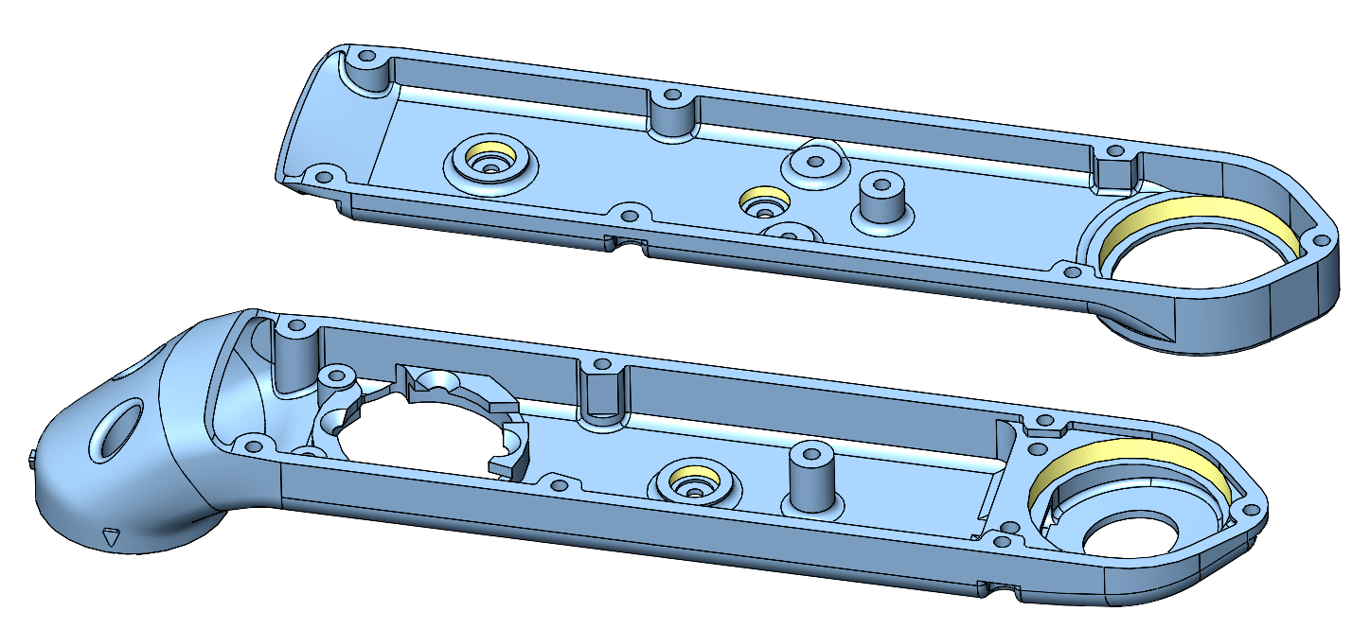***The bearing seats are marked yellow in this screenshot.*

* The tolerances of the 3d printed parts can vary quite a bit depending on the printing technology, the printer settings and the material.
* There should be a light press-fit between the bearing seats and the bearings.
* You should be able to install and remove the bearings manually with moderate force.
* If the bearing seats are too tight they have to be adjusted to the right size.
* For that we use end mills with a sharp 90 degree edge
* We don't recommend to use reamers, because they are typically chamfered and won't produce a sharp corner.
* You should dull the blades on the bottom with a file - such that the end mills remove material on the sides only.

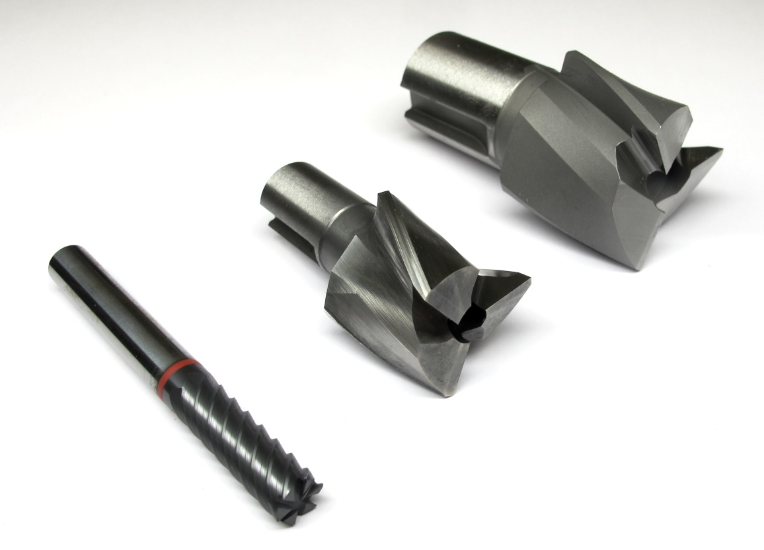  
*8mm and 32mm end mills*

## **Installing the Bearings**

**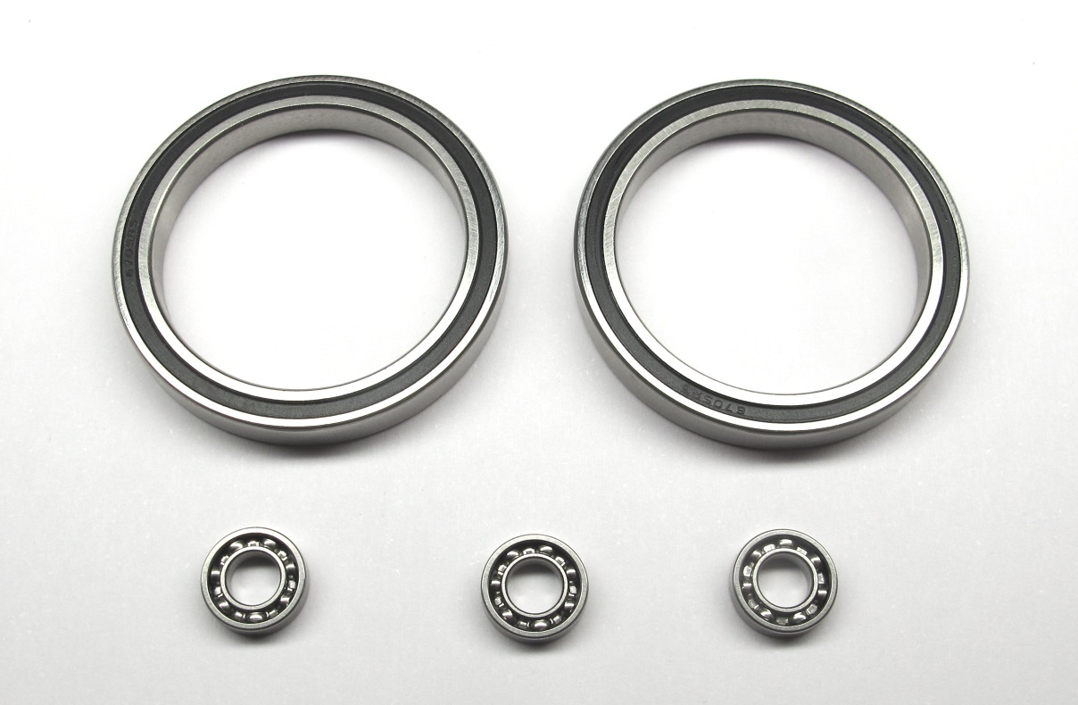***Stainless steel roller bearings.  
Two output bearings: 32mm x 25mm x 4mm  
Three transmission bearings: 8mm x 4mm x 2mm*

*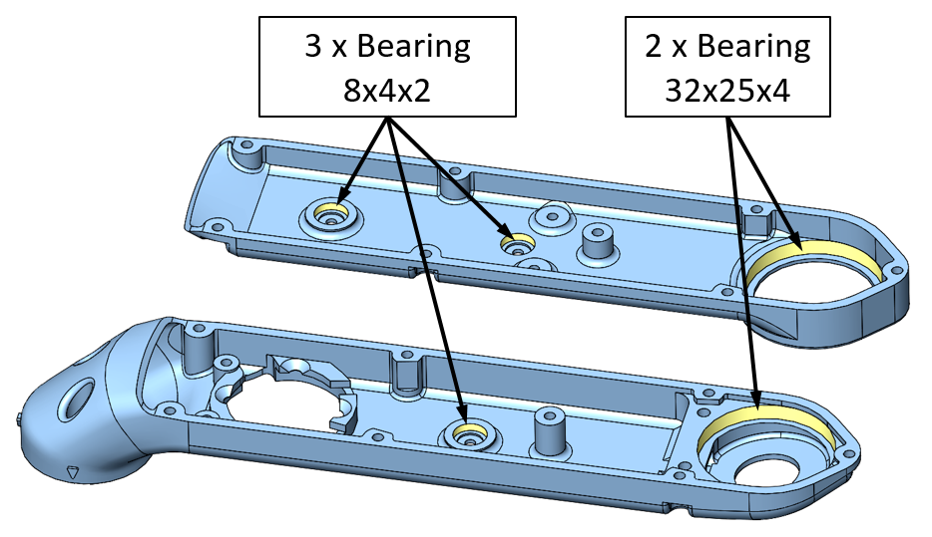  
Bearing locations for the shell base and shell cover.*

*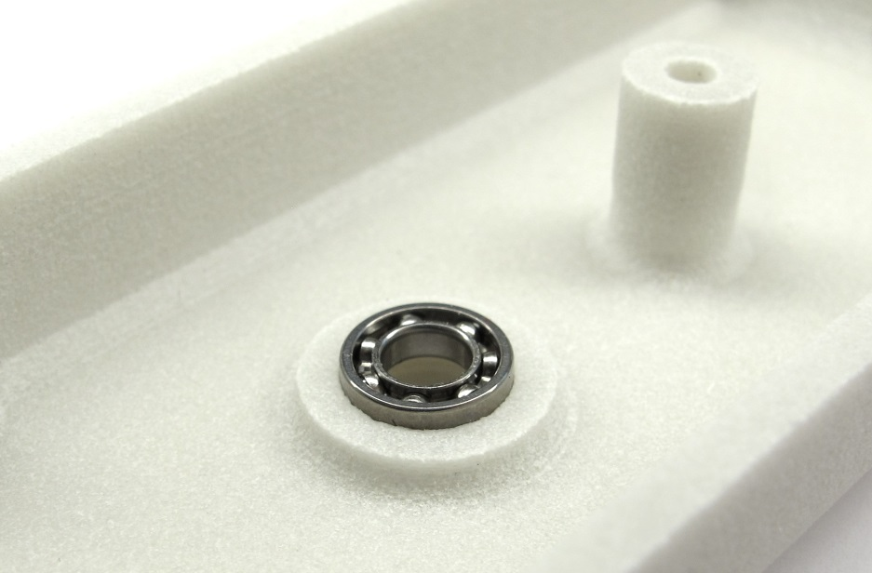  
Place the transmission bearings on the shell and push them in with your fingers.  
Try to keep the bearing horizontal while installing it.*

*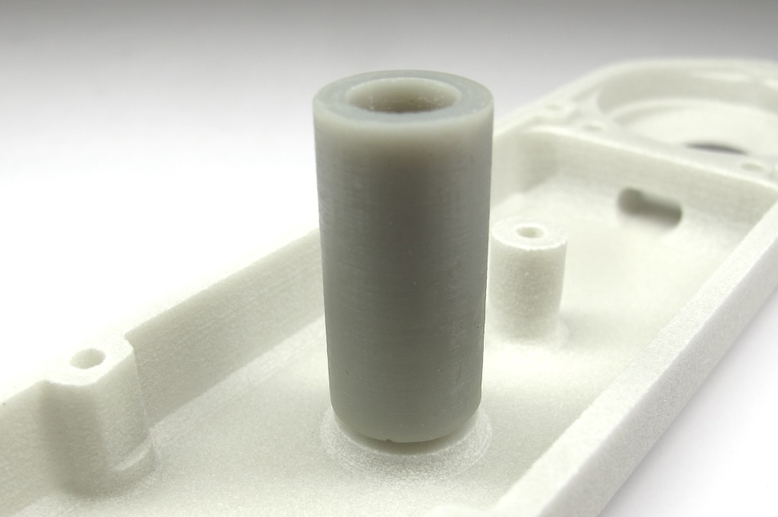  
You can also use the 3d printed tool for bonding the code wheels.*[*-> Tool Code Wheel Bonding*](https://github.com/open-dynamic-robot-initiative/open_robot_actuator_hardware/blob/master/mechanics/actuator_module_v1/stl_files/tool_code_wheel_bonding.STL)

*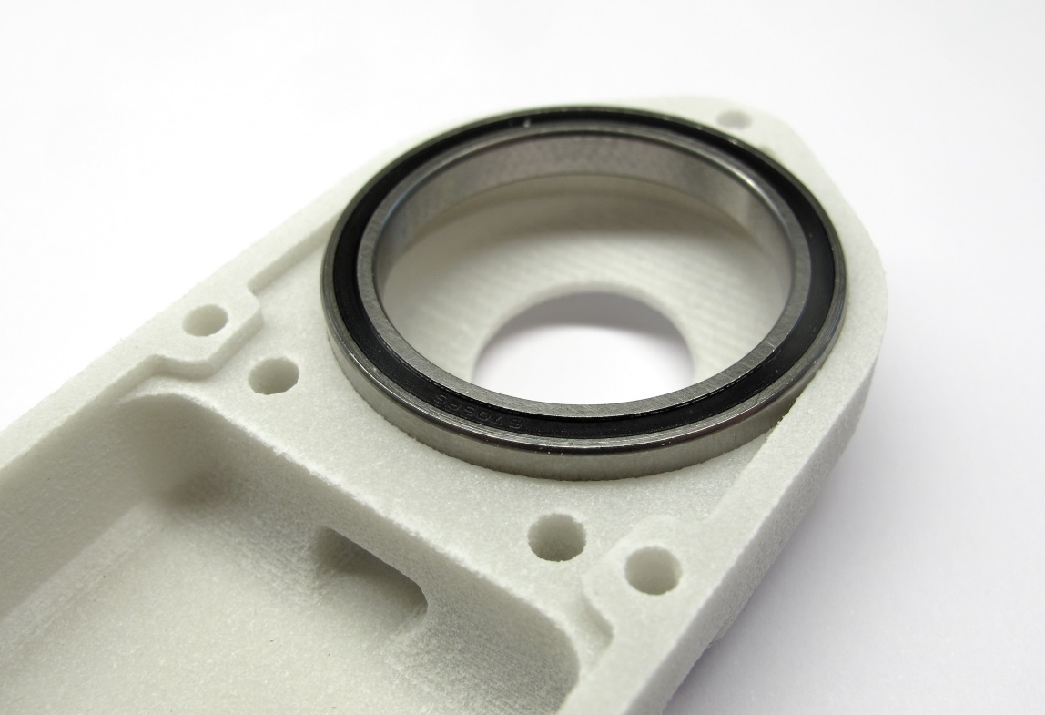  
Place the output bearing on the shell.  
Push the bearing into the bearing seat with your fingers.  
Try to keep the bearing horizontal while installing it.*

*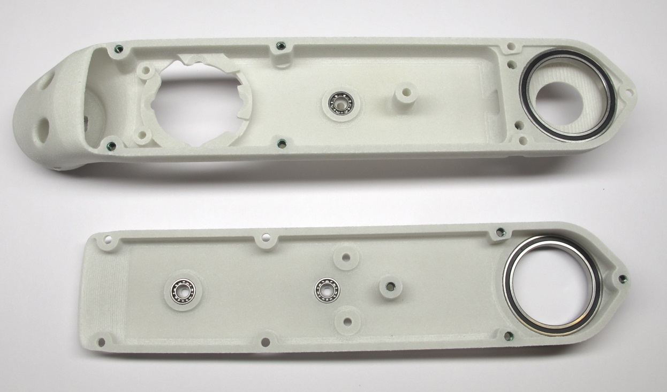  
Shell base and shell cover with bearings installed.*

## **Test-Mounting the Shells**

**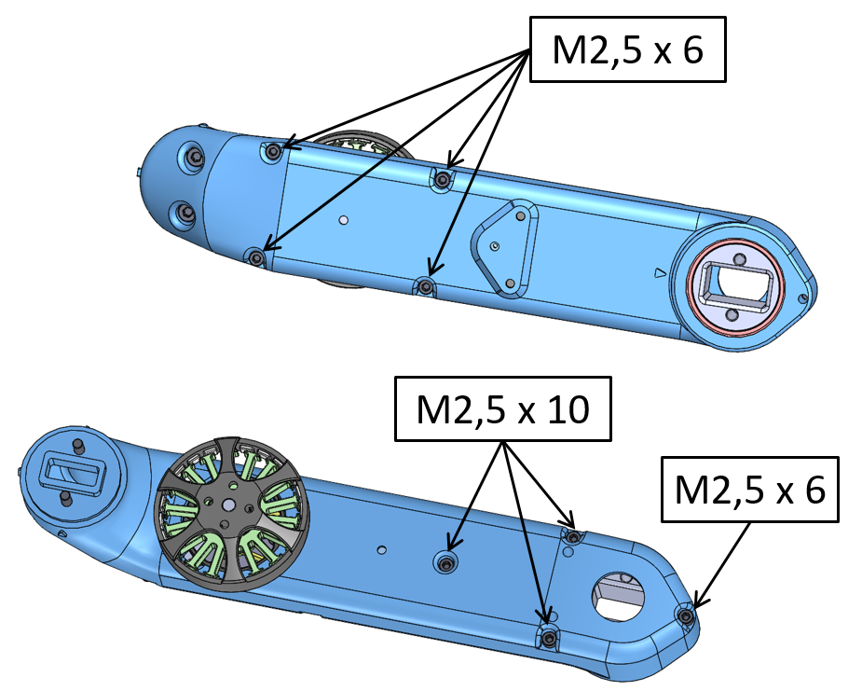***The shell parts are connected by eight screws.*

*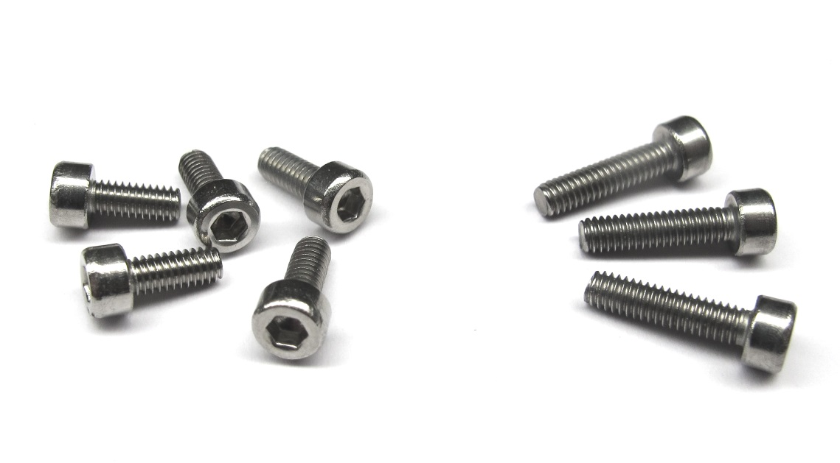  
Stainless steel socket head cap screws for connecting the shells.  
Five M2,5x6 and three M2,5x10 screws are required.*

*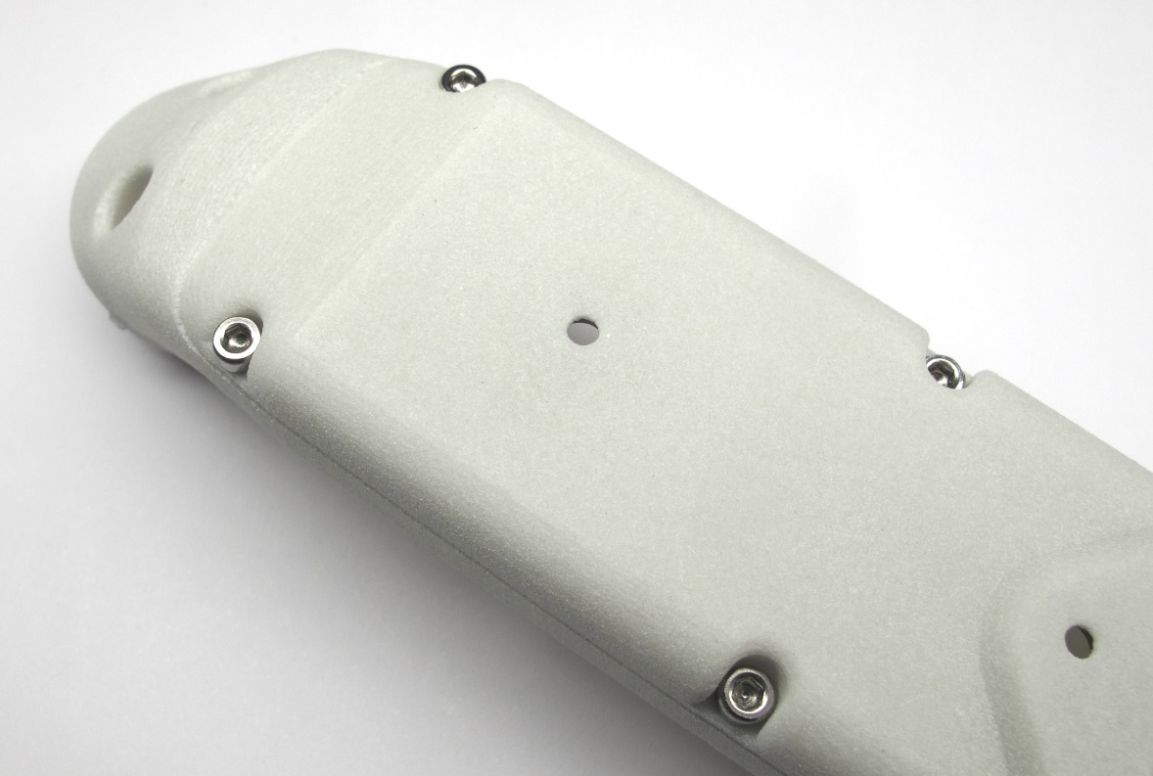  
Install the four M2,5x6 socket head cap screws on the cover.  
You will need a 2mm hex driver. Turn the shell around.*

*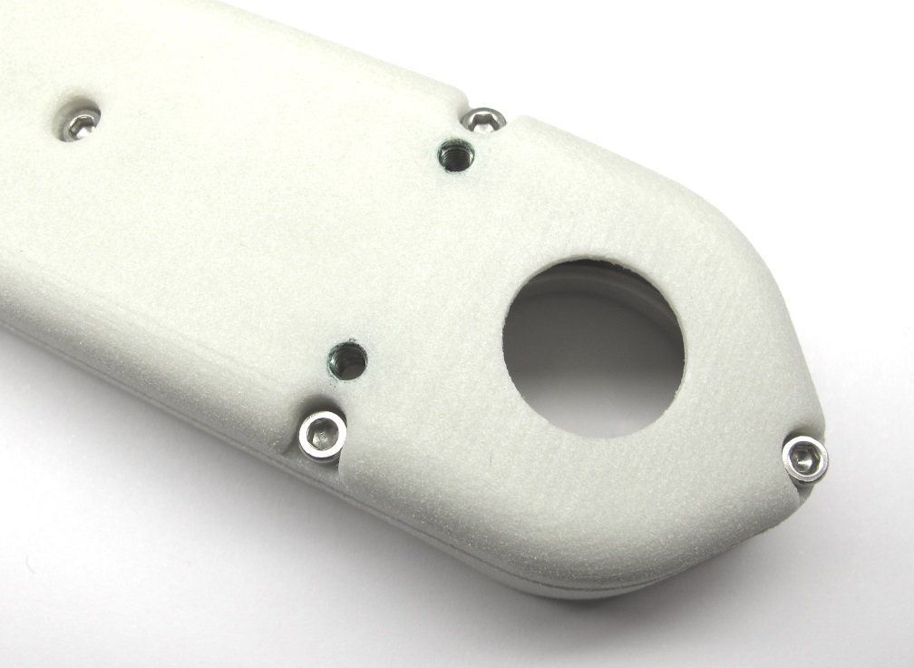  
Install three M2,5x10 screws and one M2,5x6 screw on the base shell.*

*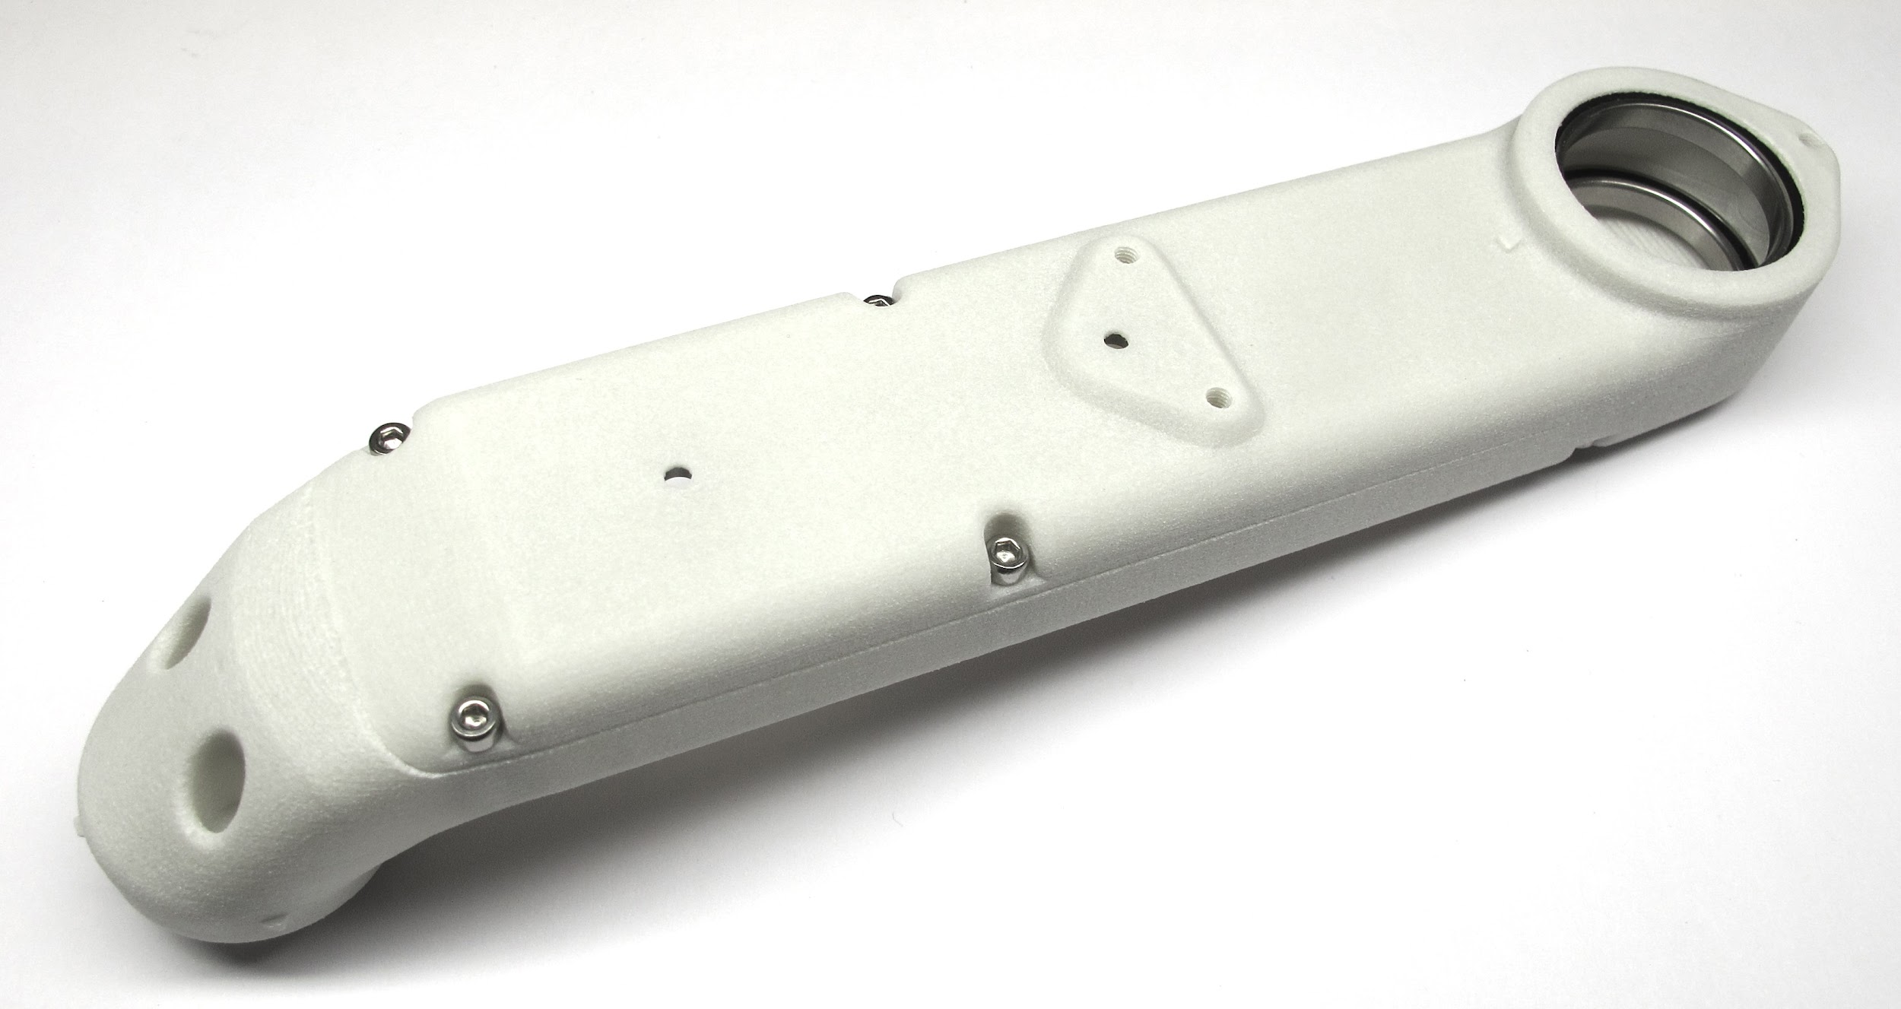  
The shell is now fully prepared and ready for assembly.  
Weight of the actuator module shell assembly: 61g*

# **Details Output Pulley Preparation**

**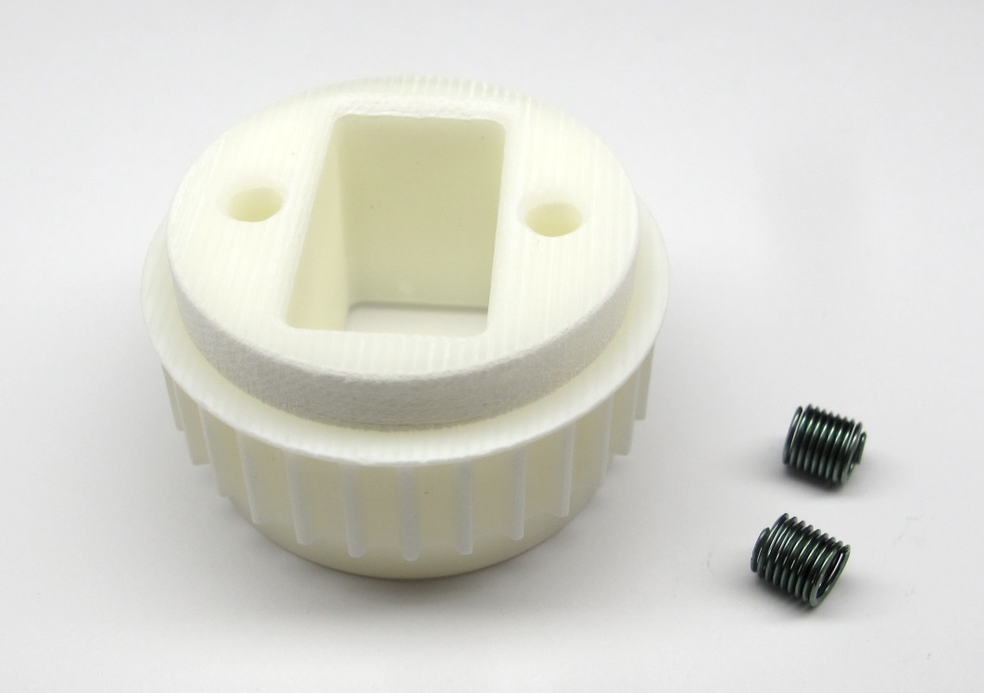***Starting Point: Output pulley and M3 Helicoil Inserts.*

*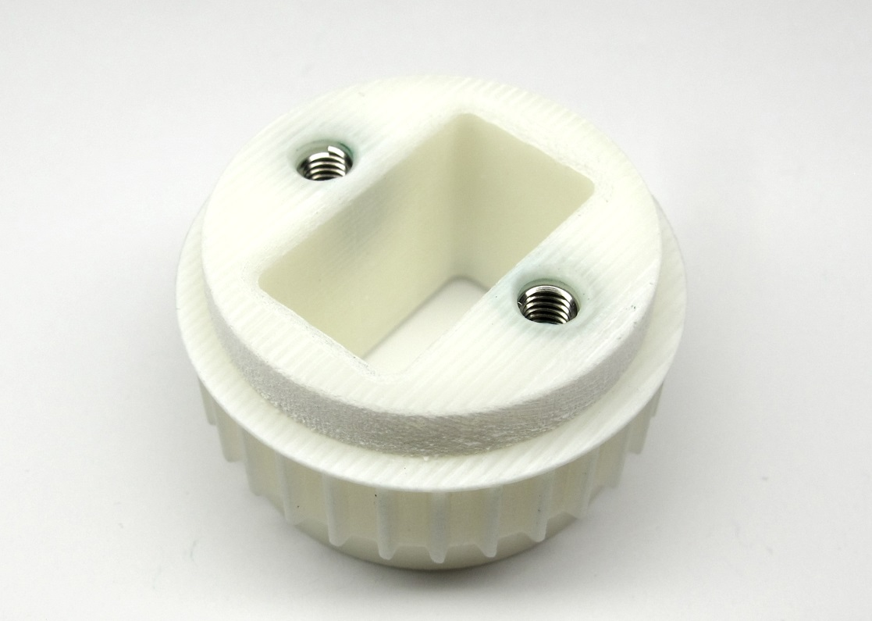  
End Result: Output pulley prepared for installation.*

## **Description**

* this page describes how to prepare the output pulley for the brushless actuator modules
* the shaft diameters of the output pulley are adjusted to fit the bearings  
  [-> Adjusting the Output Shaft Diameters](https://github.com/open-dynamic-robot-initiative/open_robot_actuator_hardware/blob/master/mechanics/actuator_module_v1/details/details_output_pulley_preparation.md#adjusting-the-output-shaft-diameters)
* two Helicoil thread inserts are installed in the mounting holes of the output pulley  
  [-> Installing Helicoil Thread Inserts](https://github.com/open-dynamic-robot-initiative/open_robot_actuator_hardware/blob/master/mechanics/actuator_module_v1/details/details_output_pulley_preparation.md#installing-helicoil-thread-inserts)
* Exeception: If you are preparing an output pulley for a Hip AA actuator module the helicoils shouldn't be installed  
  [-> Pulley for Hip AA Actuator Module](https://github.com/open-dynamic-robot-initiative/open_robot_actuator_hardware/blob/master/mechanics/actuator_module_v1/details/details_output_pulley_preparation.md#pulley-for-hip-aa-actuator-module)

### **More Information**

* More information 3d printing: [Details 3d Printed Parts](https://github.com/open-dynamic-robot-initiative/open_robot_actuator_hardware/blob/master/mechanics/actuator_module_v1/details/details_3d_printed_parts.md#details-3d-printed-parts)
* [STL File - Output Pulley](https://github.com/open-dynamic-robot-initiative/open_robot_actuator_hardware/blob/master/mechanics/actuator_module_v1/stl_files/transmission_pulley_at3_t30_output.STL)

## **Adjusting the Output Shaft Diameters**

The dimensions of 3d printed parts can vary quite a bit depending on the printer, the printing technology and the material.  
That's why we print the diameters that has to fit the bearings a bit oversize and machine the part to the right diameter on a lathe.

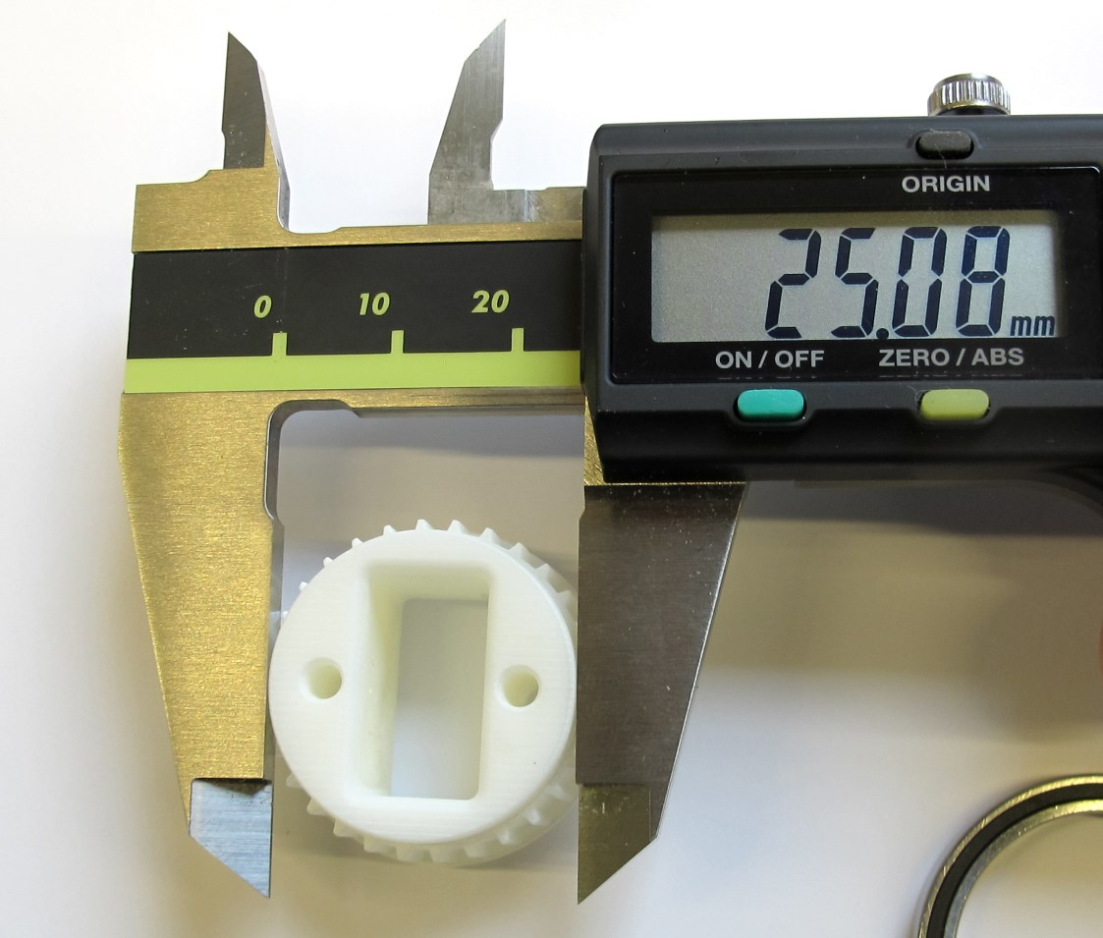  
*Output pulley - oversized diameter.*

*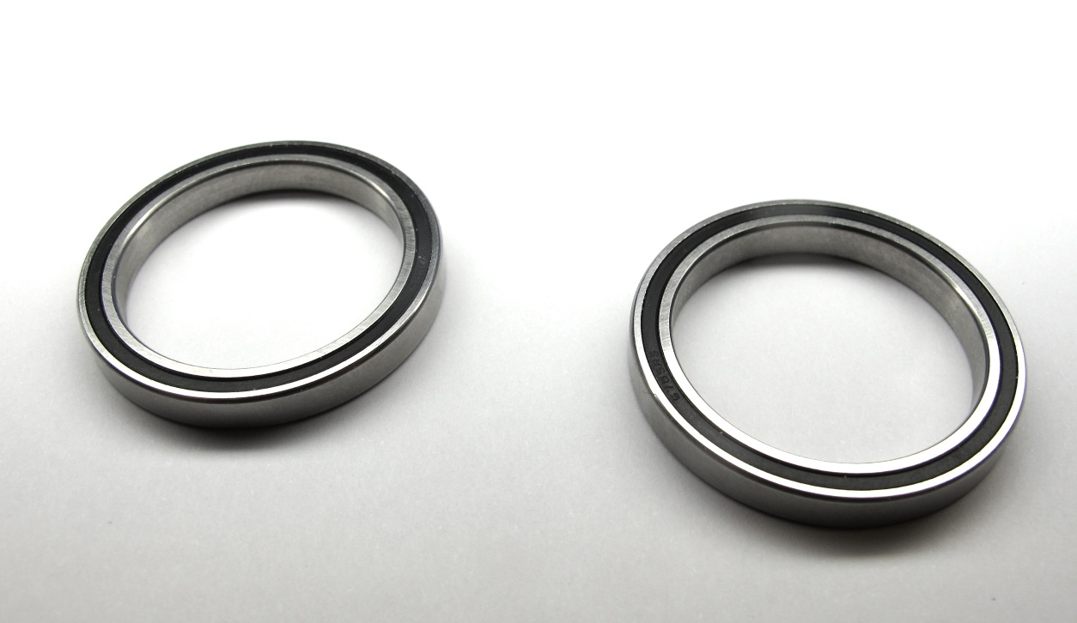  
Output bearings - dimensions: 32mm x 25mm x 4mm.*

*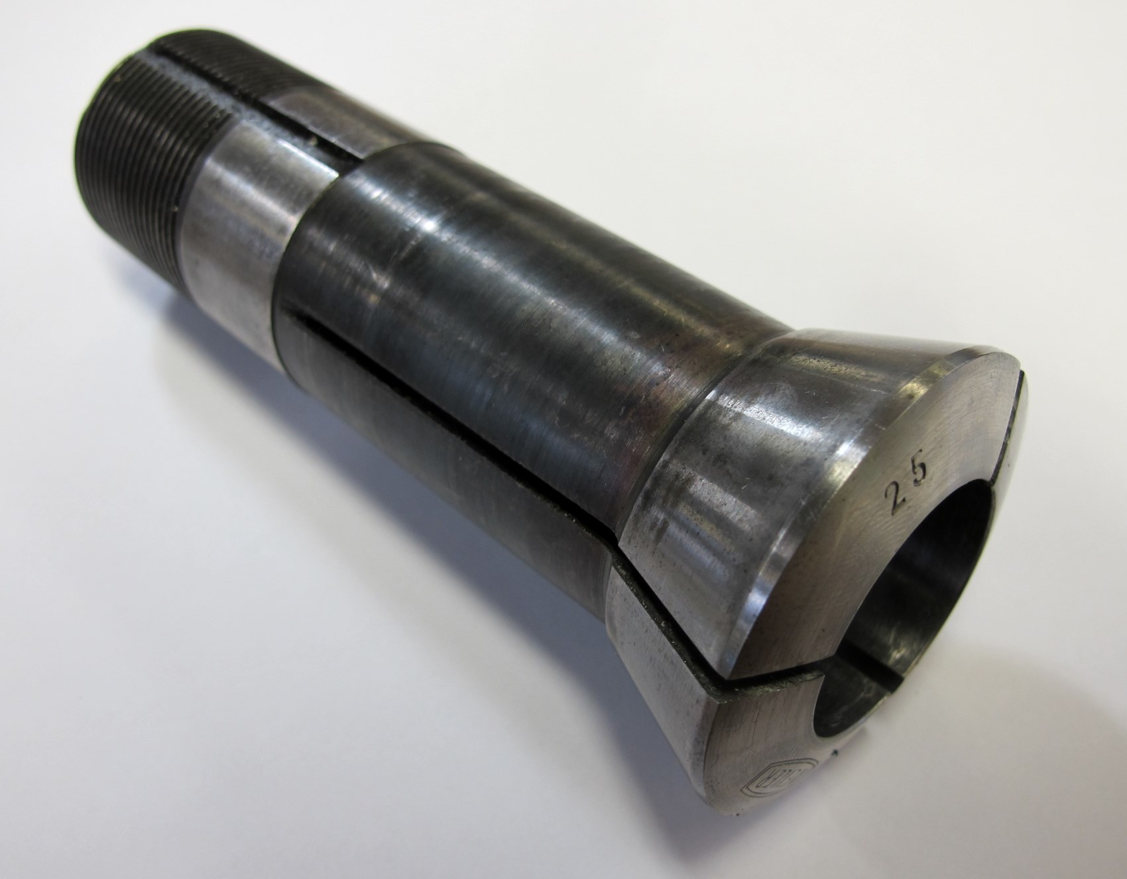  
A 25mm collet helps with clamping the output pulley.*

*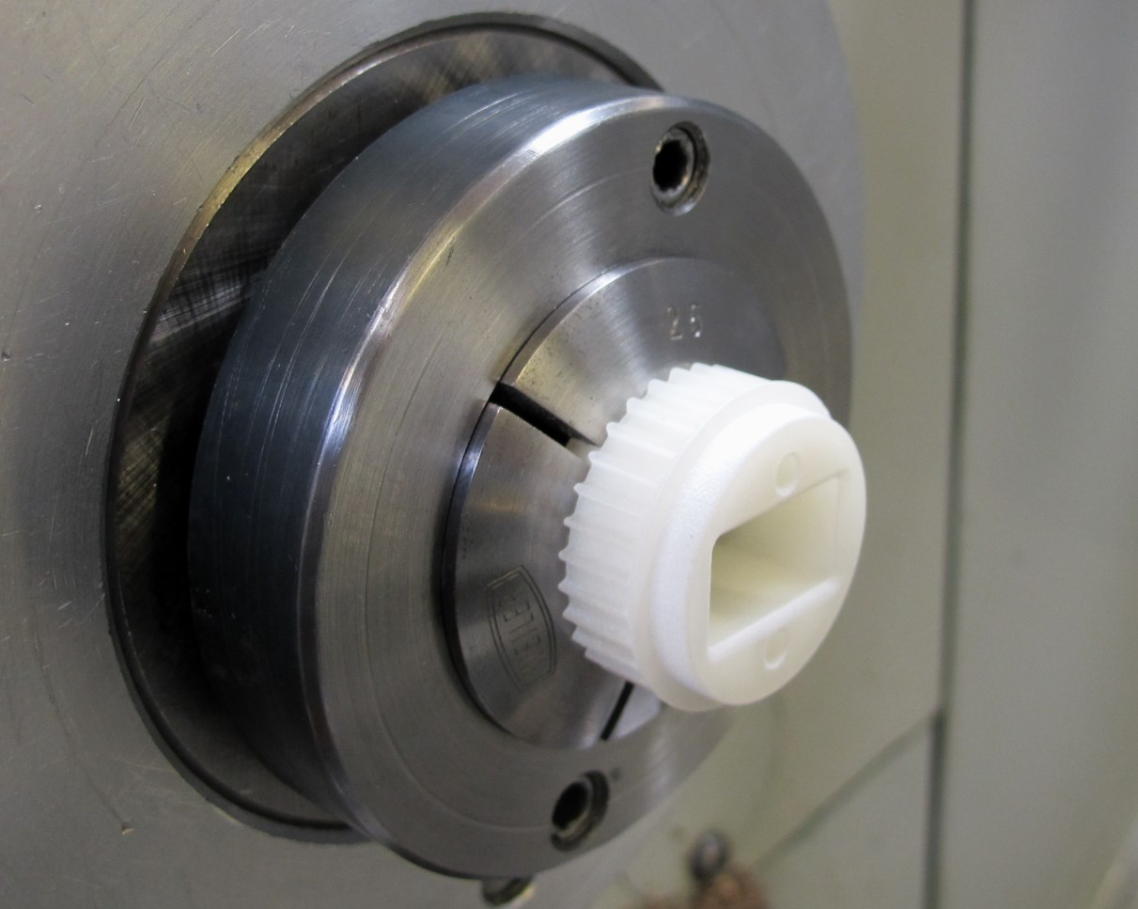  
Place the pulley on the lathe and clamp gently on one of the output shafts.*

*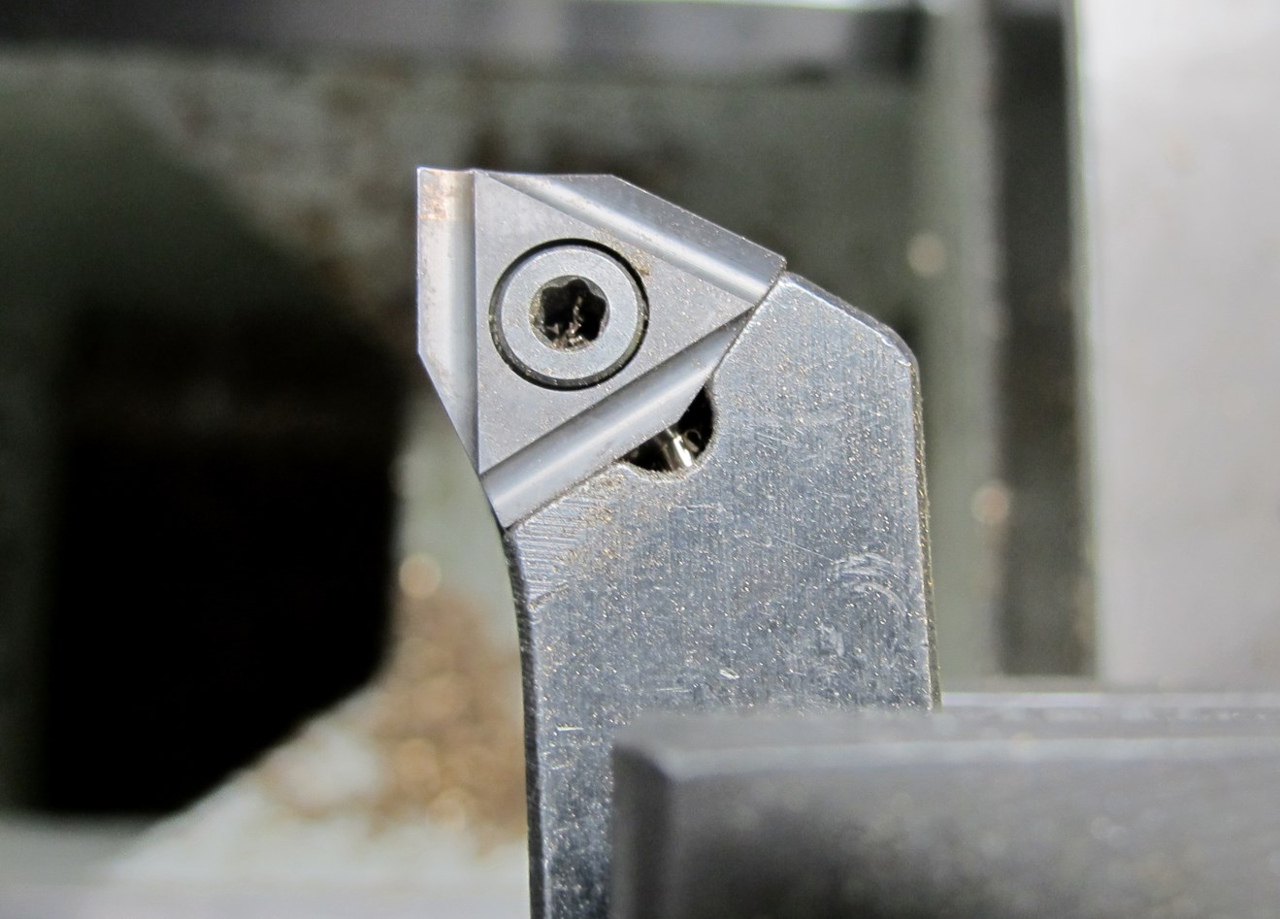  
Use a cutting tool with a sharp edge.*

*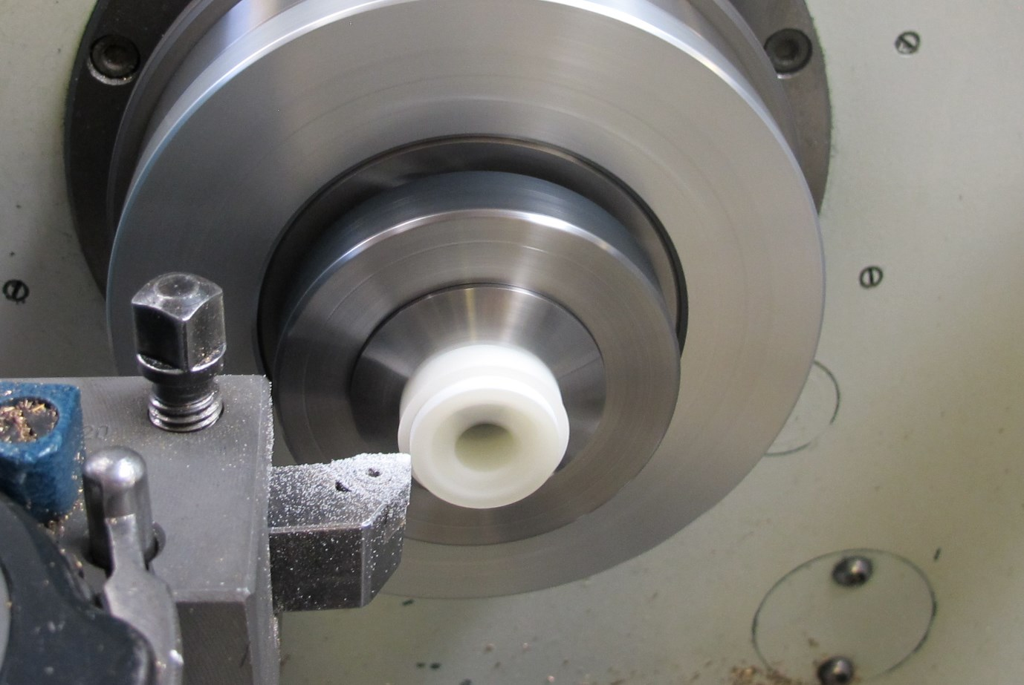  
Reduce the shaft diameter in small steps and check the fit with the output bearing.*

*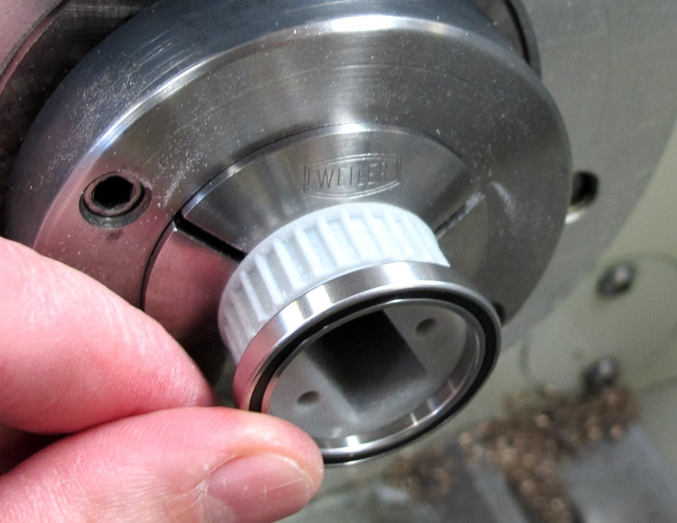  
There should be a light press-fit between the bearing and the pulley.  
You should be able to install and remove the bearing by hand with moderate force.  
When the diameter is correct - turn the pulley around and repeat the same steps for the opposite side.*

## **Pulley for Hip AA Actuator Module**

**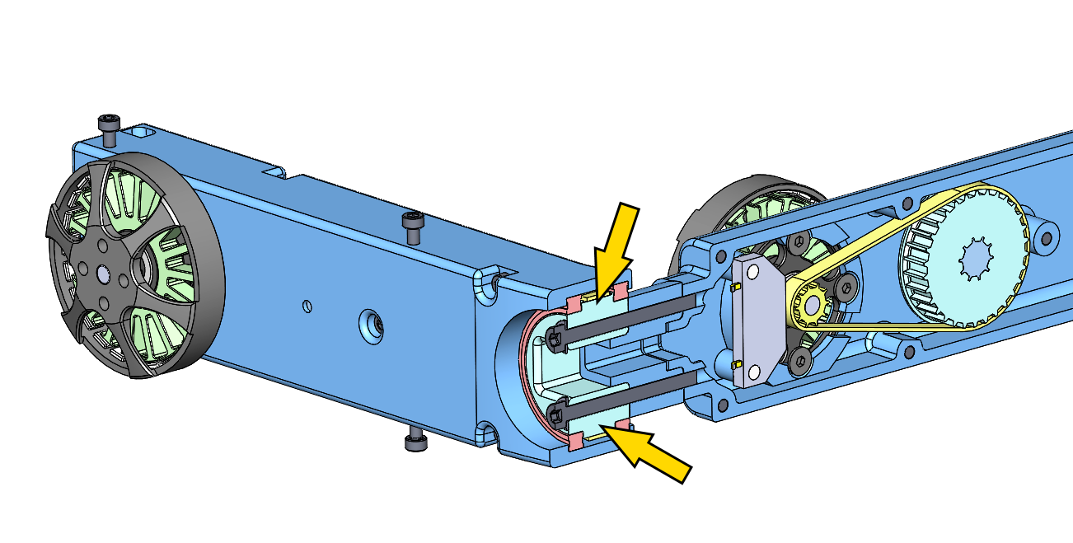***Exception: Hip AA Output Pulley - the fasteners go through the pulley.*

* the pulley for the Hip AA actuator modules is an exception
* since the fasteners go through the pulley the helicoils mustn't be installed
* increase the hole diameters to 3mm and don't install the Helicoil thread inserts

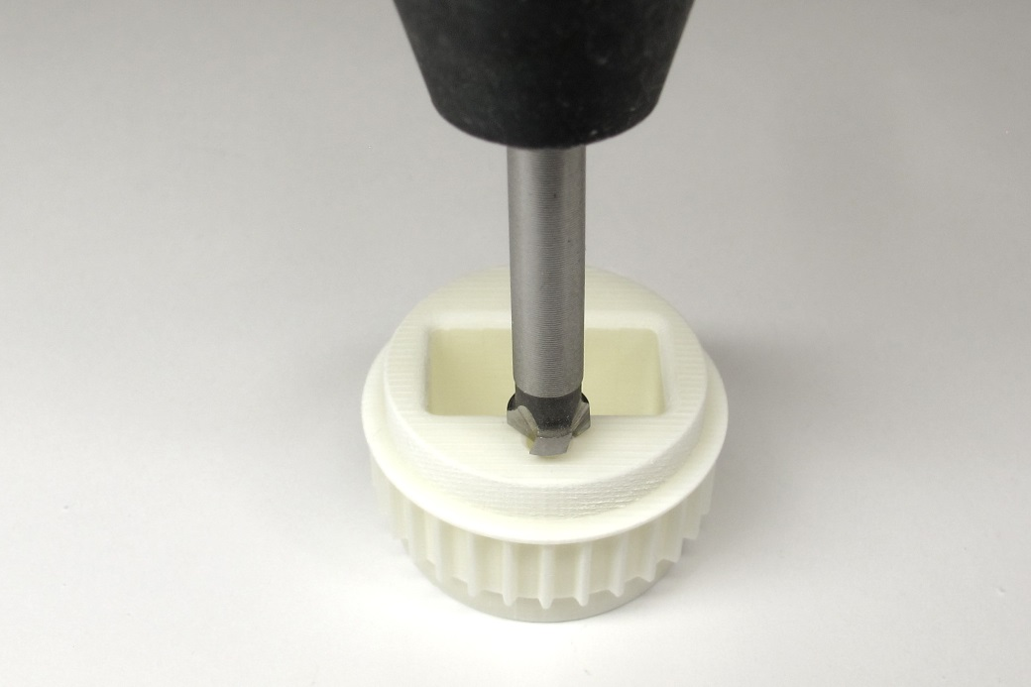  
*Put a small chamfer on the mounting holes.*

*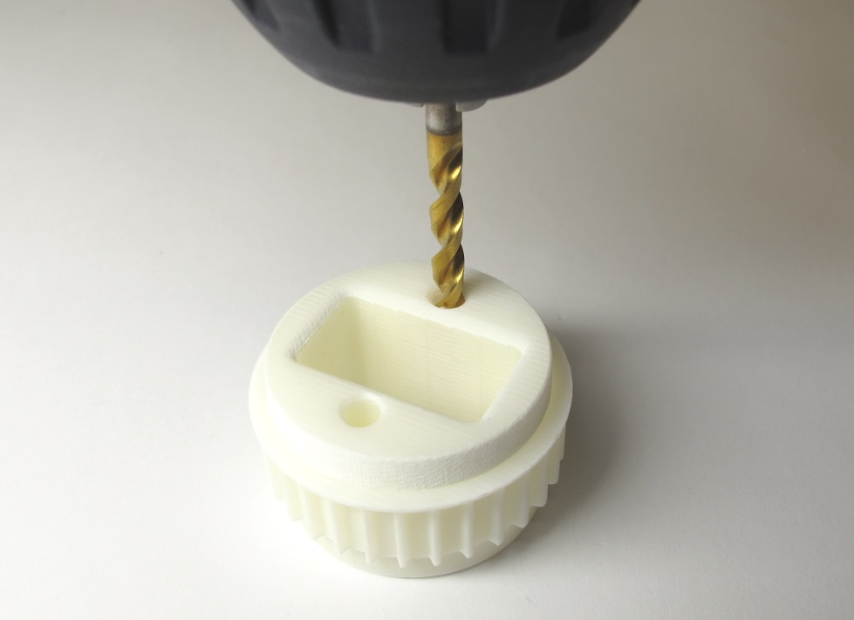  
Increase the diameter of the mounting holes using a 3mm drill bit.*

*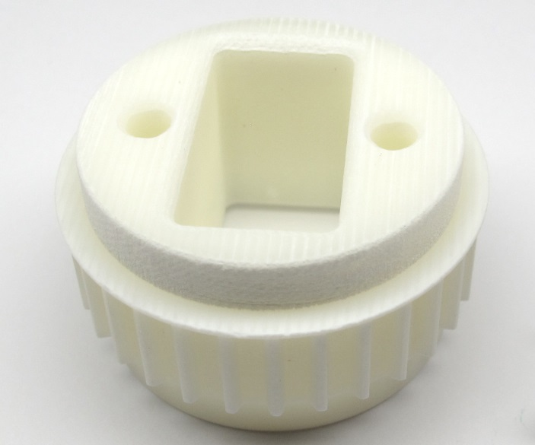  
The Hip AA Output Pulley is now ready for installation.*

If you are preparing a Hip AA output pulley you should stop here and ignore all the following steps.

## **Installing Helicoil Thread Inserts**

**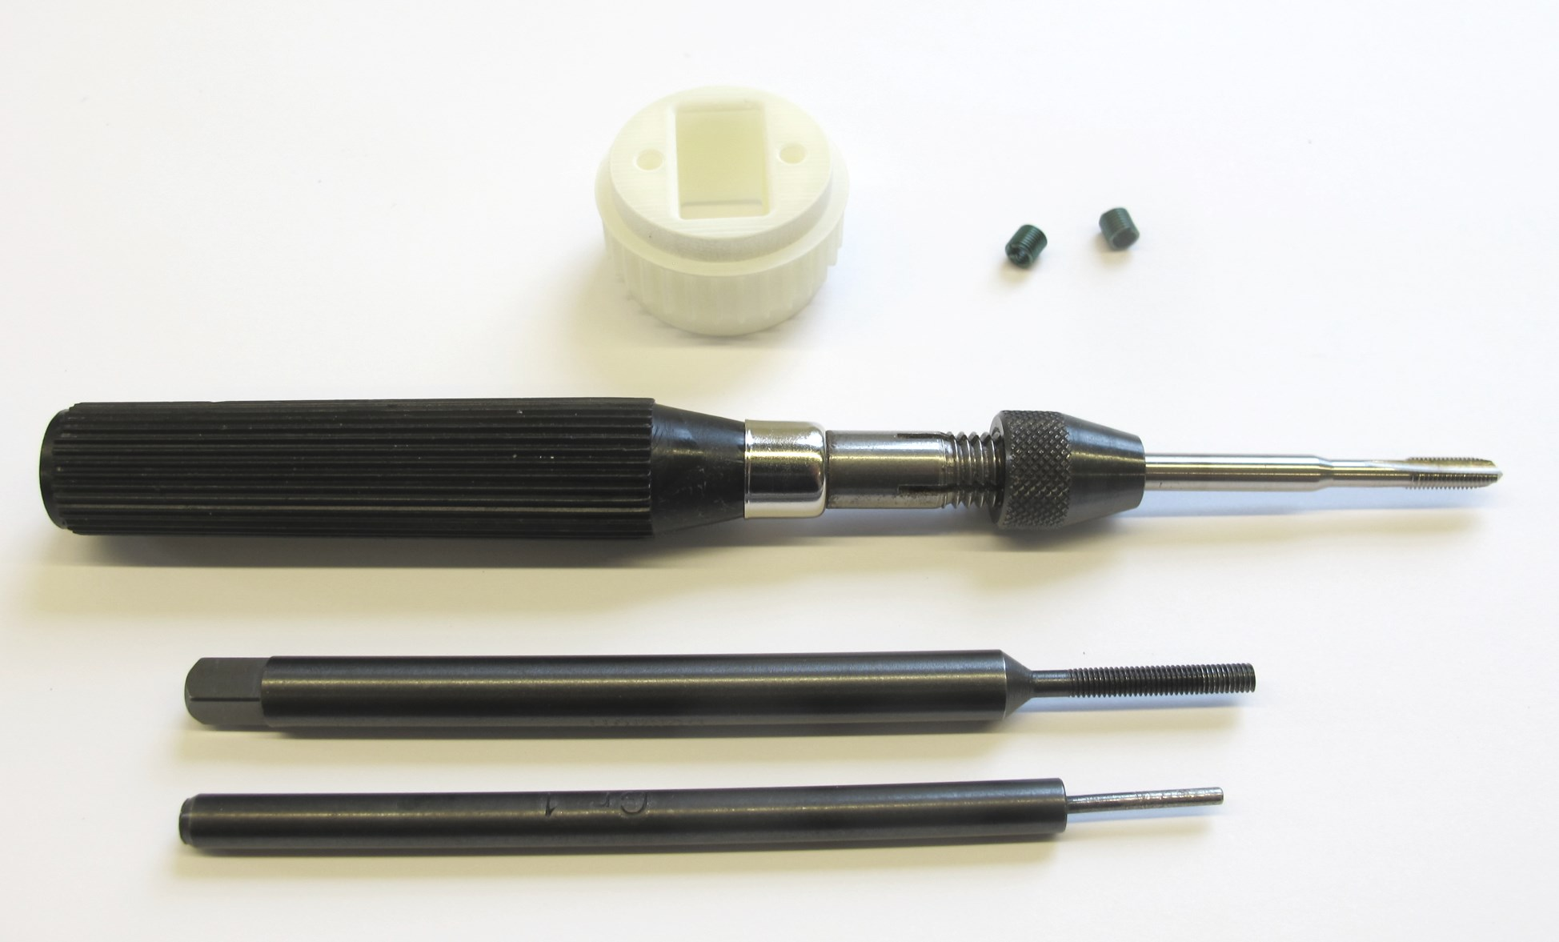***Output Pulley, M3 Helicoils and Helicoil Tools.*

*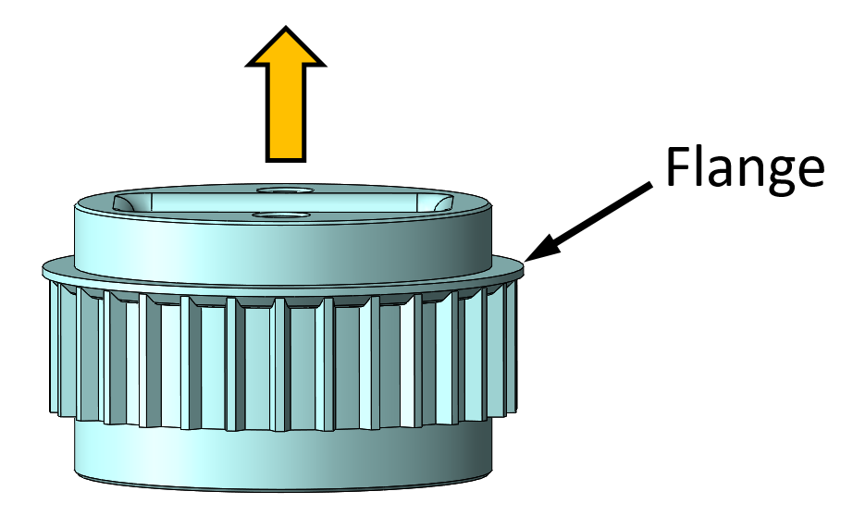  
Make sure that the flange on the pulley faces upwards for all of the following steps.*

*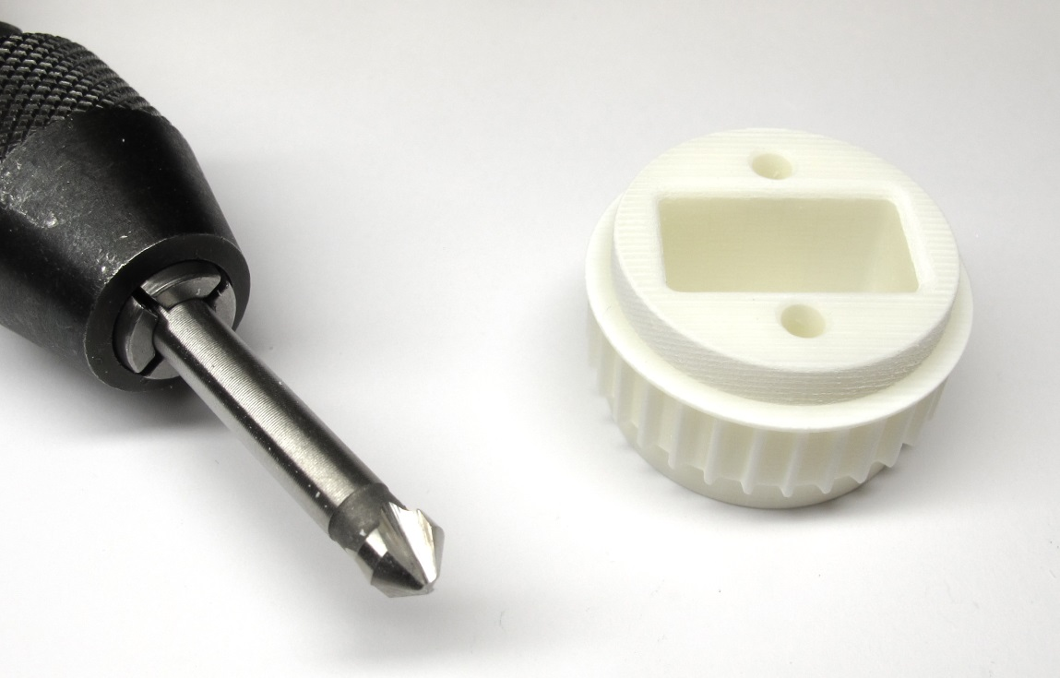  
45 degree chamfer tool and output pulley.*

*  
Put a small chamfer on the mounting holes.*

*  
The holes should have a diameter of about 2,9mm.  
Drill through with a 3mm drill bit.  
Drill with increasing drill diameters in steps of 0,1mm.  
Increase the diameter of the holes until you reach a diameter of 3.3mm.*

*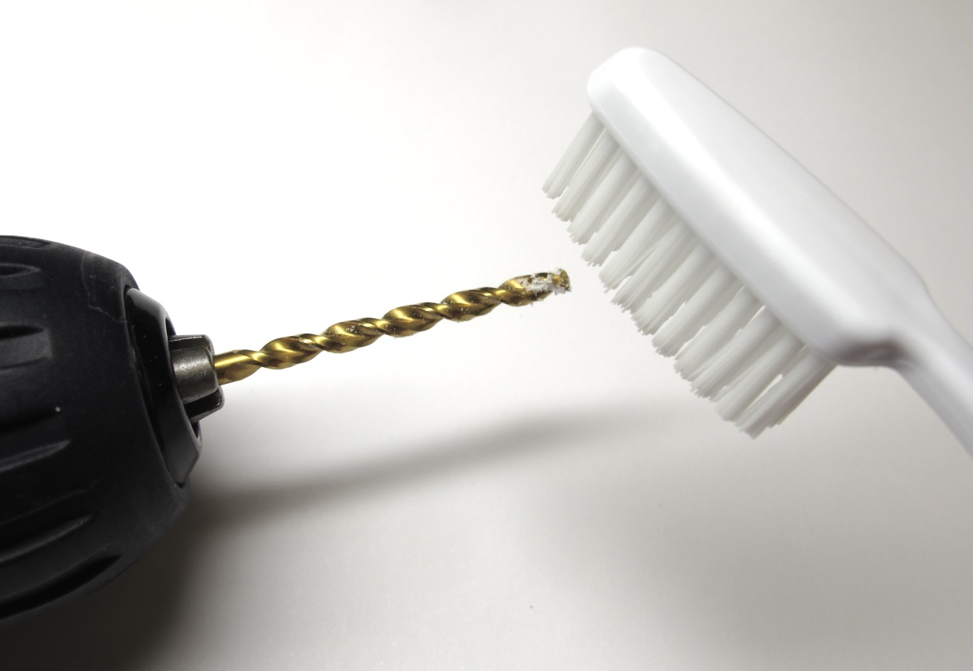  
Clean the drill with a tooth brush if required.*

*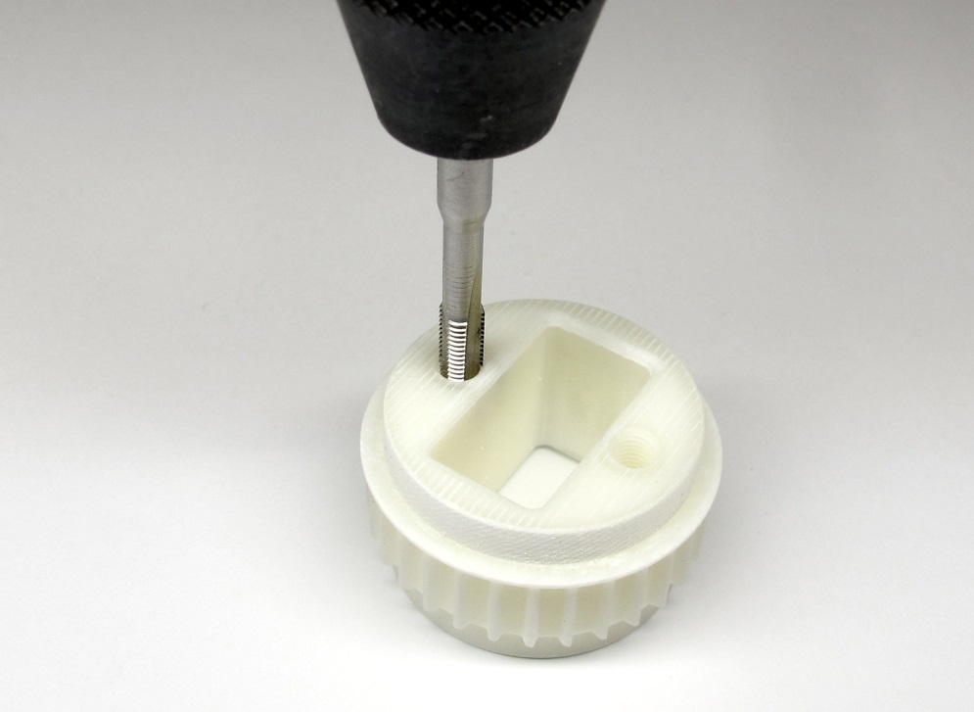  
Tap both holes using the Helicoil M3 tap.  
The flange on the pulley has to point upwards as shown in the picture.*

*  
If the resistance increases carefully back out the tap and clean it with a tooth brush.  
Continue until the Helicoil thread is fully cut.*

*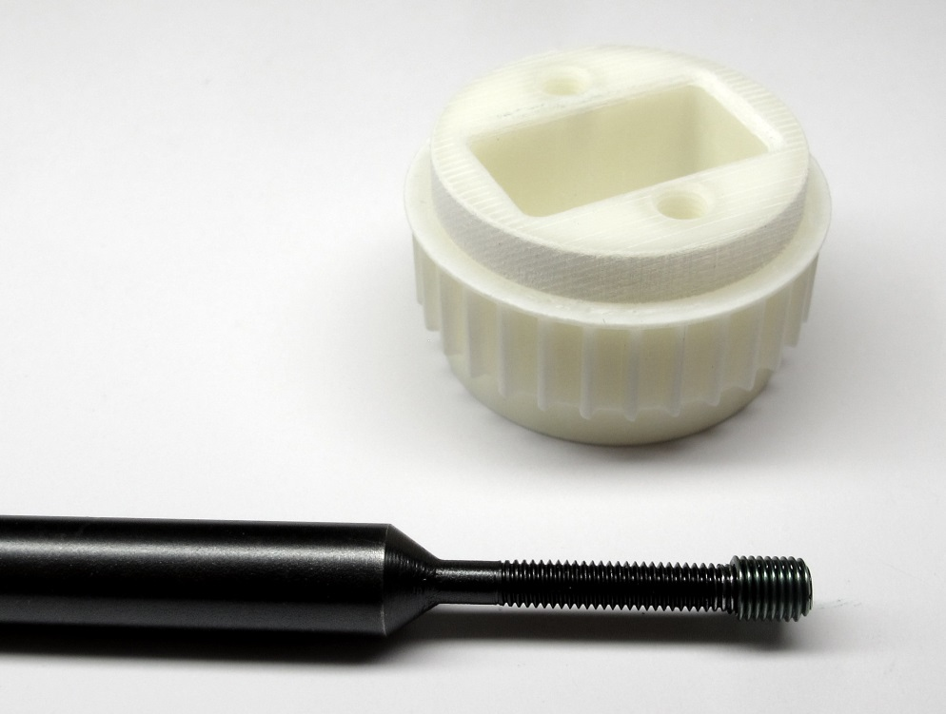  
Place a M3 Helicoil with a length of 6mm on the insertion tool.*

*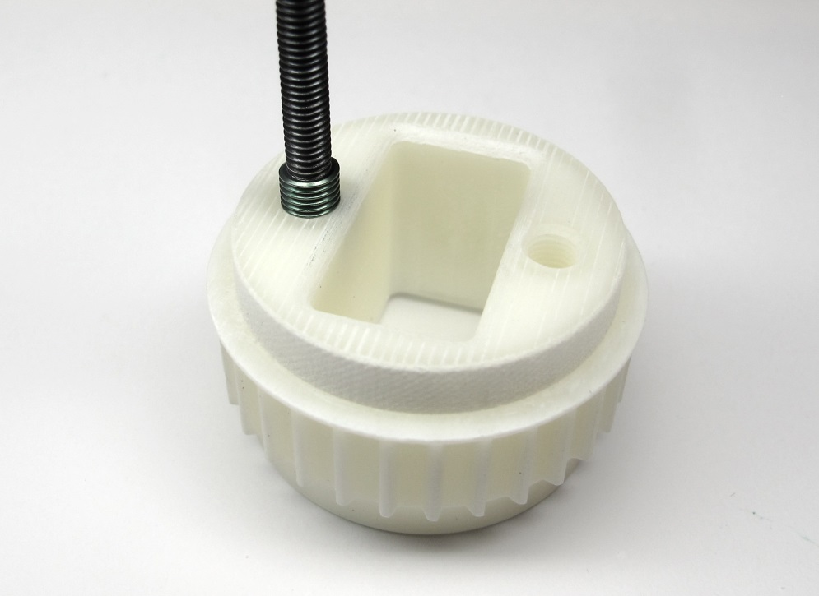  
Insert both Helicoils with the insertion tool.  
Make sure that the end of the insert is about half a turn below the outer surface*

*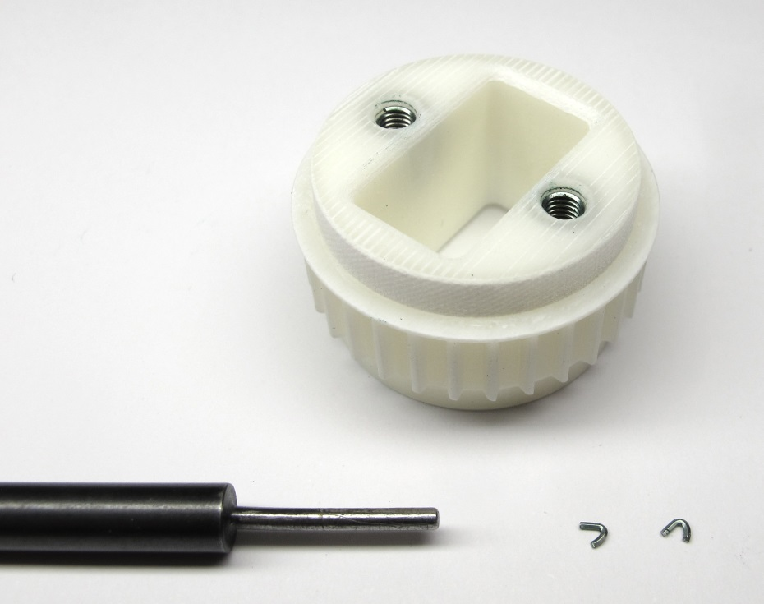  
Remove both tangs using the tang break-off tool.  
Make sure that the tangs don't stay inside of the part.*

*  
The output pulley is now ready for installation.*

# **Details Center Pulley Preparation**

**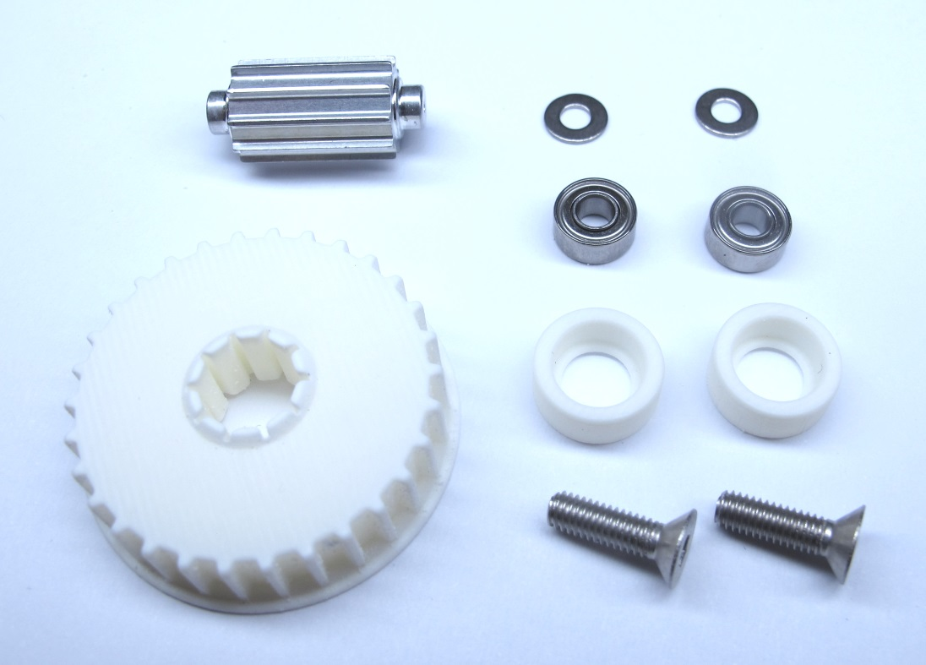***Starting Point: Center Pulley and Timing Belt Tensioner Components*

*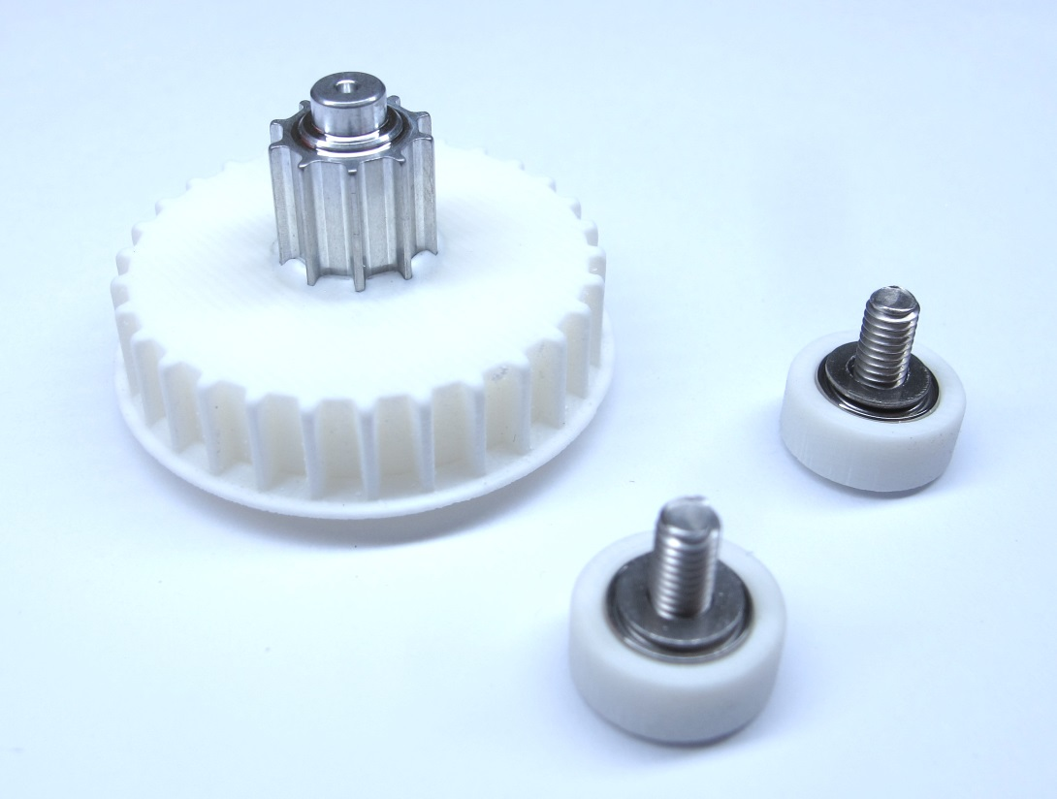  
End Result: Center Pulley and Timing Belt Tensioners assembled*

## **Description**

* This page describes how to prepare the center pulley and the timing belt tensioners for the brushless actuator modules
* The center pulley consits of the 10 tooth aluminium pulley and the 30 tooth 3d printed pulley.
* The pulleys are press-fit using an arbor press and 3d printed tools. [-> Press-Fitting the Pulleys](https://github.com/open-dynamic-robot-initiative/open_robot_actuator_hardware/blob/master/mechanics/actuator_module_v1/details/details_center_pulley_preparation.md#press-fitting-the-pulleys)
* The timing belt tensioners are prepared and assembled. [-> Assembling the Timing Belt Tensioners](https://github.com/open-dynamic-robot-initiative/open_robot_actuator_hardware/blob/master/mechanics/actuator_module_v1/details/details_center_pulley_preparation.md#assembling-the-timing-belt-tensioners)

### **More Information**

* More information on the 3d printing: [Details 3d Printed Parts](https://github.com/open-dynamic-robot-initiative/open_robot_actuator_hardware/blob/master/mechanics/actuator_module_v1/details/details_3d_printed_parts.md#details-3d-printed-parts)
* More information on the machined part: [Details Machined Parts](https://github.com/open-dynamic-robot-initiative/open_robot_actuator_hardware/blob/master/mechanics/actuator_module_v1/details/details_machined_parts.md#details-machined-parts)
* [PDF File - Pulley AT3 T10 Center](https://github.com/open-dynamic-robot-initiative/open_robot_actuator_hardware/blob/master/mechanics/actuator_module_v1/drawings/center_pulley_at3_t10.PDF)
* [STL File - Pulley AT3 T30 Center](https://github.com/open-dynamic-robot-initiative/open_robot_actuator_hardware/blob/master/mechanics/actuator_module_v1/stl_files/transmission_pulley_at3_t30_center.STL)
* [STL File - Timing Belt Tensioner Rollers 10mm](https://github.com/open-dynamic-robot-initiative/open_robot_actuator_hardware/blob/master/mechanics/actuator_module_v1/stl_files/transmission_belt_tensioner_roller_10.0mm.STL)
* [STL File - Tool Center Pulley Protection](https://github.com/open-dynamic-robot-initiative/open_robot_actuator_hardware/blob/master/mechanics/actuator_module_v1/stl_files/tool_center_pulley_protection.STL)
* [STL File - Tool Center Pulley Assembly](https://github.com/open-dynamic-robot-initiative/open_robot_actuator_hardware/blob/master/mechanics/actuator_module_v1/stl_files/tool_center_pulley_assembly.STL)

## **Press-Fitting the Pulleys**

**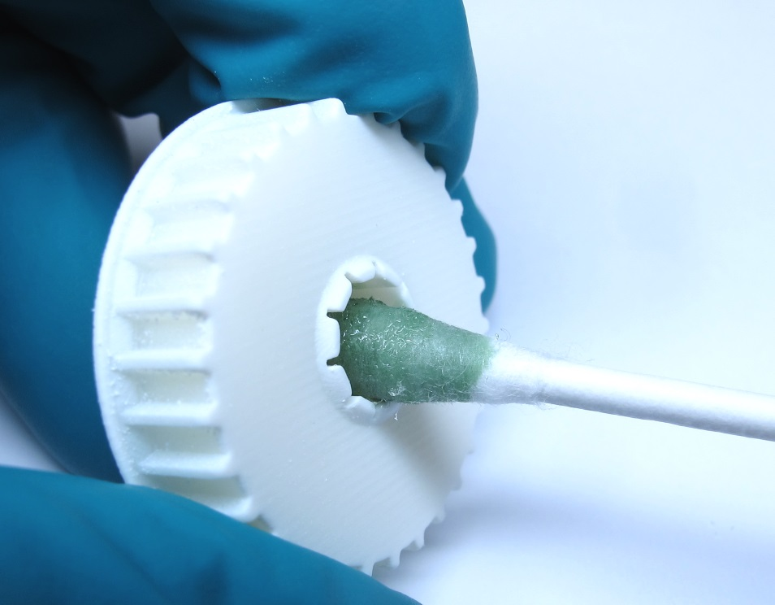***Apply a bit of Loctite 648 onto the internal tooth profile of the 3d printed pulley.*

*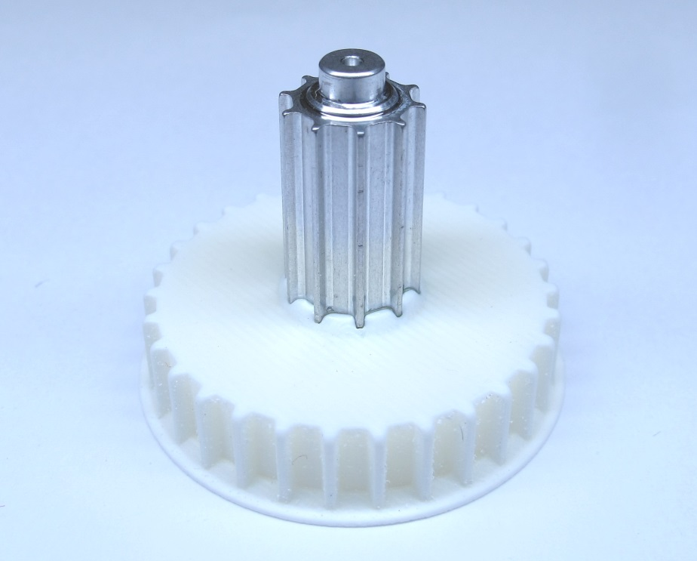  
Place the aluminum pulley on the 3d printed pulley.  
Make sure it's vertical and matches the tooth pattern.  
Push it in a bit by hand - the centering hole should be facing upwards.*

*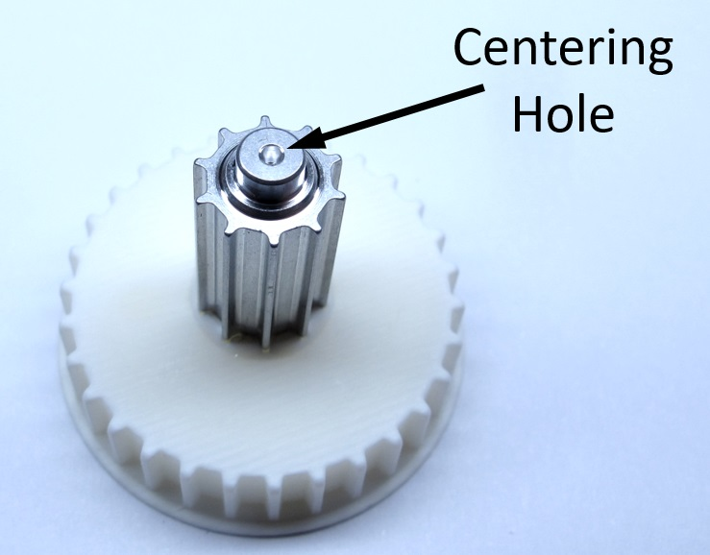  
Make sure that the centering hole is facing upwards.*

*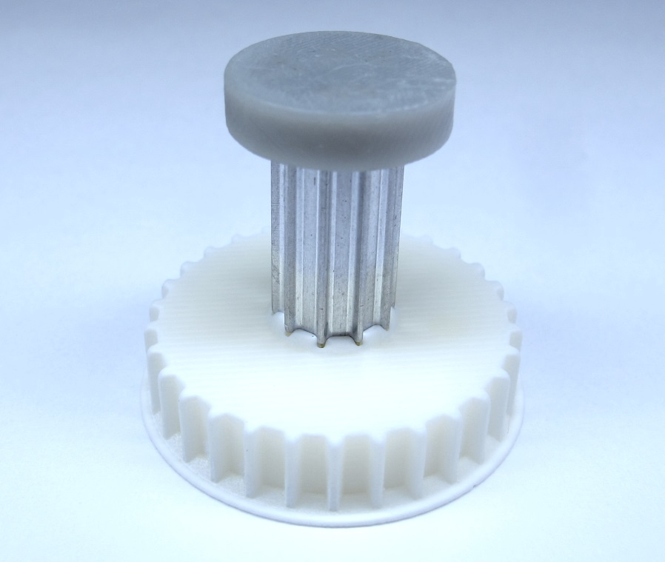  
Place the 3d printed protection tool on the aluminum pulley.*

*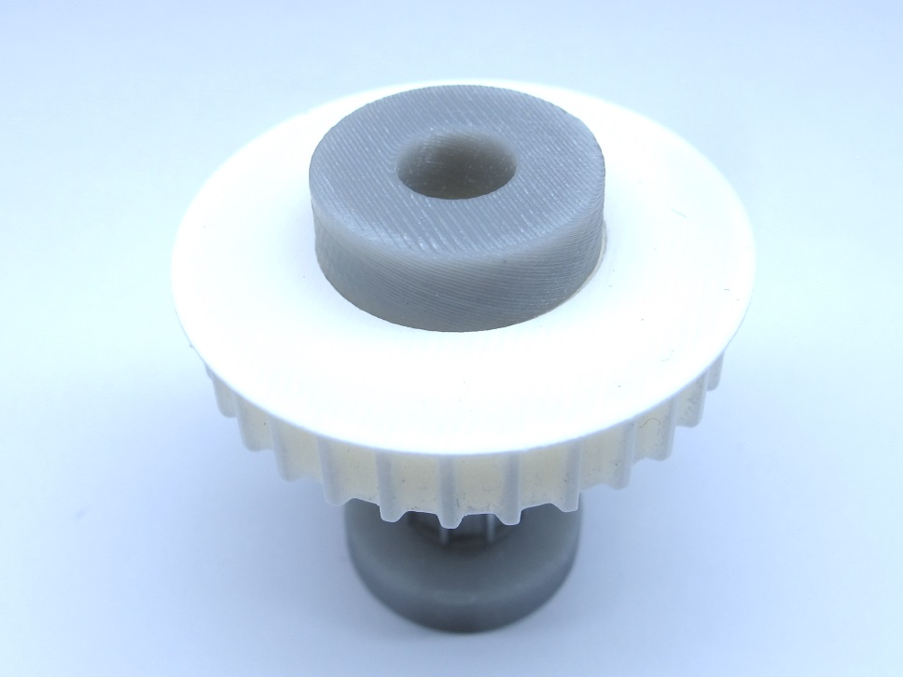  
Turn your assembly around.  
Place and center the 3d printed assembly tool on the bottom side.*

*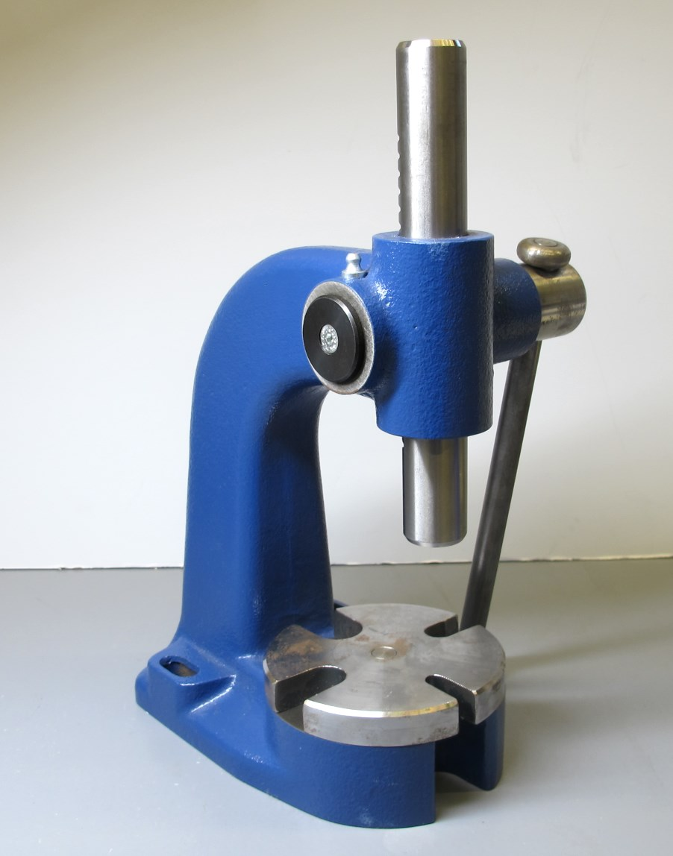  
We use an arbor press to join the parts.*

*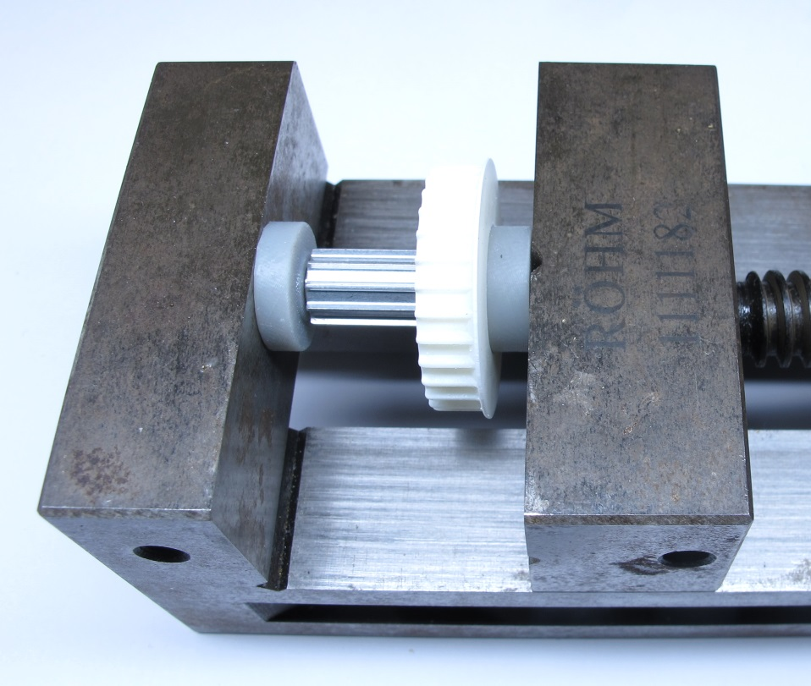  
Alternative: You can also use a vise to press-fit the parts.*

*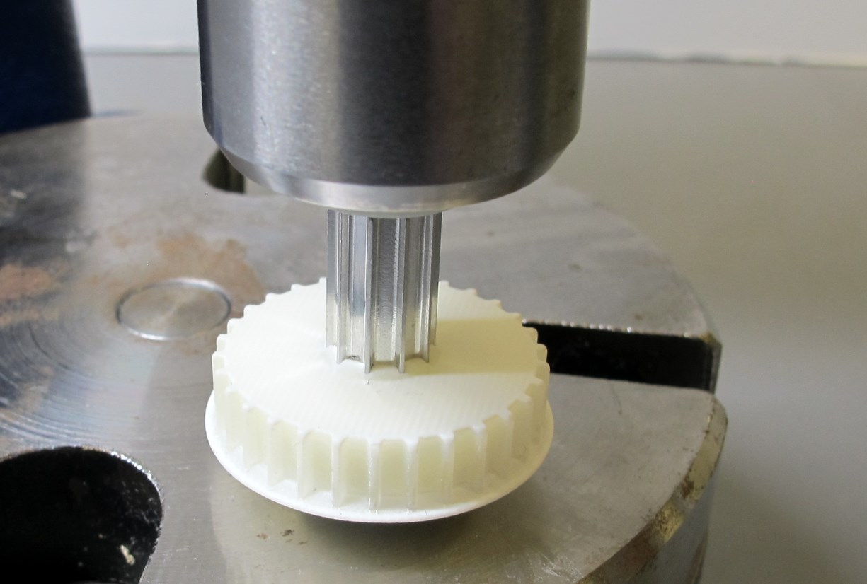  
Place your stack of parts on the arbor press.  
Slowly push the aluminum pulley all the way down.*

*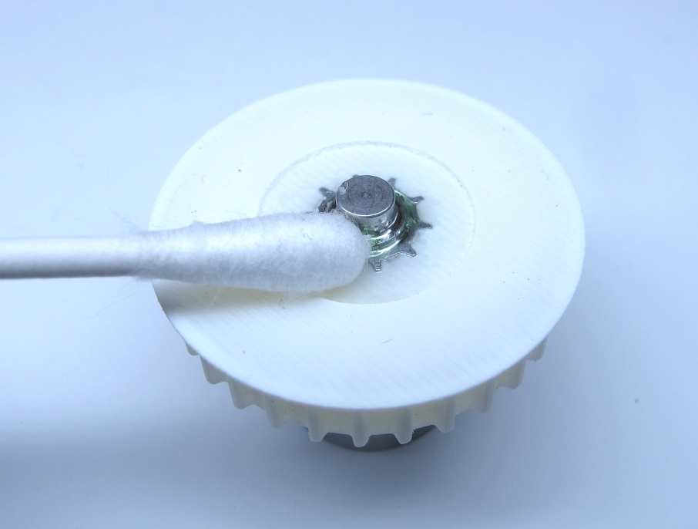  
Remove the protection and the assembly tool.  
Use a cotton swab to remove excess Loctite.*

*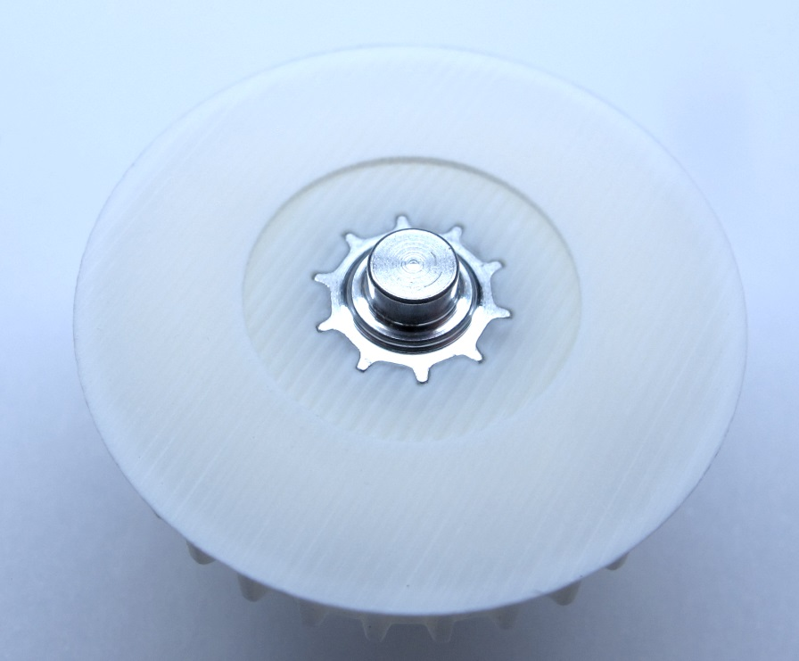  
The parts should be flush on the bottom side.  
Remove scraped-off material with a tooth brush.  
Use the arbor press again if the parts don't line up.*

*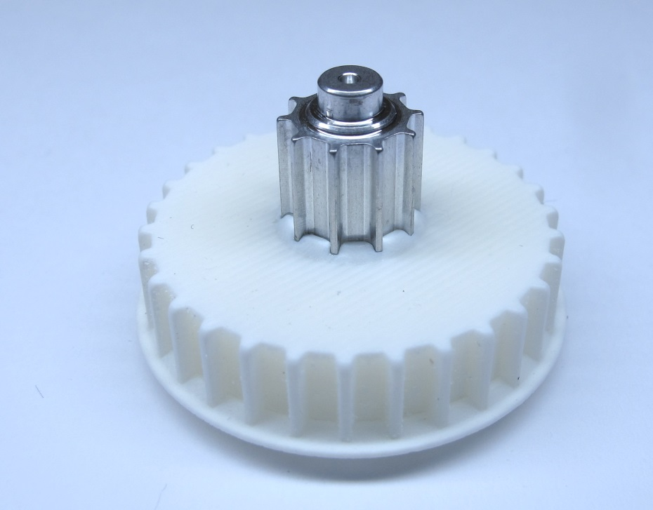  
The center pulley is now ready for installation.*

## **Assembling the Timing Belt Tensioners**

**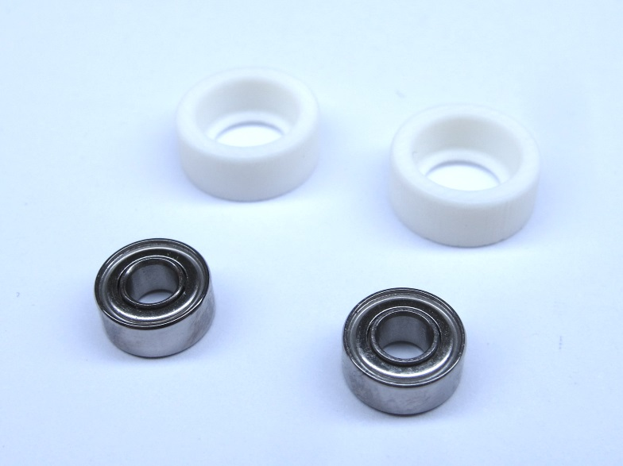***Timing belt tensioner bearings and 3d printed rollers.  
For each actuator module two timing belt tensioner assemblies are required.  
We use the 10mm diameter roller as default size.  
Larger roller diameters can be used to adjust the timing belt tension.*

*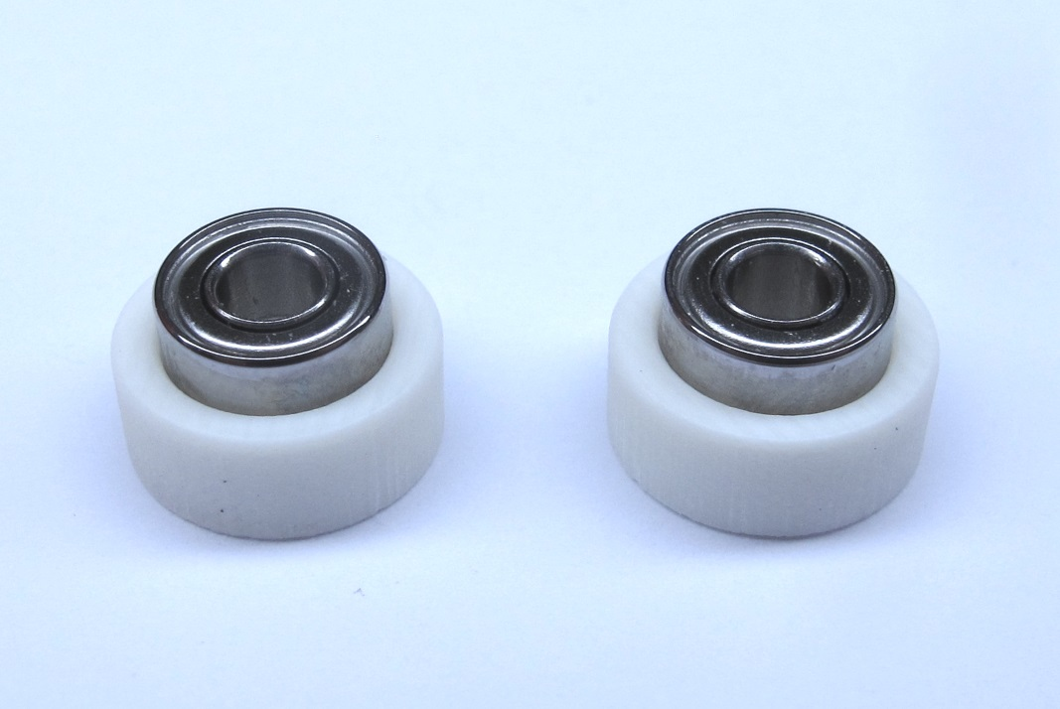  
Place the bearings on the 3d printed rollers.*

*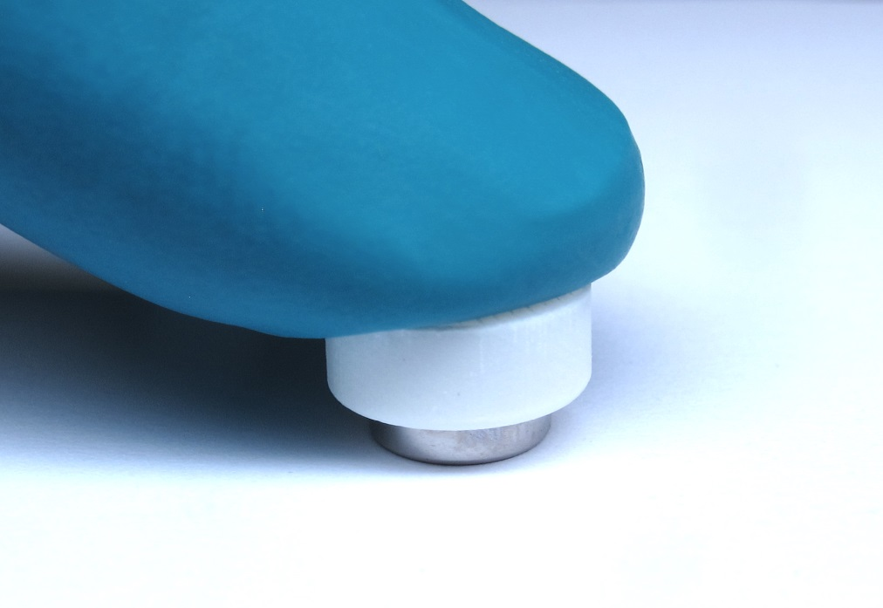  
Turn the parts around and push the roller onto the bearing.*

*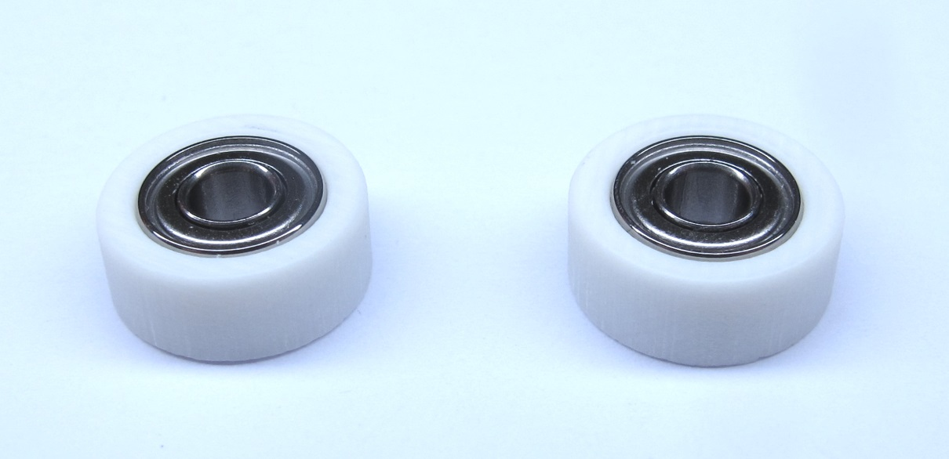  
Make sure that the bearings are inserted all the way.*

*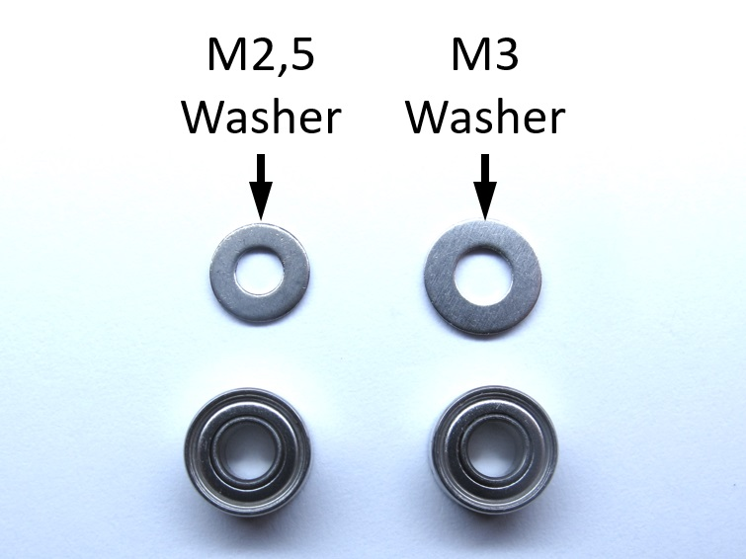  
We use stainless steel washers as a rigid surface for supporting the inner ring of the bearing.  
We use M3 screws but M3 washers are too large and prevent the outer ring of the bearing to rotate freely.  
Therefore we modify M2,5 washers to fit the M3 screws.*

*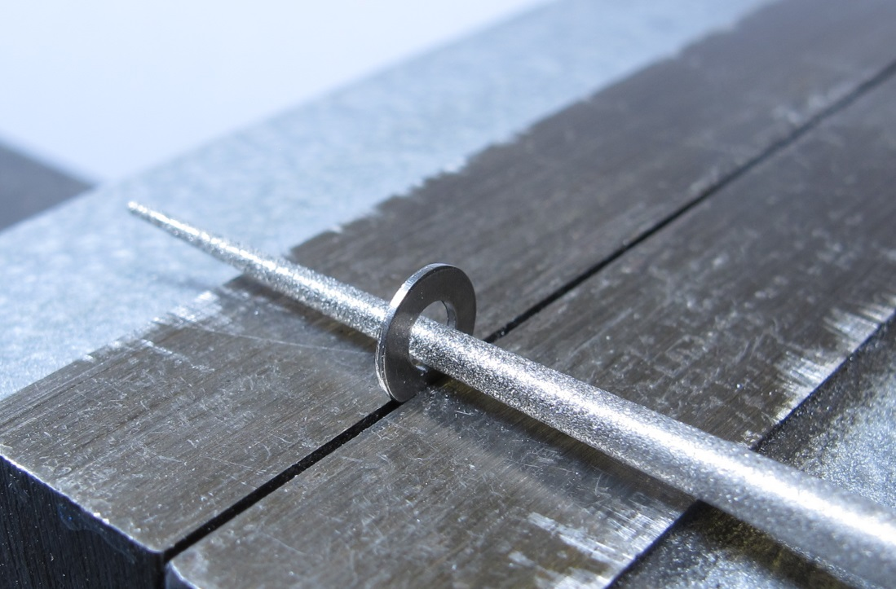  
The M2,5 washers have the following dimensions: ID 2,7mm / OD 5,8mm  
Use a round file to evenly increase the inner diameter of the washer to about 3mm.*

*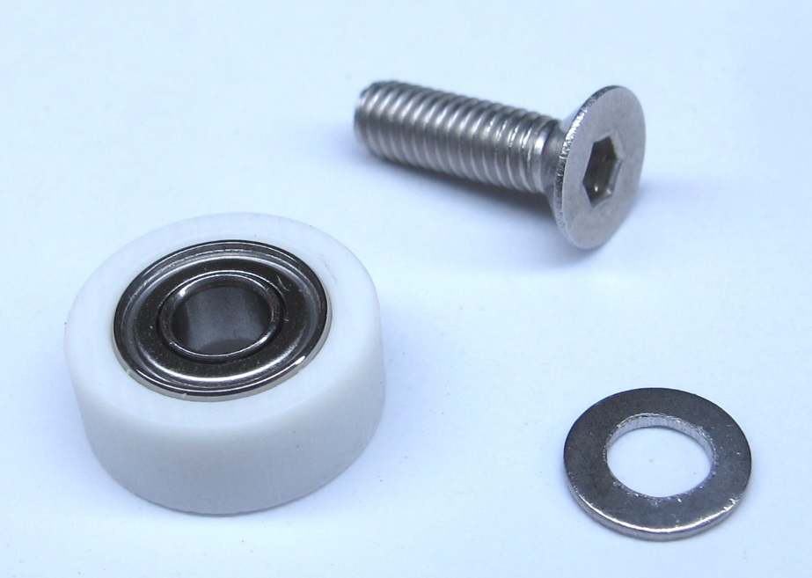  
Timing belt tensioner, M3x10 flat head screw and modified M2,5 washer.*

*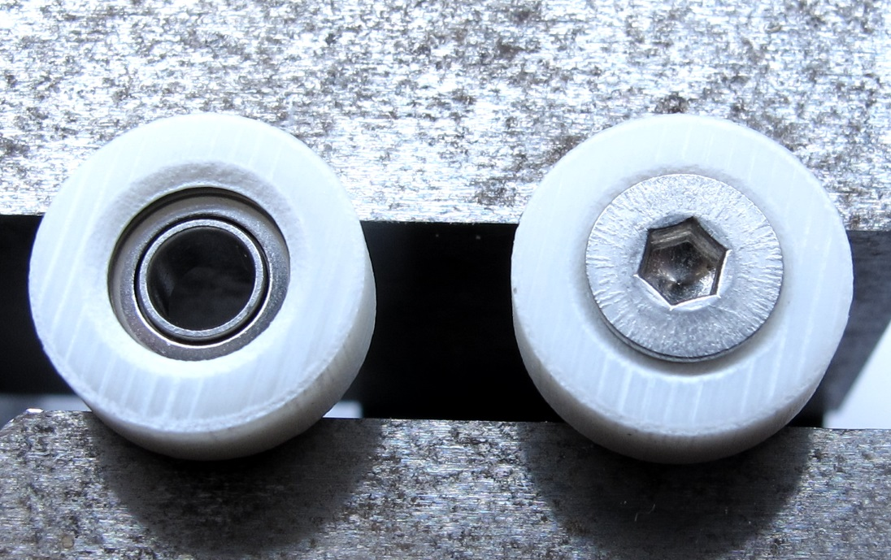  
Insert the M3 screw into the side with the ledge as shown in the picture.  
Turn the assembly around and install the modified M2,5 washers.*

*  
The center pulley and the two timing belt tensioners are now ready for assembly.*

# **Details Encoder Preparation**

**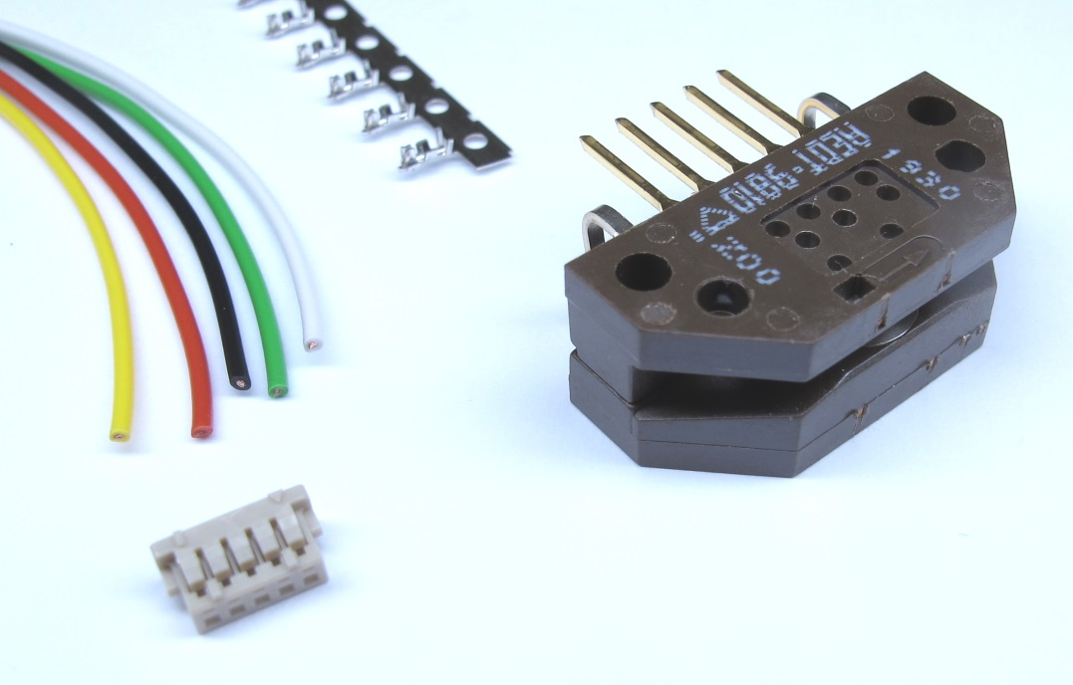***Starting Point: Encoder, wires, Hirose connector and crimp contacts.*

*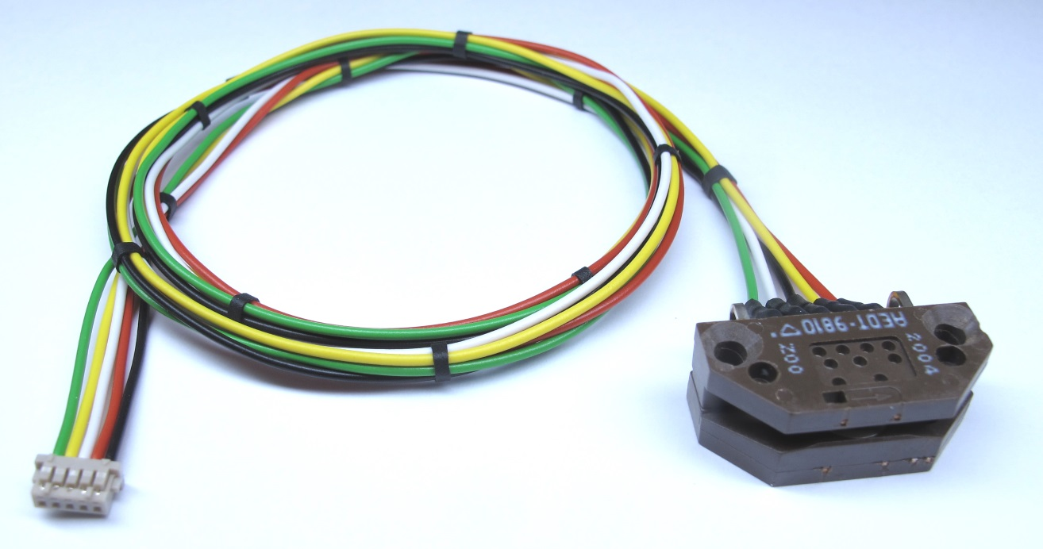  
End Result: Modified Encoder with extension wires and connector*

## **Description**

* this page describes how to prepare the encoder for the brushless actuator modules
* the mounting holes of the encoder are modified [-> Mechanical Modification Encoder](https://github.com/open-dynamic-robot-initiative/open_robot_actuator_hardware/blob/master/mechanics/actuator_module_v1/details/details_encoder_preparation.md#mechanical-modification-encoder)
* the extension wires are attached to the encoder pins [-> Soldering Extension Wires](https://github.com/open-dynamic-robot-initiative/open_robot_actuator_hardware/blob/master/mechanics/actuator_module_v1/details/details_encoder_preparation.md#soldering-extension-wires)
* the Hirose connector is crimped to the extension wires [-> Crimping Hirose Connector](https://github.com/open-dynamic-robot-initiative/open_robot_actuator_hardware/blob/master/mechanics/actuator_module_v1/details/details_encoder_preparation.md#crimping-hirose-connector)

## **Mechanical Modification Encoder**

**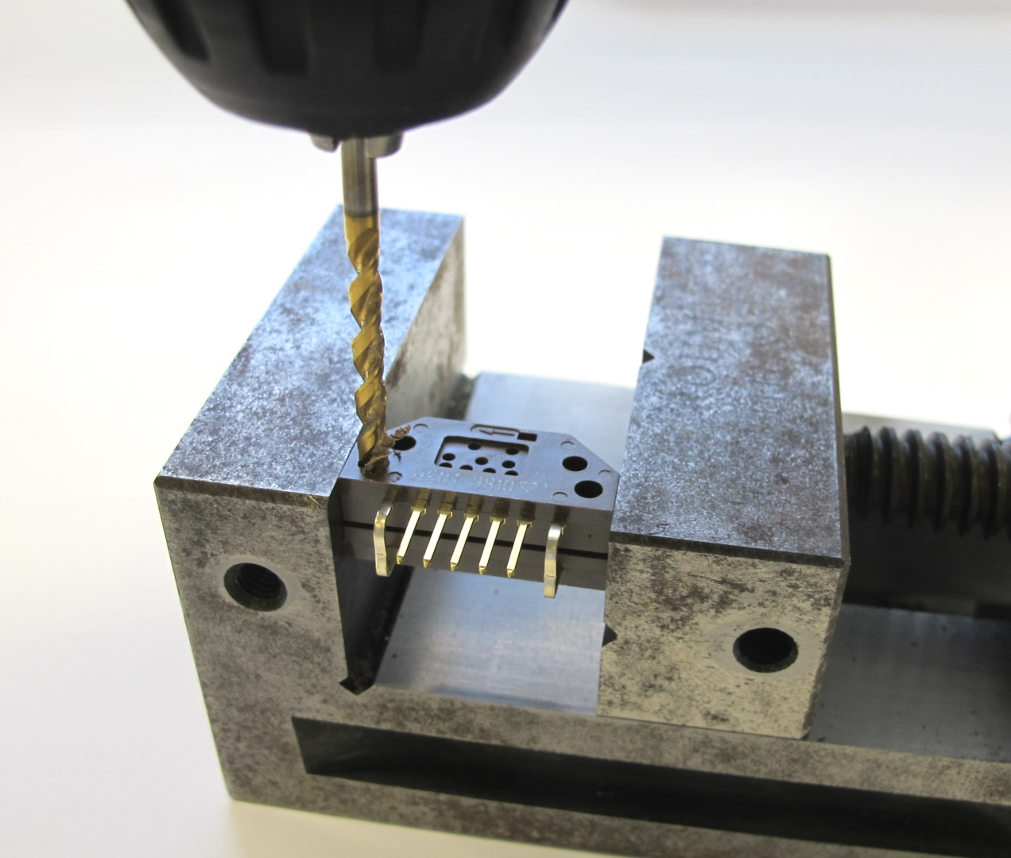***Use a 3mm drill bit to increase the diameter of the two mounting holes.  
The original diameter is 2,8mm.*

*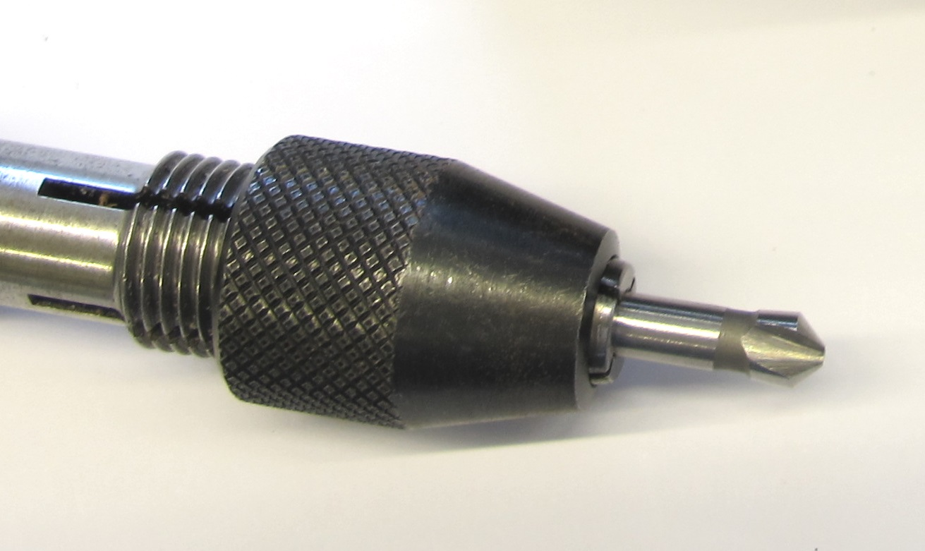  
Use a 45 degree chamfer tool to prepare the encoder for the flat head screws.*

*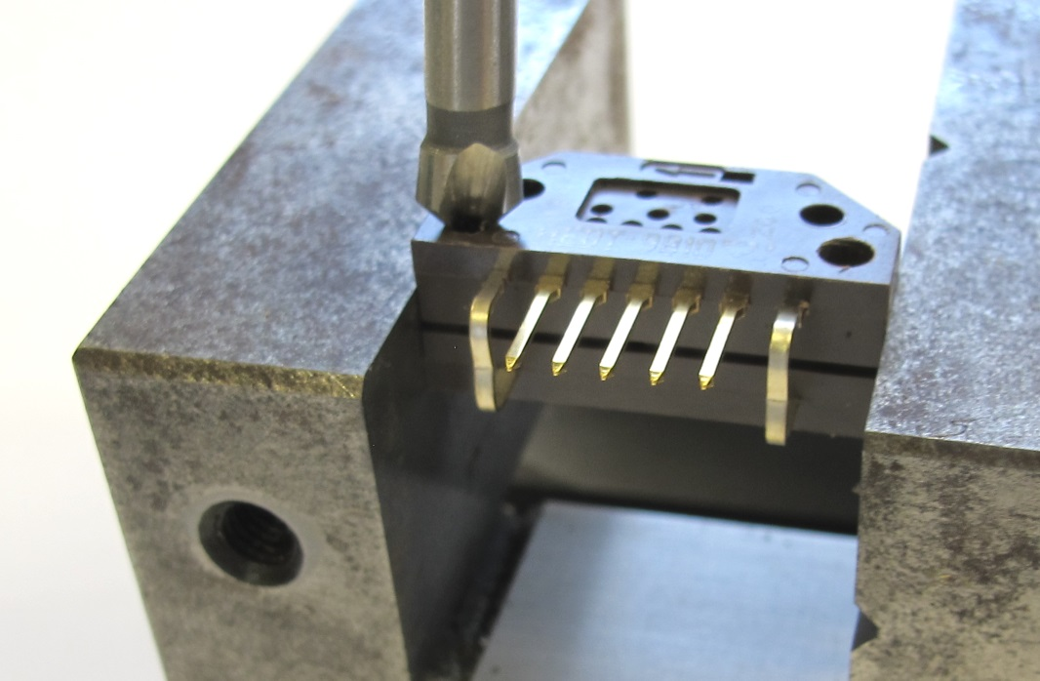  
Chamfer the mounting holes.*

*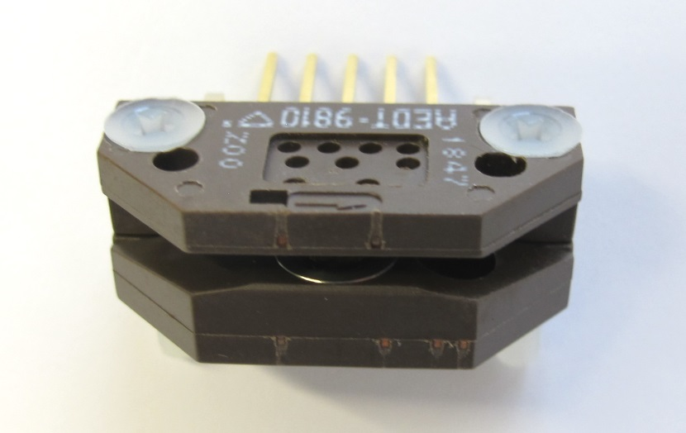  
The M3 flat head screws should be flush with the surface of the encoder.*

*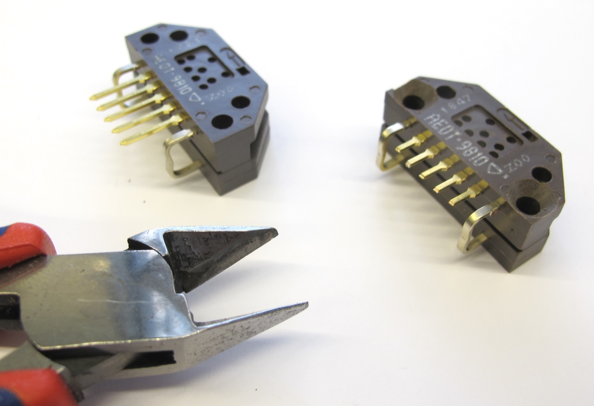  
Shorten the pins*

*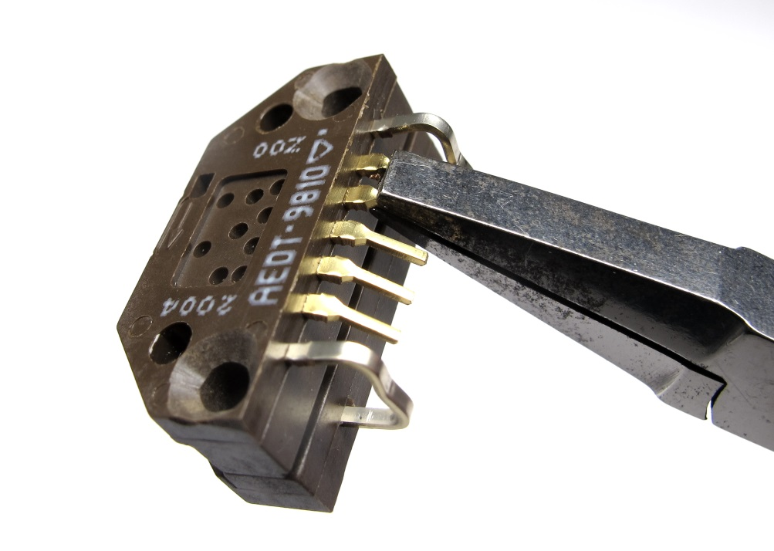  
Use flat pliers to bend the pins 45 degrees downwards.*

*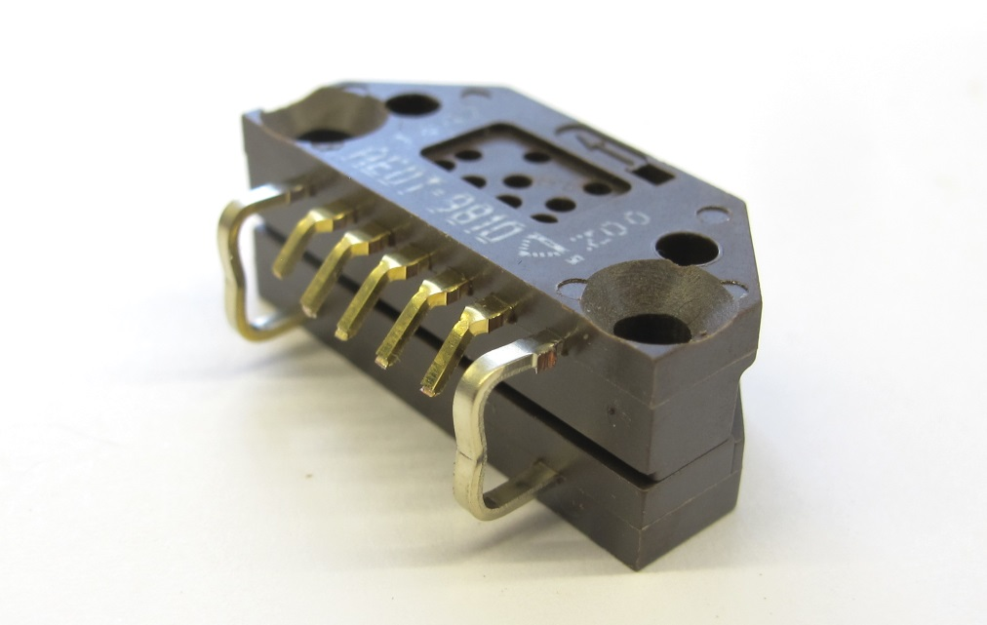  
You can now attach the extension wires.*

## **Soldering Extension Wires**

**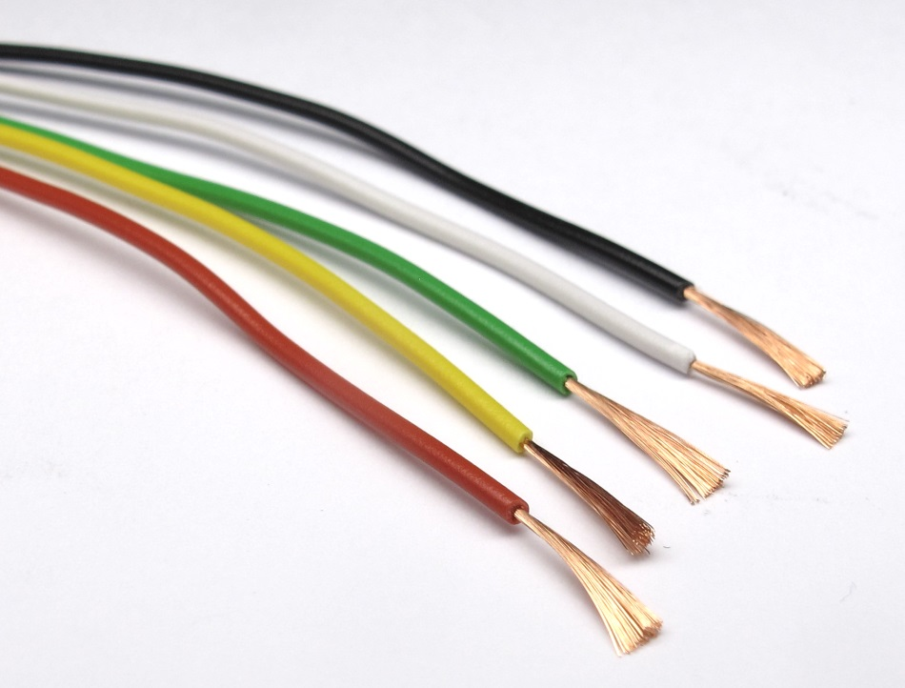***Prepare 5 extension wires - we use 0,14mm² wires from Kabeltronik.  
The* [*wiring diagram*](https://github.com/open-dynamic-robot-initiative/open_robot_actuator_hardware/blob/master/mechanics/actuator_module_v1/details/details_encoder_preparation.md#wiring-diagram) *is below.*

*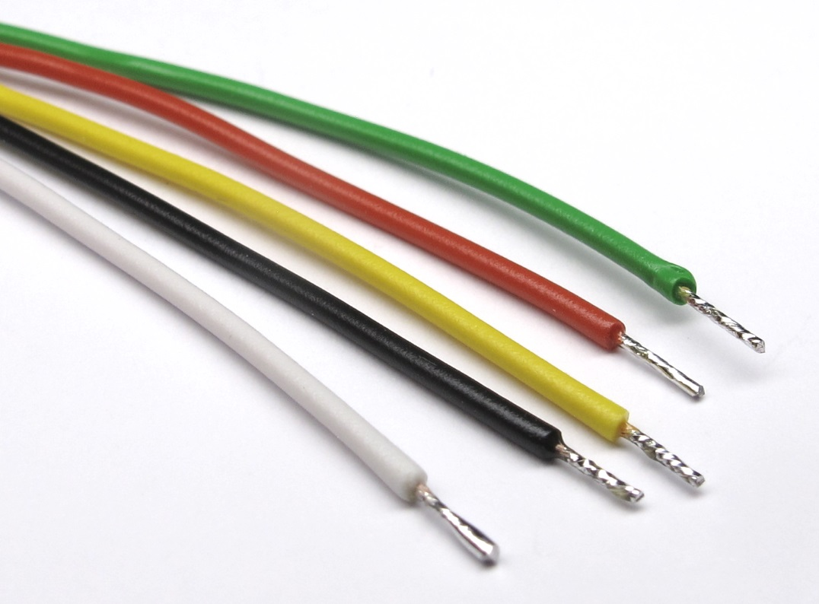  
Remove the insulation at the ends, twist, solder and shorten the wires.*

*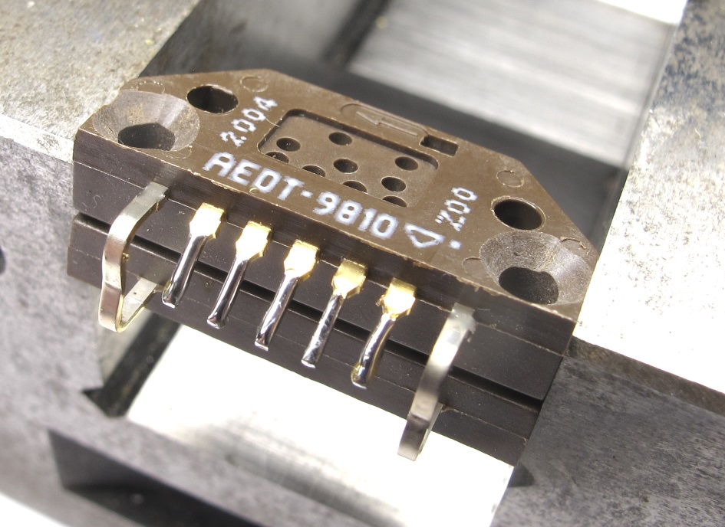  
Put a bit of solder onto the encoder pins.*

*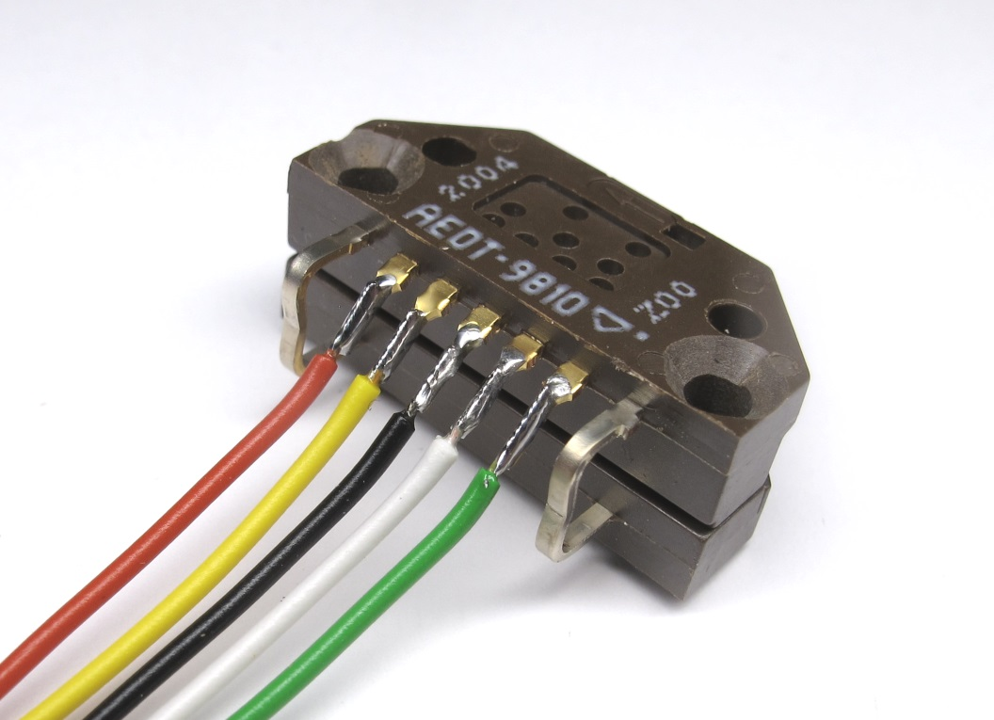  
Solder the wires to the pins according to the* [*wiring diagram*](https://github.com/open-dynamic-robot-initiative/open_robot_actuator_hardware/blob/master/mechanics/actuator_module_v1/details/details_encoder_preparation.md#wiring-diagram)*.*

*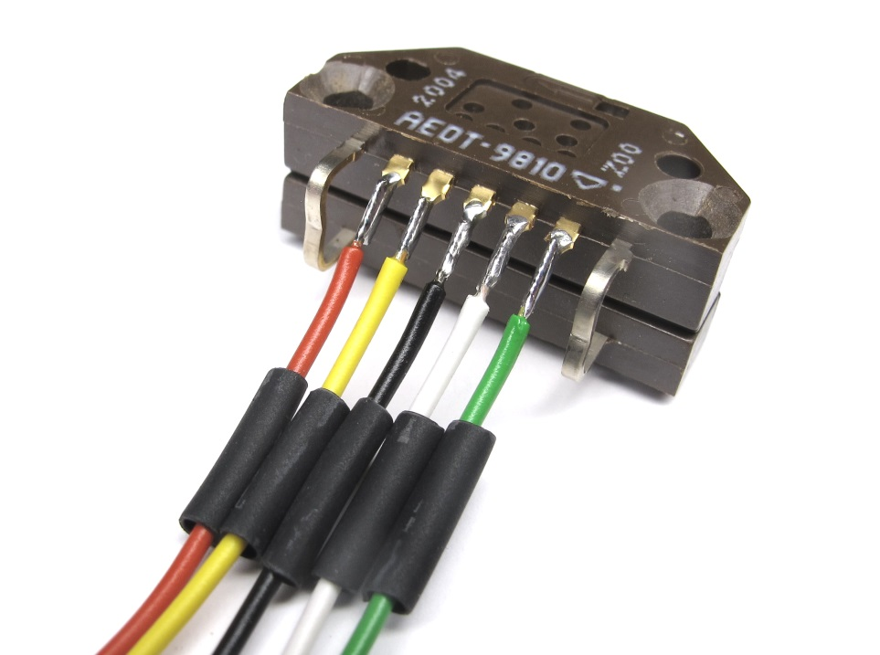  
Prepare the heat shrink - try to keep it short.*

*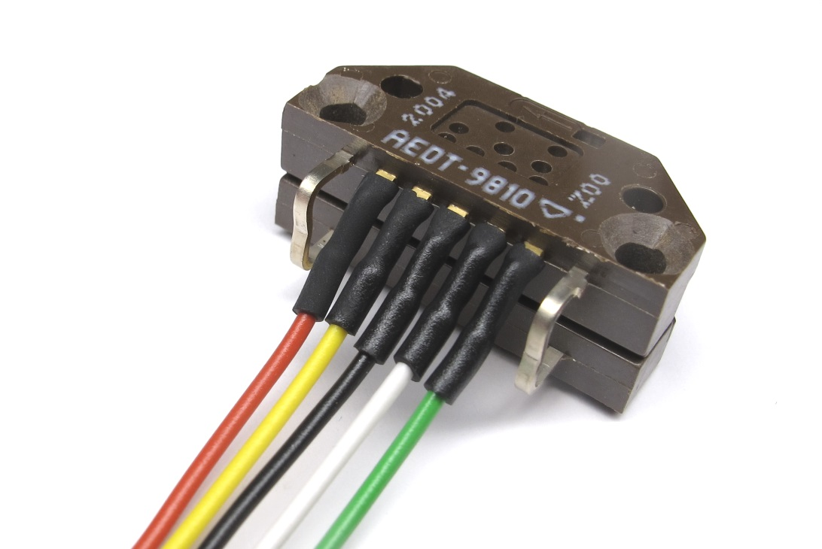  
Apply the heat shring using a heat gun.*

*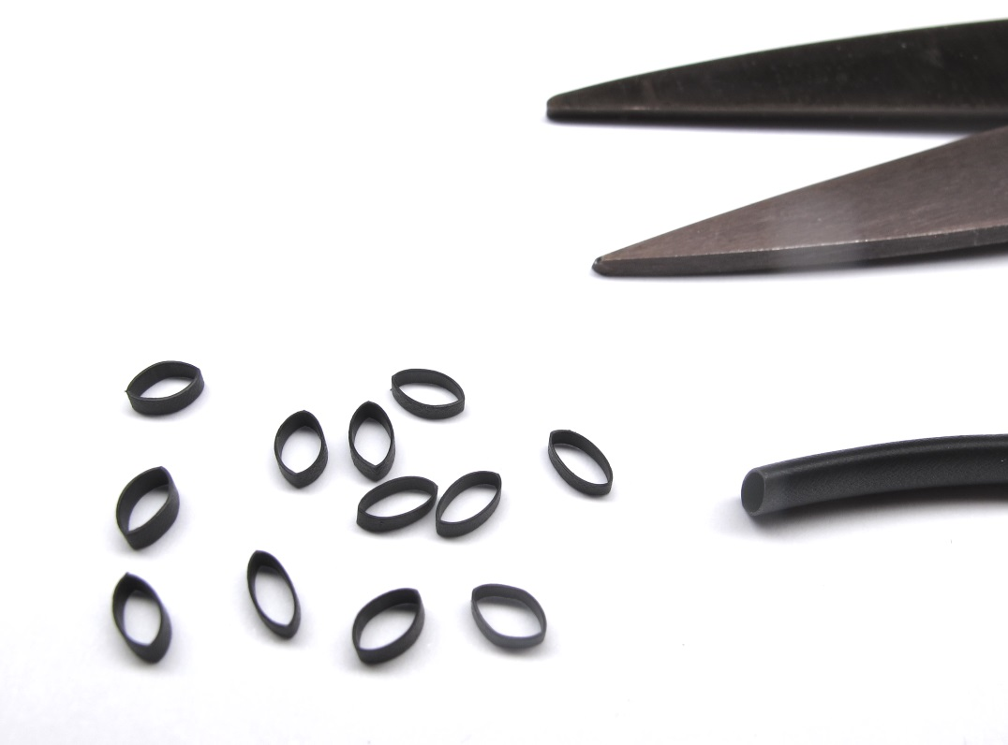  
Cut some small pieces of larger diameter heat shrink to bundle the wires.*

*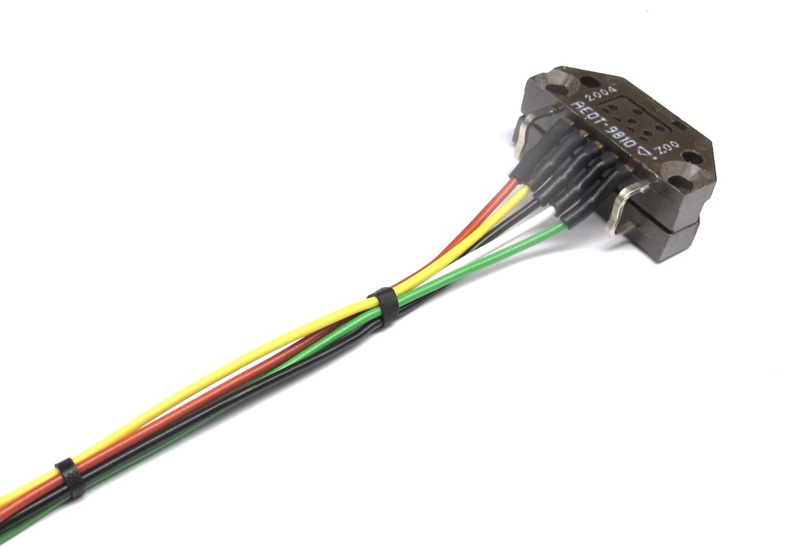  
Place the heat shrink pieces on the wires and leave a couple of centimeters between them.  
Apply the heat shrink pieces with a heat gun.*

*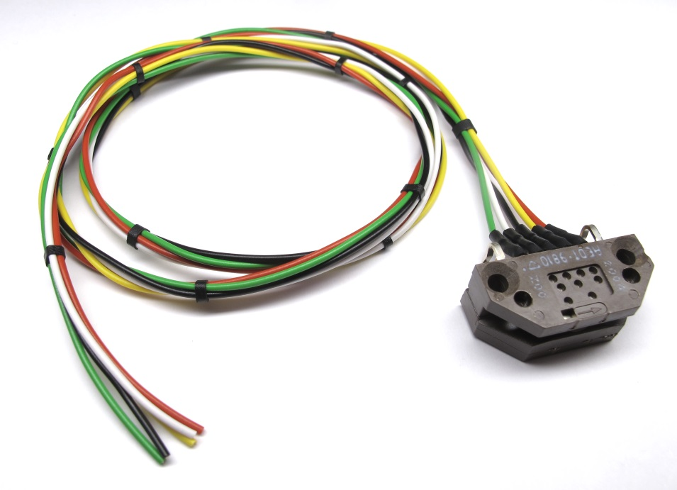  
If you are unsure about the correct wire length you can stop here.  
Follow the other preparation steps and fully assemble the actuator module.  
You can then determine the right wire length and crimp the Hirose connector later.*

## **Crimping Hirose Connector**

**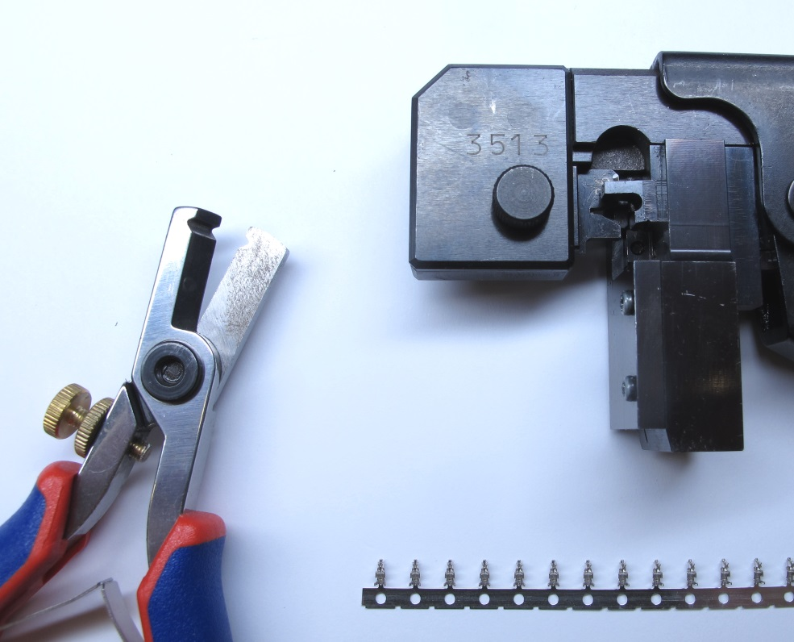***For this step you will need the Hirose DF13 Crimping Tool, the crimp contacts and a wire stripper.*

*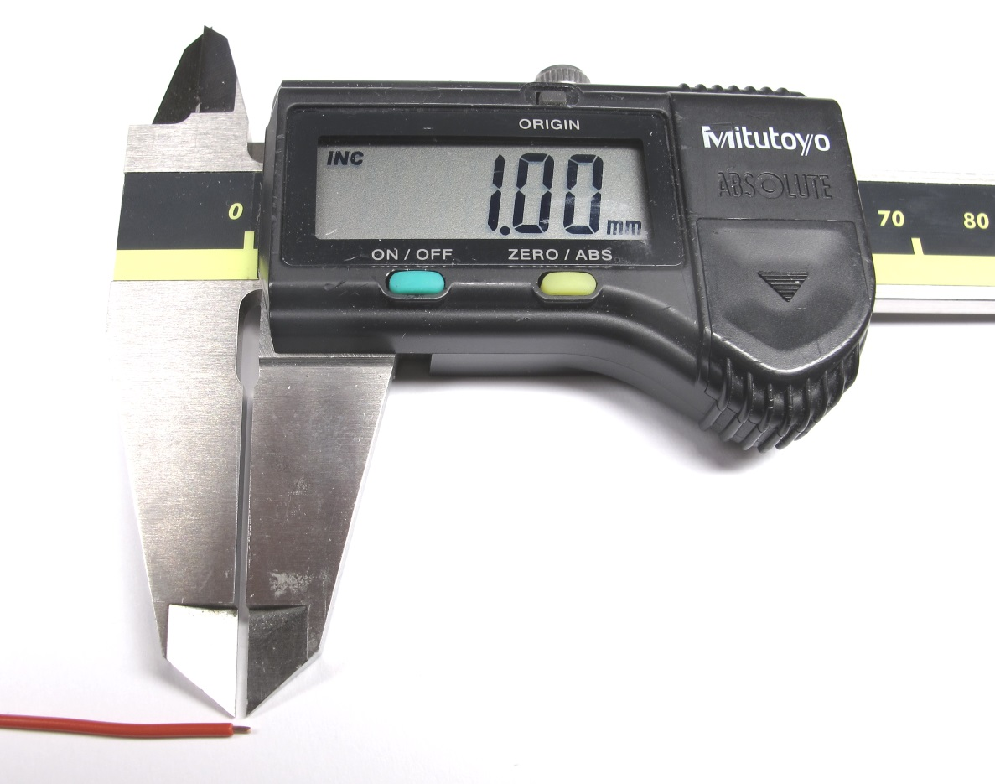  
For crimping about 1mm of the insulation has to be removed.*

*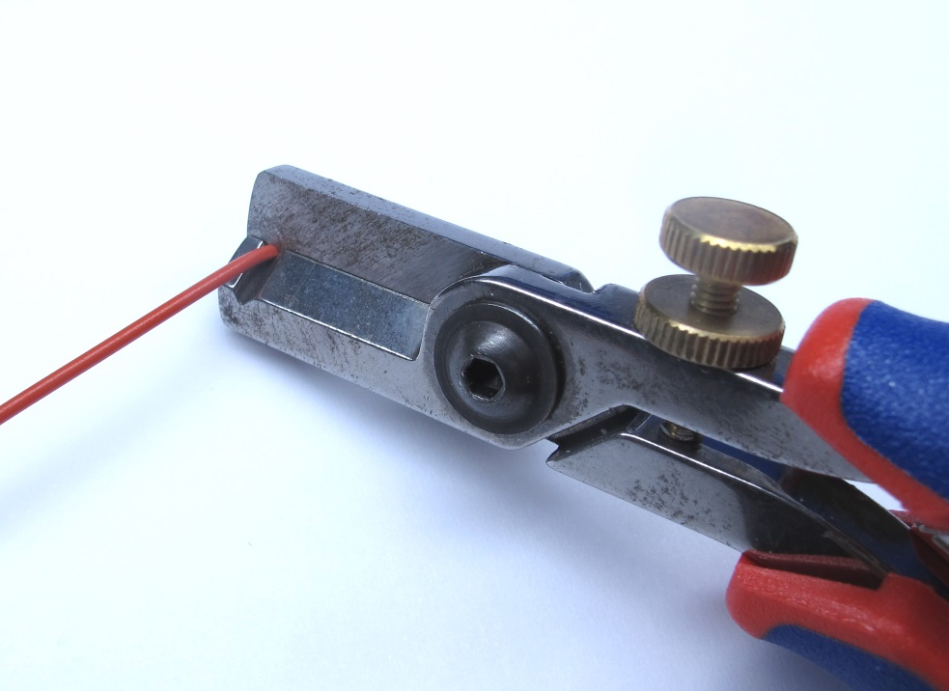  
Cut the wires to the required length.  
Use a wire stripper to remove about 1mm of the insulation at the end.*

*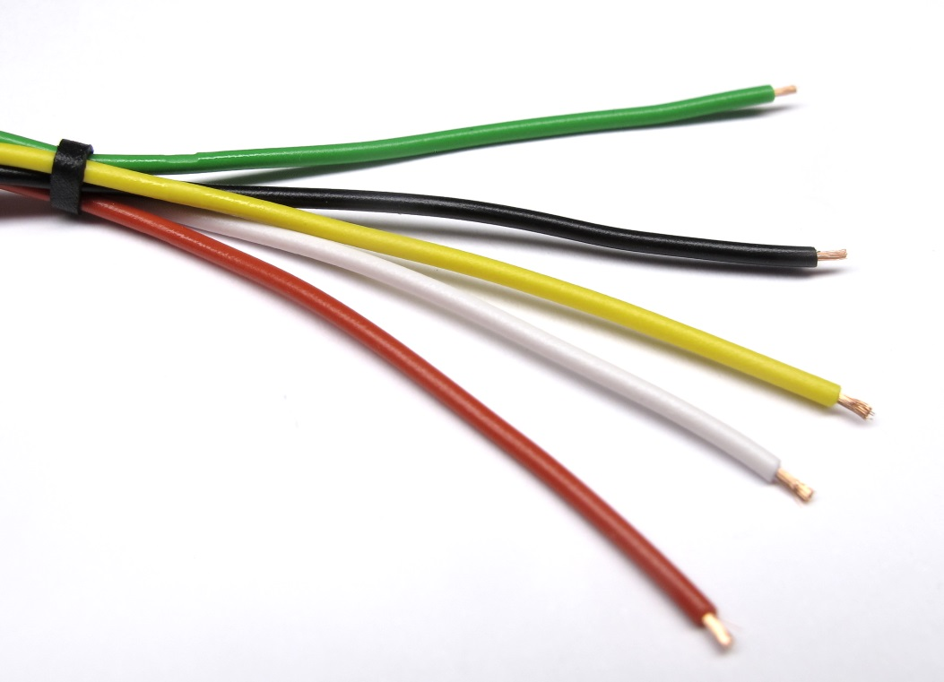  
Wires prepared for crimping.*

*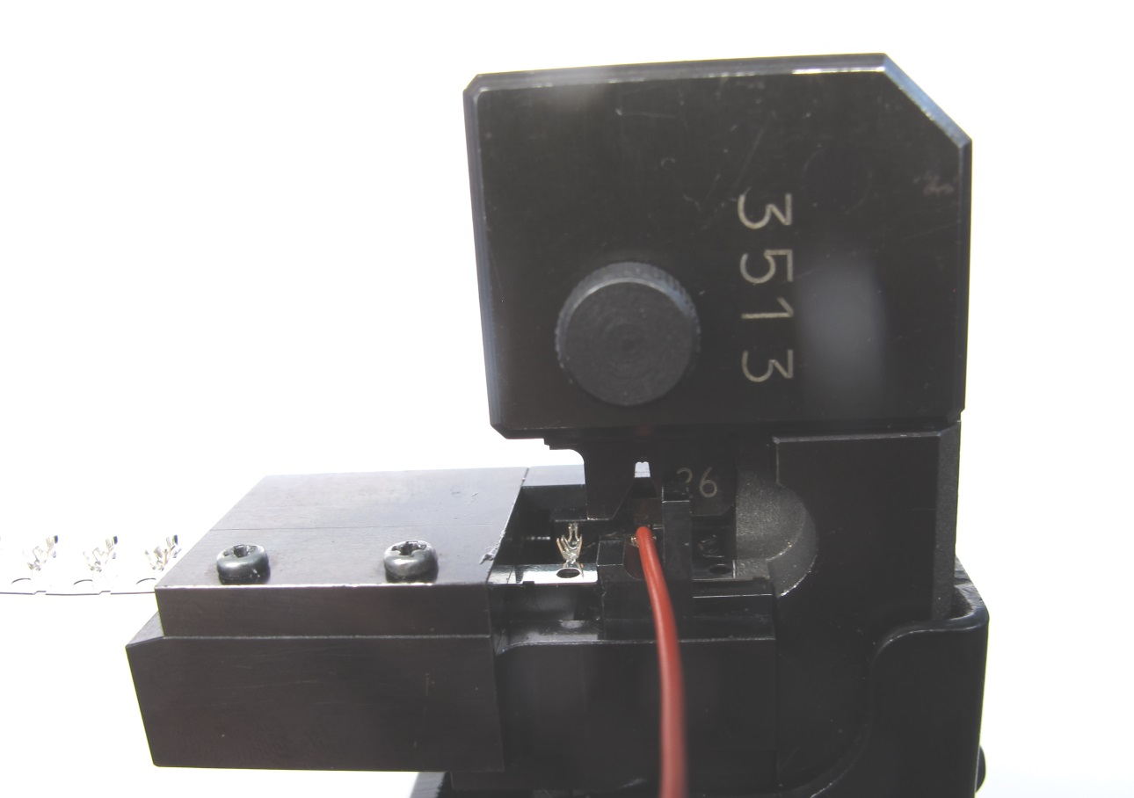  
Insert the wire as straight as possible into the crimping tool.  
Carefully move the wire inwards until the wire strands touch the end stop of the tool.  
Close the handle all the way and release.*

*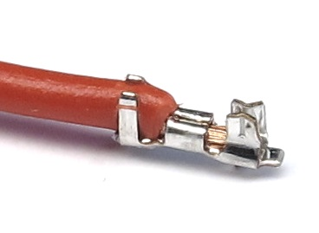  
The insulation should be captured by the first clamp of the crimp.  
The wire strands should be captured by the second clamp of the crimp.*

*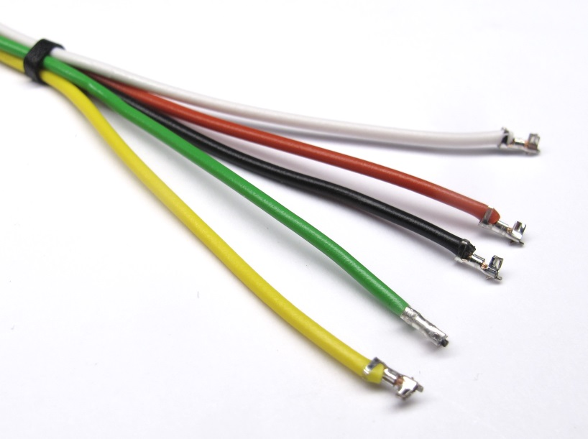  
Apply a crimp contact to all the wires.*

*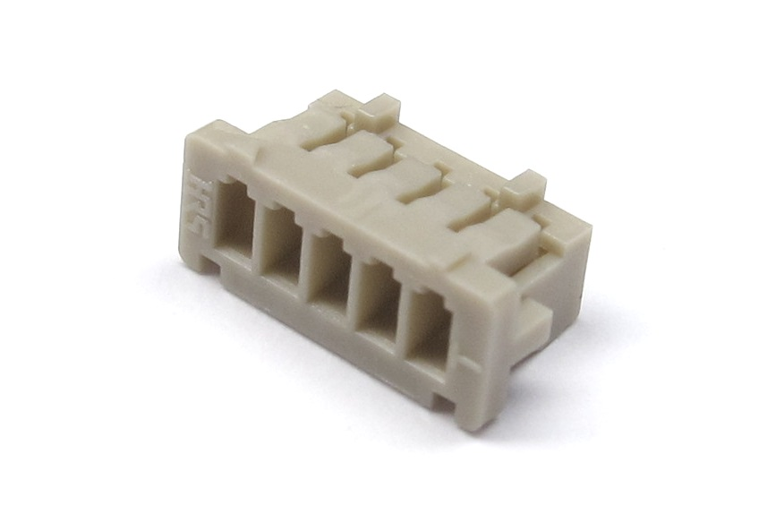  
Prepare the Hirose 5pin connector.*

*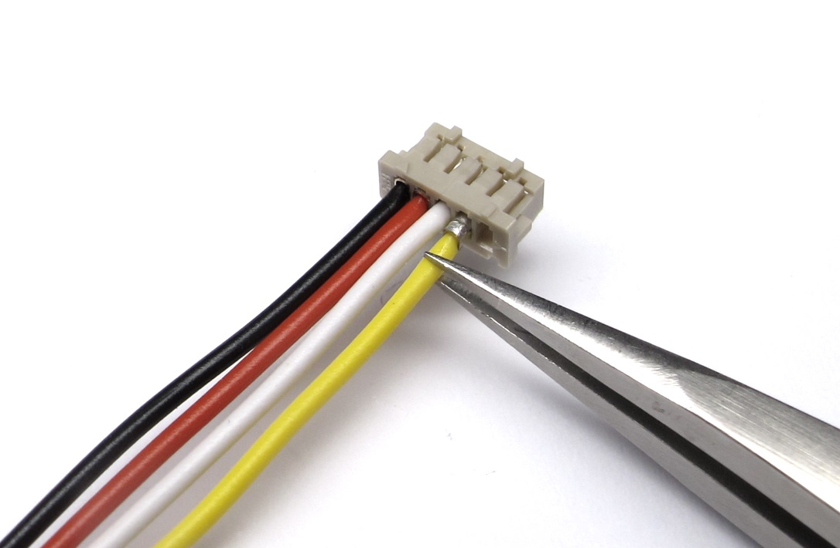  
Insert the crimped wires into the connector.  
Tweezers make it easier to insert the contacts.  
The order is documented in the wiring diagramm below.*

*  
The encoder is now ready for installation.*

## **Wiring Diagram**

**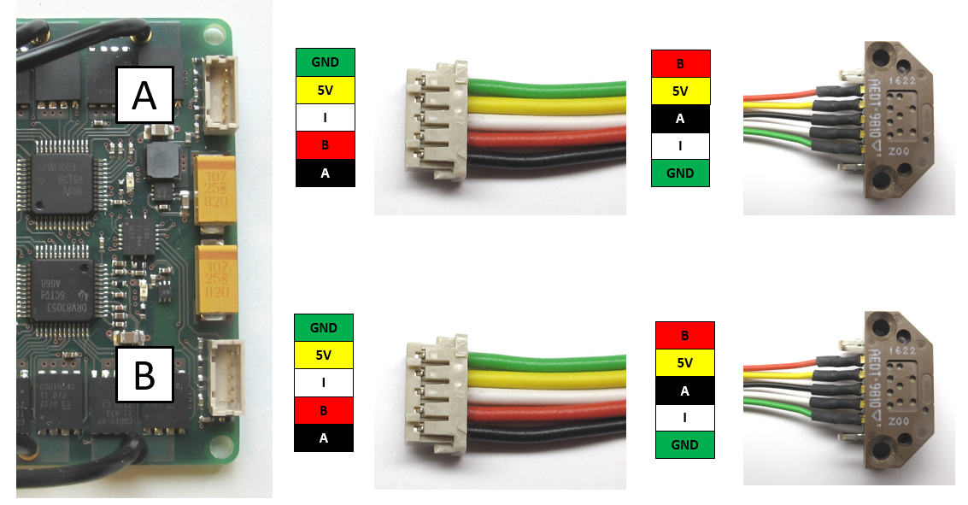***Encoder Wiring for the Micro Driver Electronics*

# **Details Motor Shaft Preparation**

**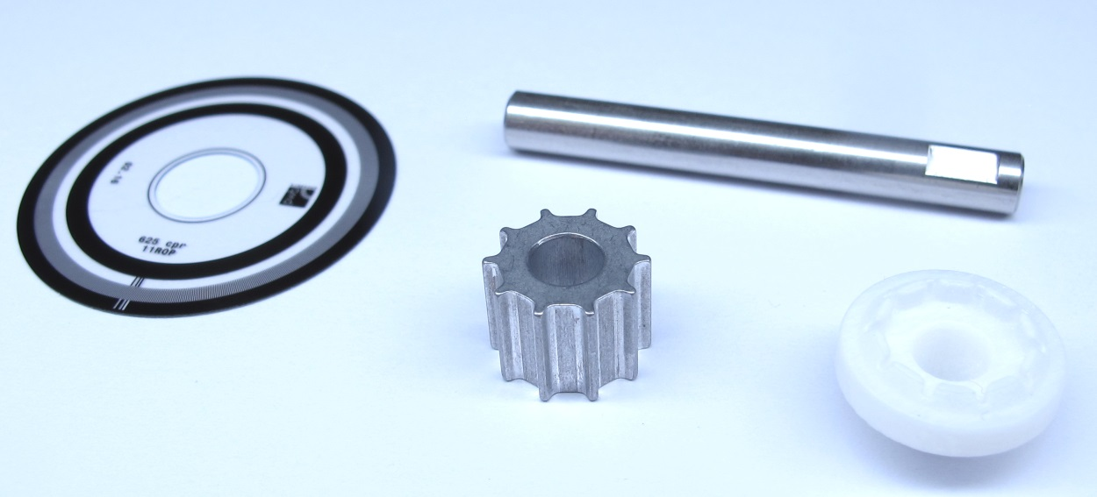***Starting Point: Components for the motor shaft assembly.*

*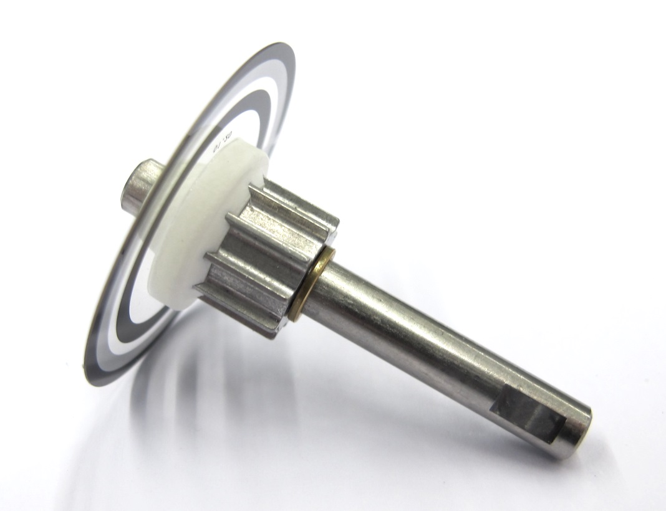  
End Result: Motor shaft, pulley and codewheel fully assembled.*

## **Description**

* this page describes how to prepare the the motor shaft assembly for the brushless actuator modules
* the aluminum motor pulley and the stainless steel motor shaft are bonded with Loctite 648  
  [-> Bonding the Pulley to the Motor Shaft](https://github.com/open-dynamic-robot-initiative/open_robot_actuator_hardware/blob/master/mechanics/actuator_module_v1/details/details_motor_shaft_preparation.md#bonding-the-pulley-to-the-motor-shaft)
* the code wheel mount is installed and the code wheel is bonded to the mount  
  [-> Bonding the Codewheel](https://github.com/open-dynamic-robot-initiative/open_robot_actuator_hardware/blob/master/mechanics/actuator_module_v1/details/details_motor_shaft_preparation.md#bonding-the-codewheel)

### **More Information**

* More information on the 3d printing: [Details 3d Printed Parts](https://github.com/open-dynamic-robot-initiative/open_robot_actuator_hardware/blob/master/mechanics/actuator_module_v1/details/details_3d_printed_parts.md#details-3d-printed-parts)
* More information on the machined part: [Details Machined Parts](https://github.com/open-dynamic-robot-initiative/open_robot_actuator_hardware/blob/master/mechanics/actuator_module_v1/details/details_machined_parts.md#details-machined-parts)
* [PDF Drawing - Motor Shaft](https://github.com/open-dynamic-robot-initiative/open_robot_actuator_hardware/blob/master/mechanics/actuator_module_v1/drawings/motor_shaft.PDF)
* [PDF Drawing Motor Pulley](https://github.com/open-dynamic-robot-initiative/open_robot_actuator_hardware/blob/master/mechanics/actuator_module_v1/drawings/motor_pulley_at3_t10.PDF)
* [STL File - Codewheel mount for code wheel ordered from PWB](https://github.com/open-dynamic-robot-initiative/open_robot_actuator_hardware/blob/master/mechanics/actuator_module_v1/stl_files/encoder_codewheel_pwb_mount.STL)
* [STL File - Codewheel mount for code wheel from kit](https://github.com/open-dynamic-robot-initiative/open_robot_actuator_hardware/blob/master/mechanics/actuator_module_v1/stl_files/encoder_codewheel_kit_mount.STL)
* [STL File - Tool Motor Shaft Pulley Bonding](https://github.com/open-dynamic-robot-initiative/open_robot_actuator_hardware/blob/master/mechanics/actuator_module_v1/stl_files/tool_motor_shaft_pulley_bonding.STL)
* [STL File - Tool Code Wheel Bonding](https://github.com/open-dynamic-robot-initiative/open_robot_actuator_hardware/blob/master/mechanics/actuator_module_v1/stl_files/tool_code_wheel_bonding.STL)

## **Bonding the Pulley to the Motor Shaft**

**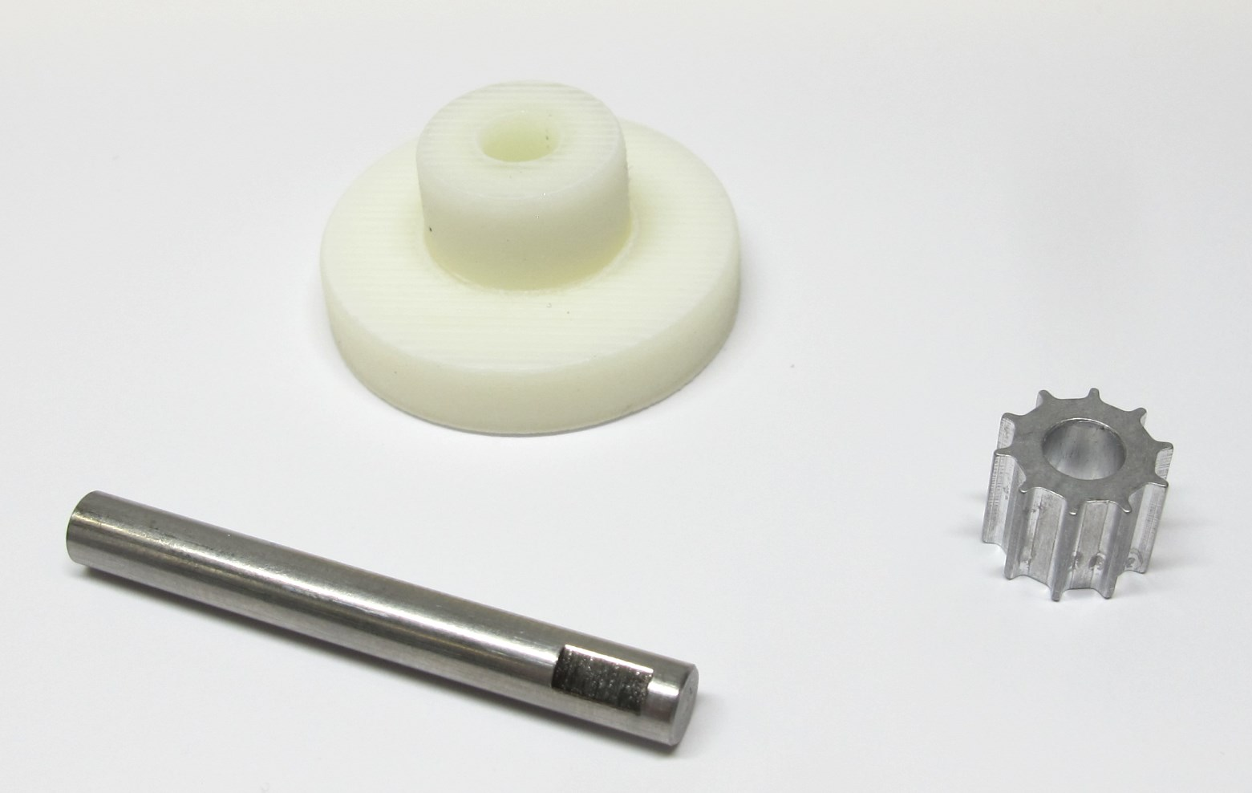***Motor shaft, motor pulley and tool for motor shaft bonding.*

*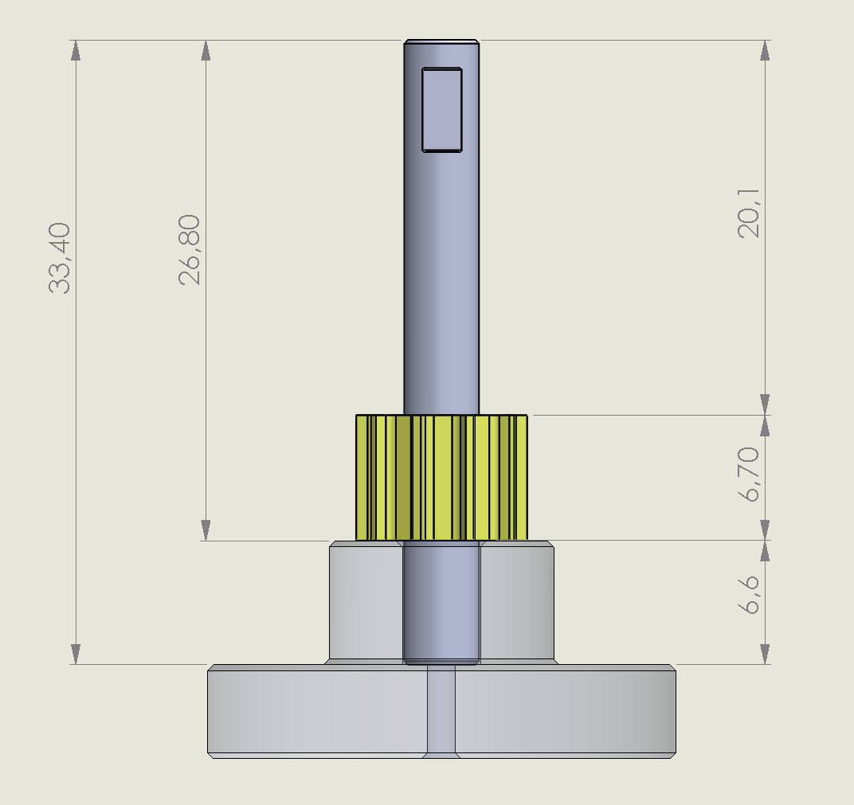  
Make sure that the tool supports the pulley in the right position before bonding.*

*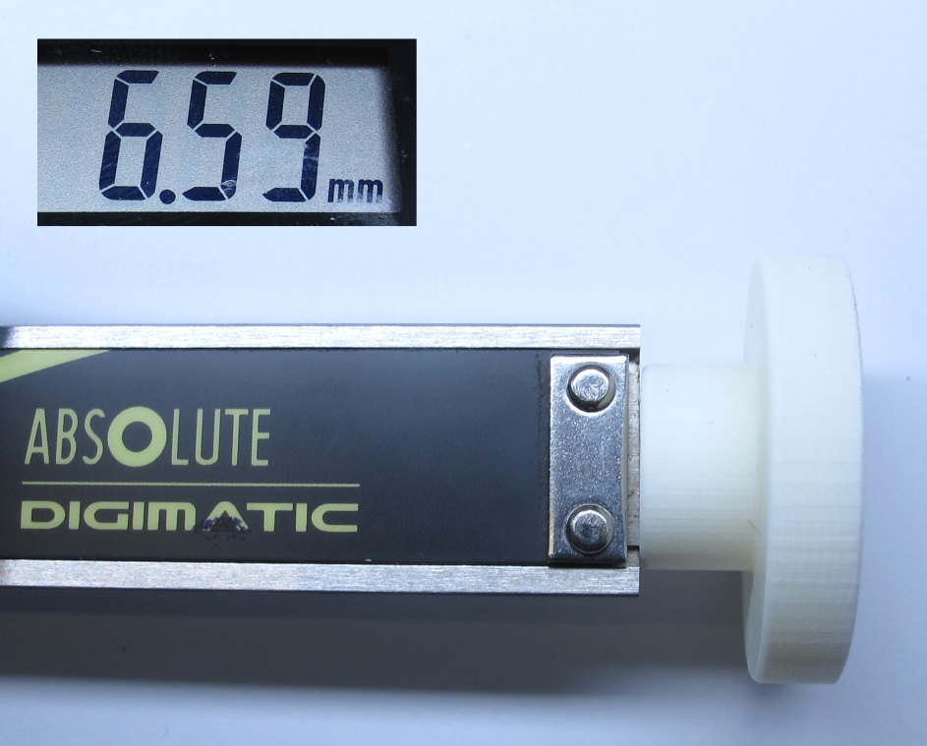  
Measure the depth of the tool using the depth gauge of a digital caliper.  
The depth should be around 6,6mm.*

*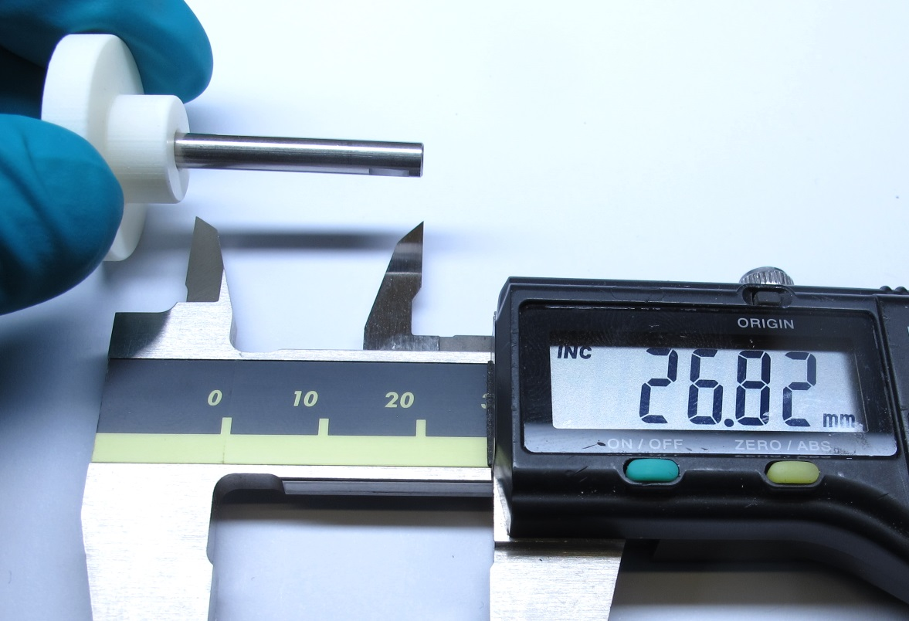  
The distance between the tool and the end of the motor shaft should be about 26,8mm.*

*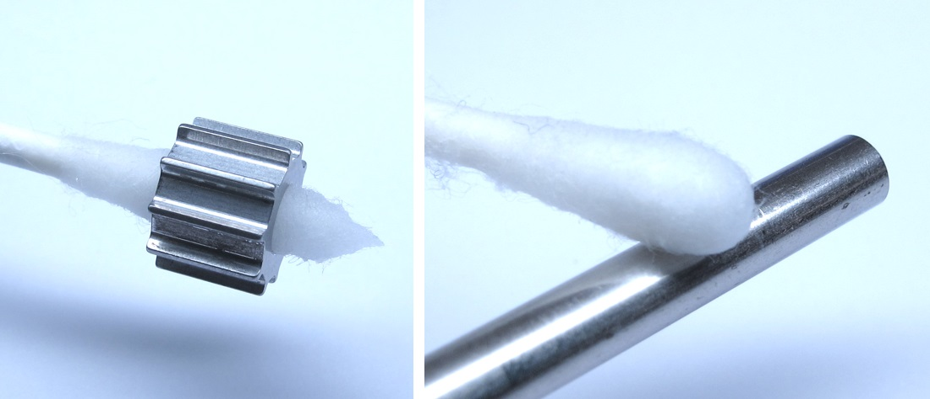  
Clean the bonding surfaces with a cotton swab and ethanol.*

*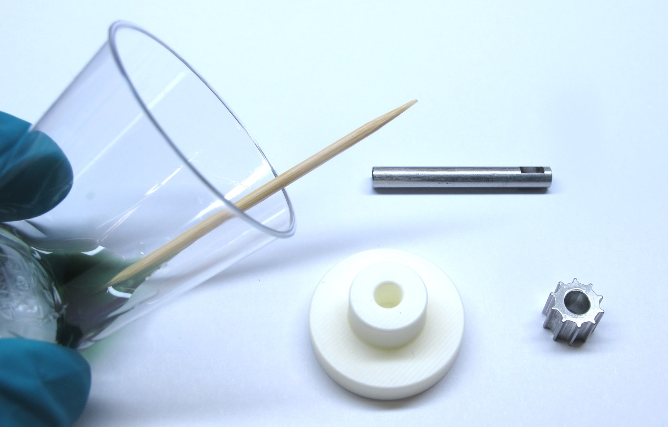  
Prepare some Locitite 648, tooth picks and cotton swabs.  
Wear gloves to protect your skin.*

*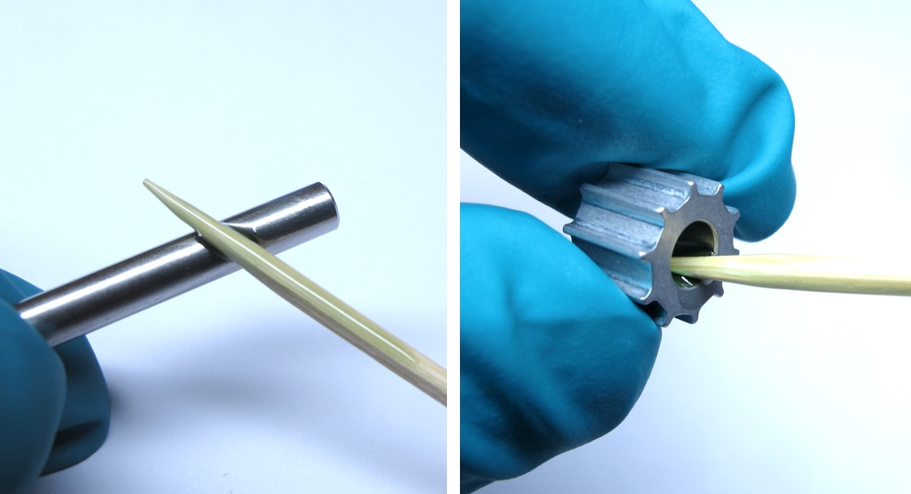  
Apply a thin layer of Locitite 648 onto the bonding surfaces.*

*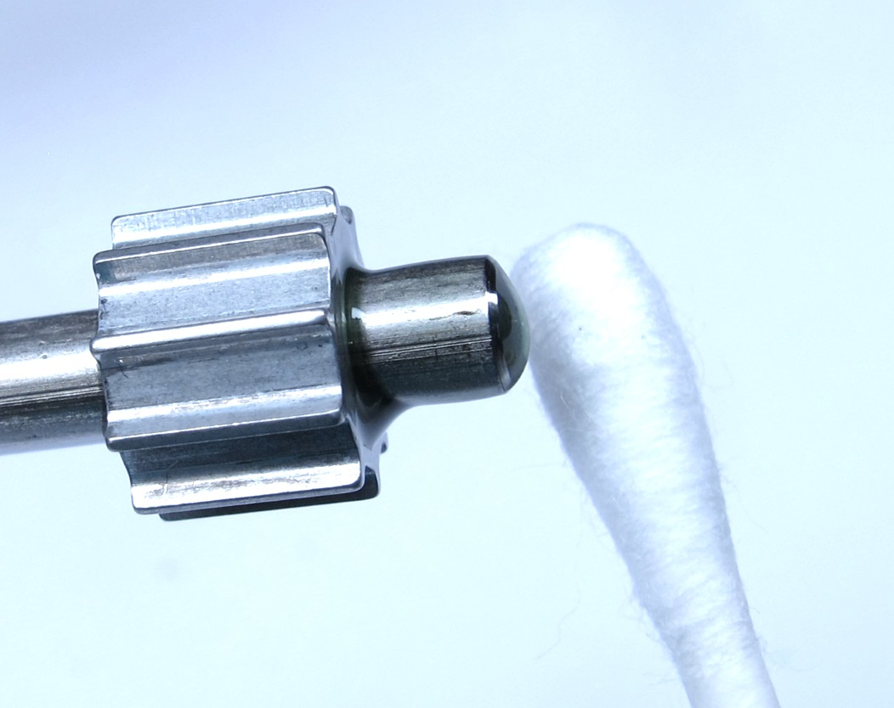  
Insert the motor shaft into the pulley and rotate it a bit.  
Remove the excess Loctite from the bottom using a cotton swab.*

*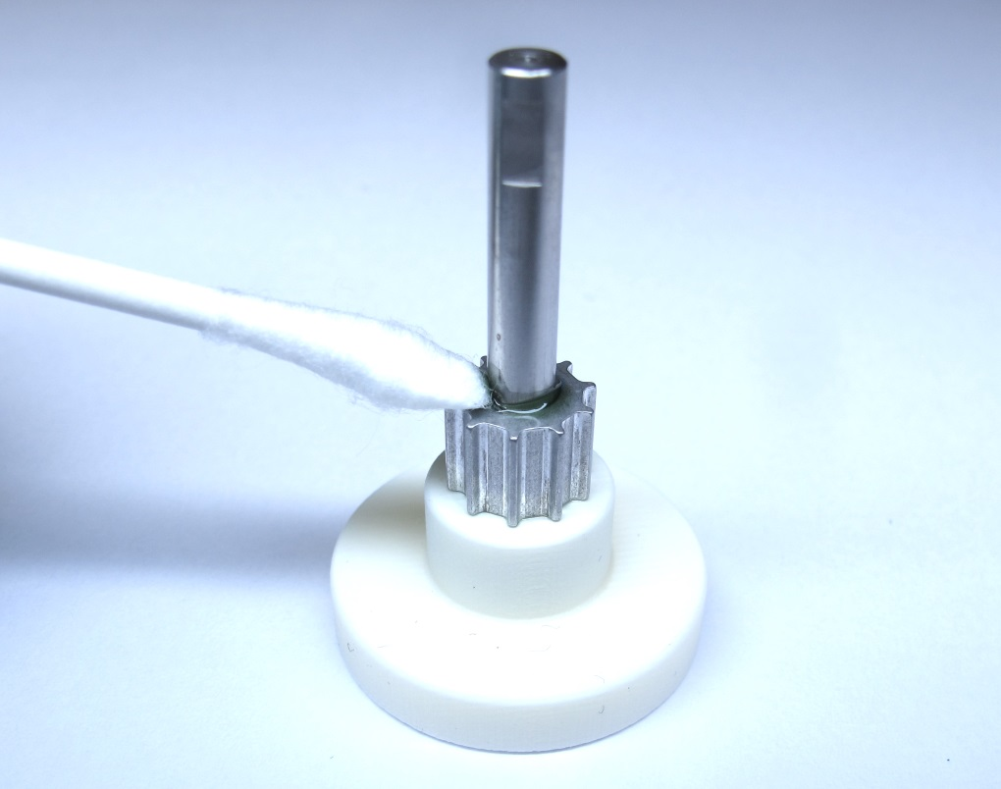  
Place the motor shaft and pulley on the bonding tool.  
Make sure that the flats on the motor shaft are pointing upwards.  
Remove the excess Loctite from the top using a cotton swab.*

*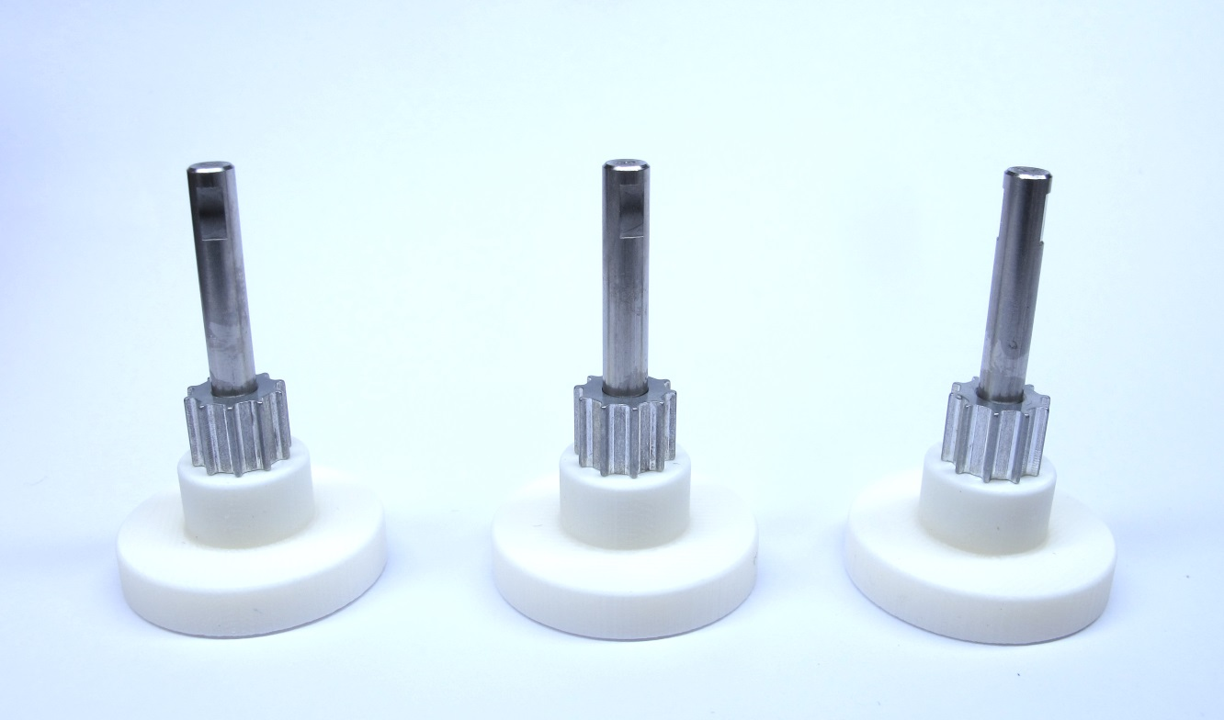  
Make sure that the motor shaft vertical and fully inserted into the tool.  
Let the parts cure at room temperature for a couple of hours.*

*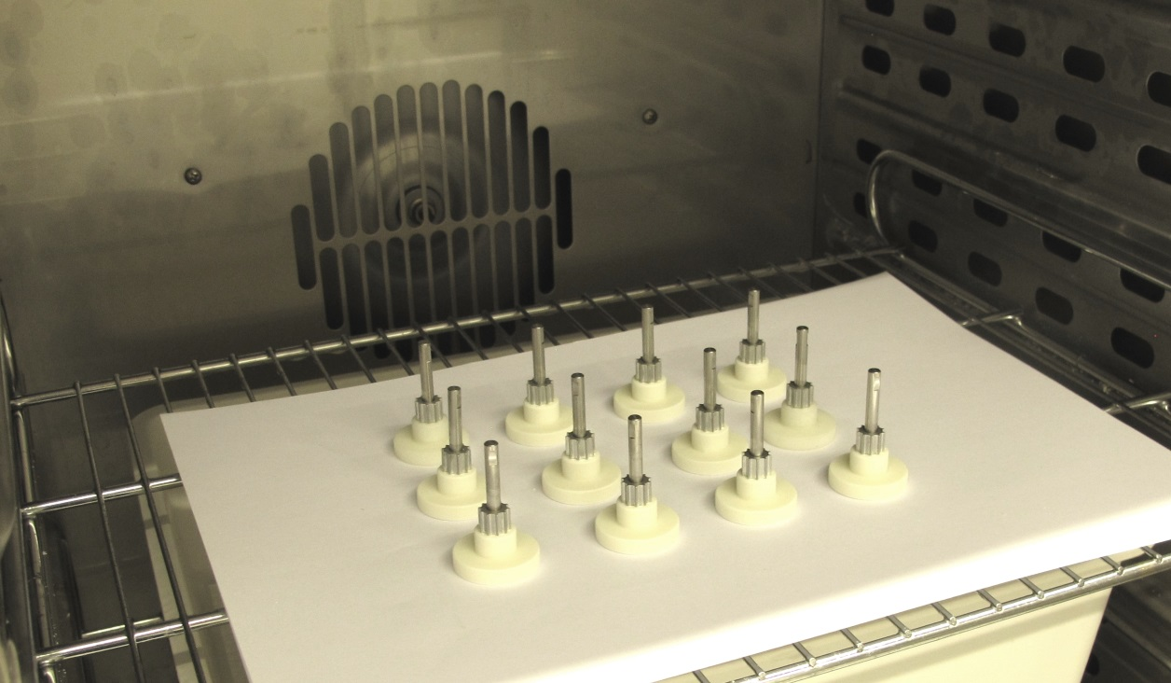  
Leave the parts on the tool, put them in an oven.  
Cure the bond for another couple of hours for full strength.*

*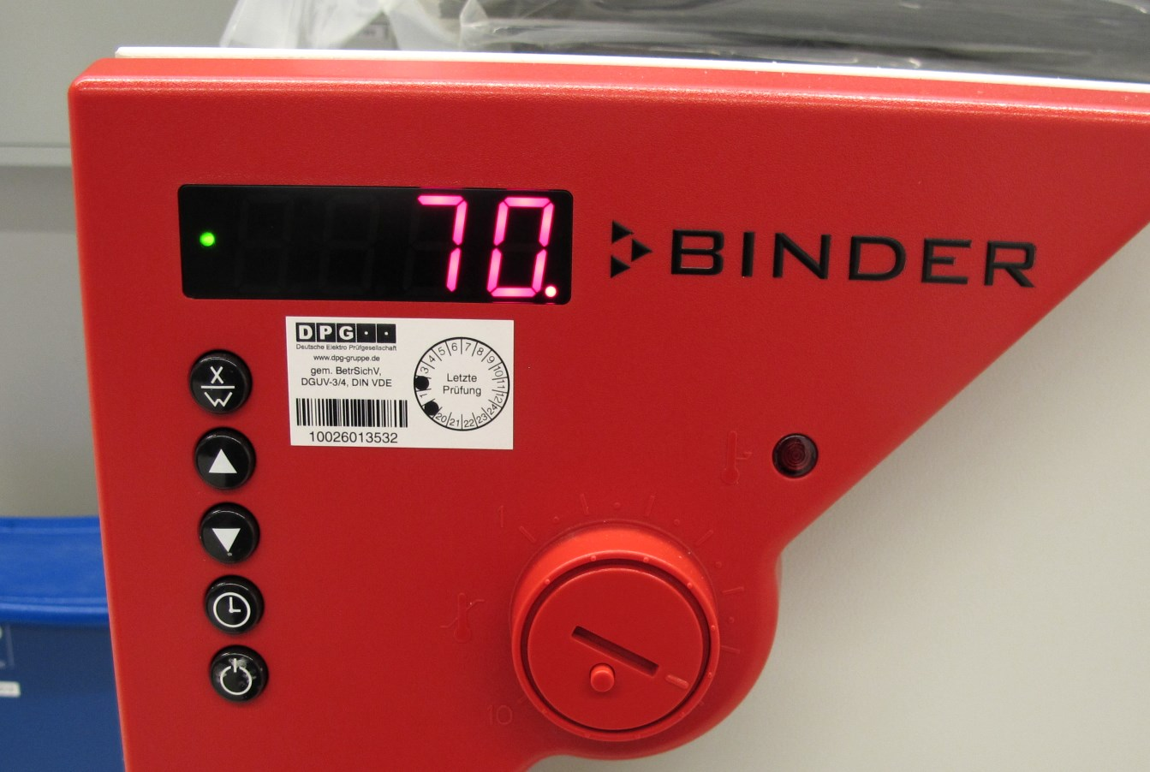  
We cure the parts at 70 degrees celcius for about 3 hours.*

*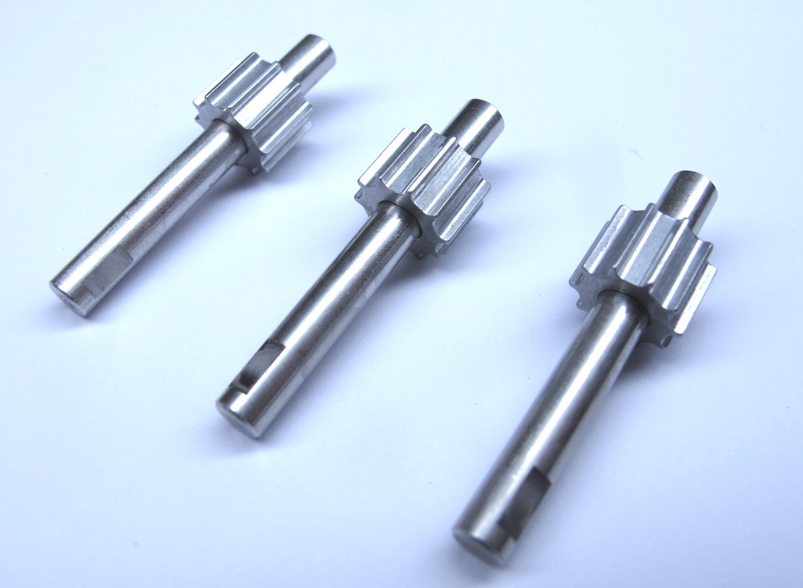  
The motor shaft and pulley assemblies are now ready and can be used for the next step.*

## **Bonding the Codewheel**

**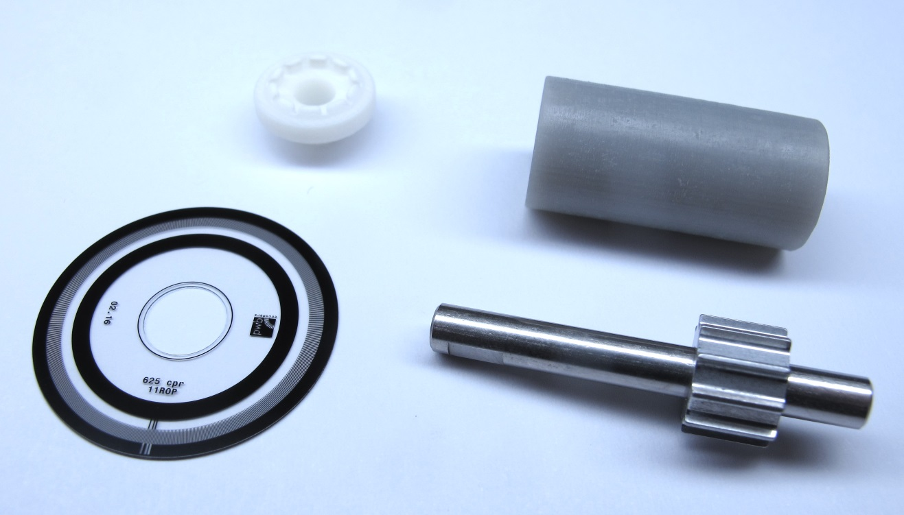***Code wheel, code wheel mount, motor shaft with pulley and bonding tool.*

*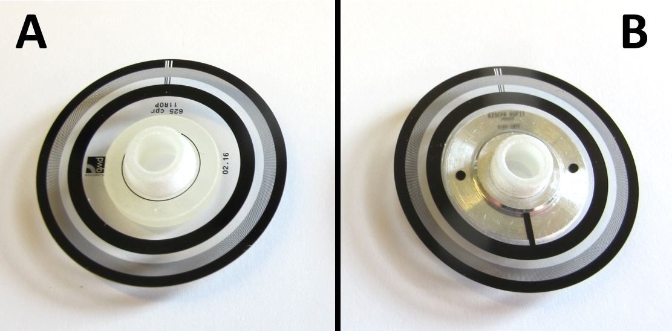  
There are two different sources for the code wheel.  
A: Code wheel ordered from PWB / B: Code wheel from encoder kit.  
Make sure to use the corresponding code wheel mount stl file.*[*A: Codewheel mount for code wheel ordered from PWB*](https://github.com/open-dynamic-robot-initiative/open_robot_actuator_hardware/blob/master/mechanics/actuator_module_v1/stl_files/encoder_codewheel_pwb_mount.STL)[*B: Codewheel mount for code wheel from encoder kit*](https://github.com/open-dynamic-robot-initiative/open_robot_actuator_hardware/blob/master/mechanics/actuator_module_v1/stl_files/encoder_codewheel_kit_mount.STL)*All the other assembly steps are identical.*

*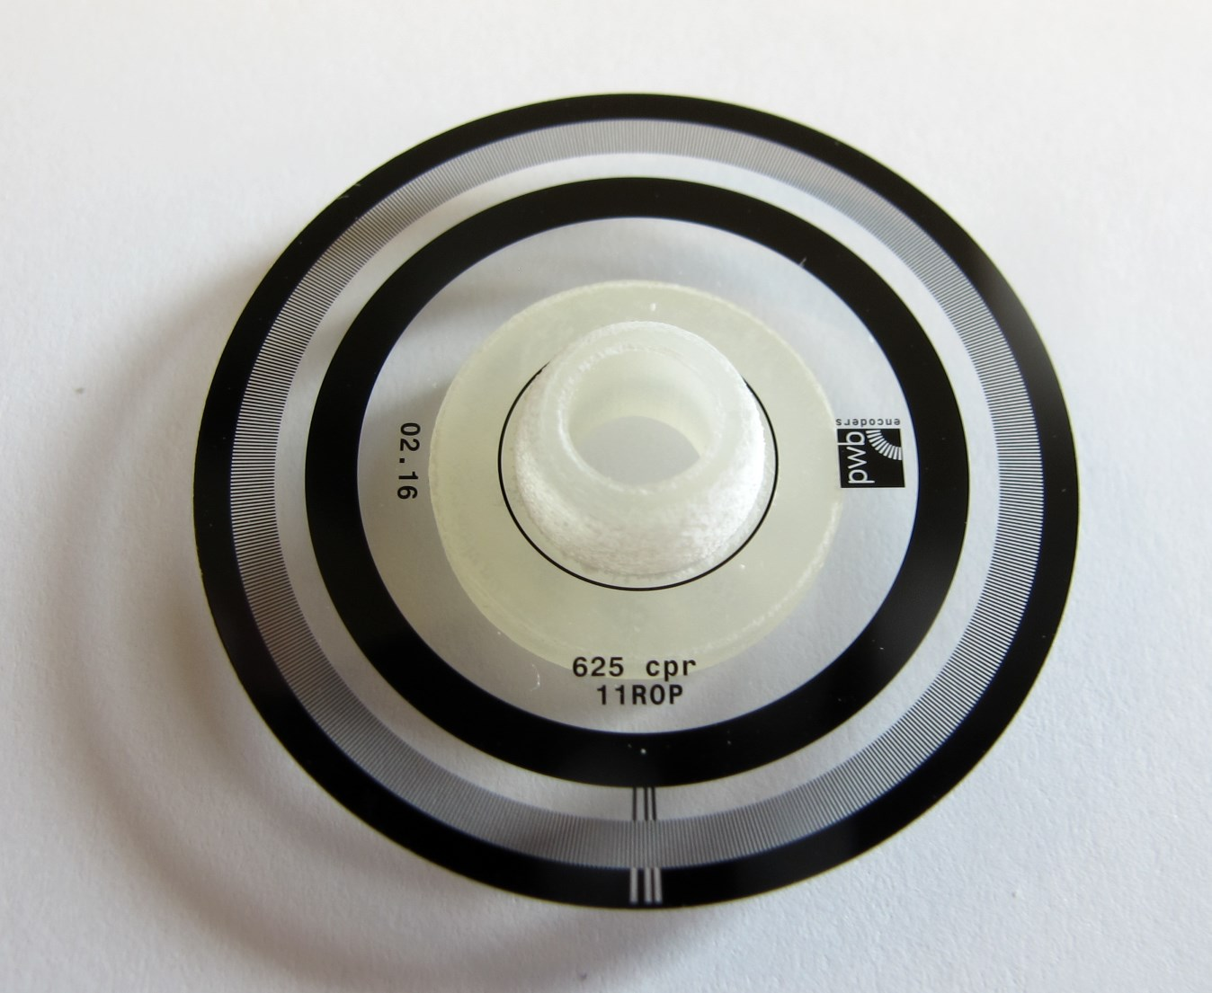  
Place the code wheel on the code wheel mount and make sure it fits before you apply glue.*

*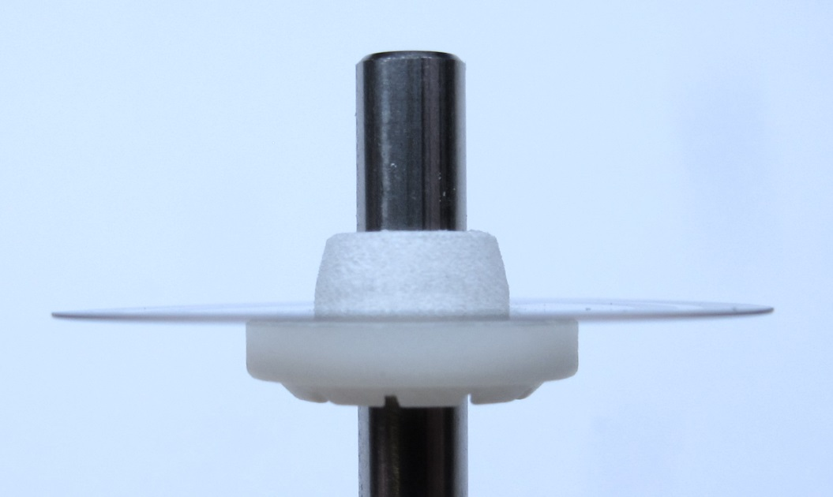  
Make sure that the code wheel is fully seated, flat and doesn't wobble when you turn it.*

*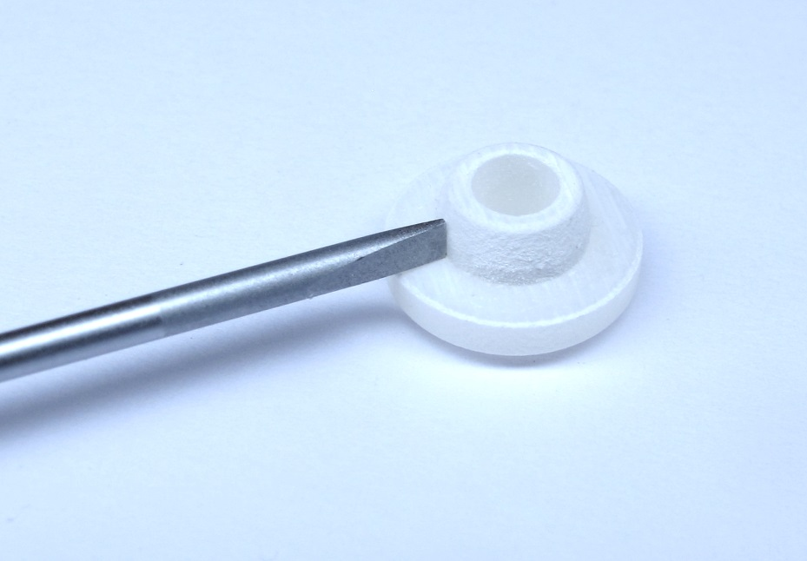  
Sometimes the codewheel doesn't sit flat on the surface because of residue from the 3d printing.  
Use a flat screw driver to scratch off the residue from the corner of the part.*

*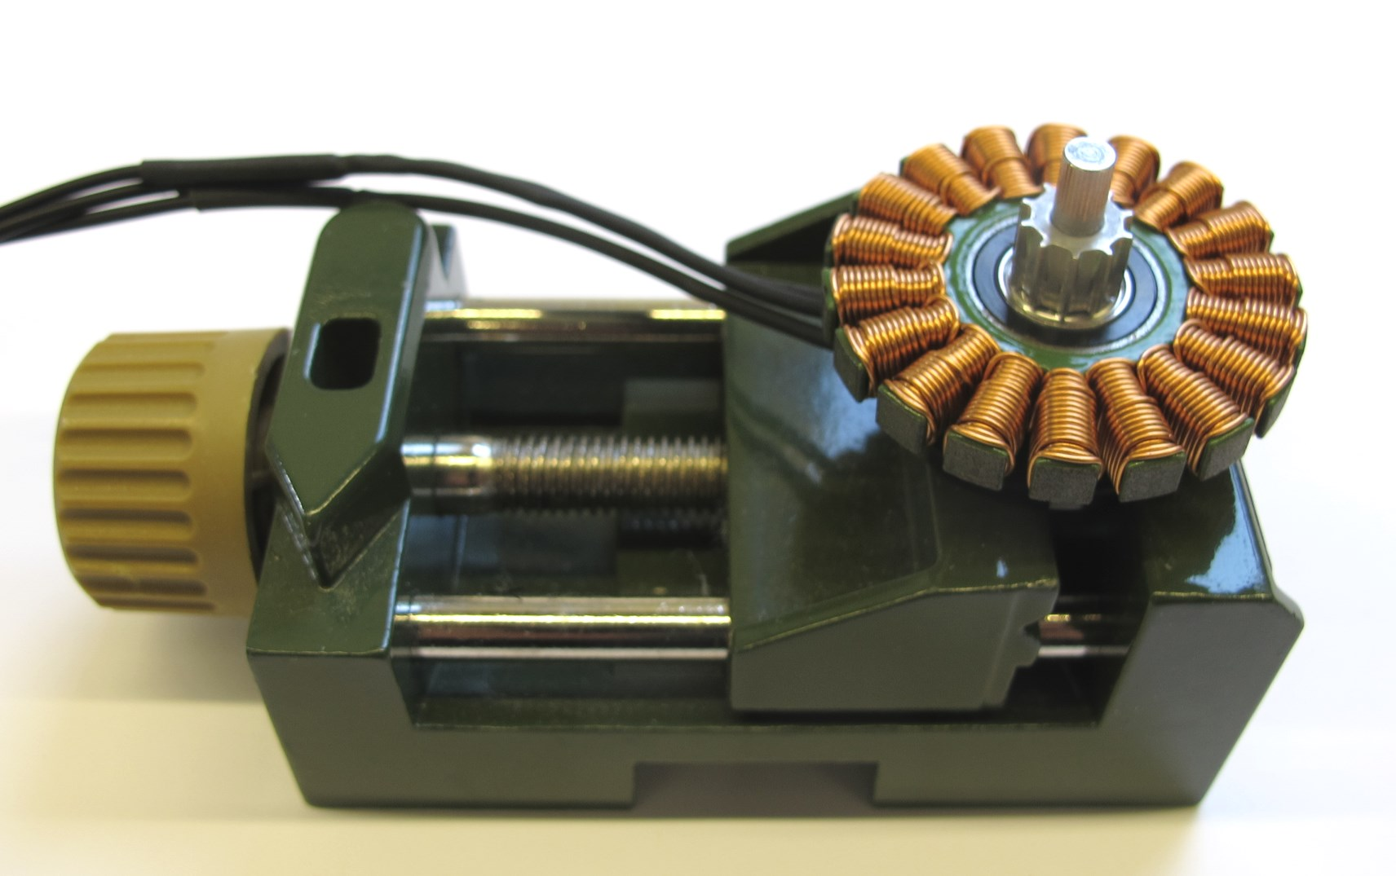  
I find it easiest to bond the code wheel on the stator.  
Insert the motor shaft with the flats downwards into the bearings of the stator.*

*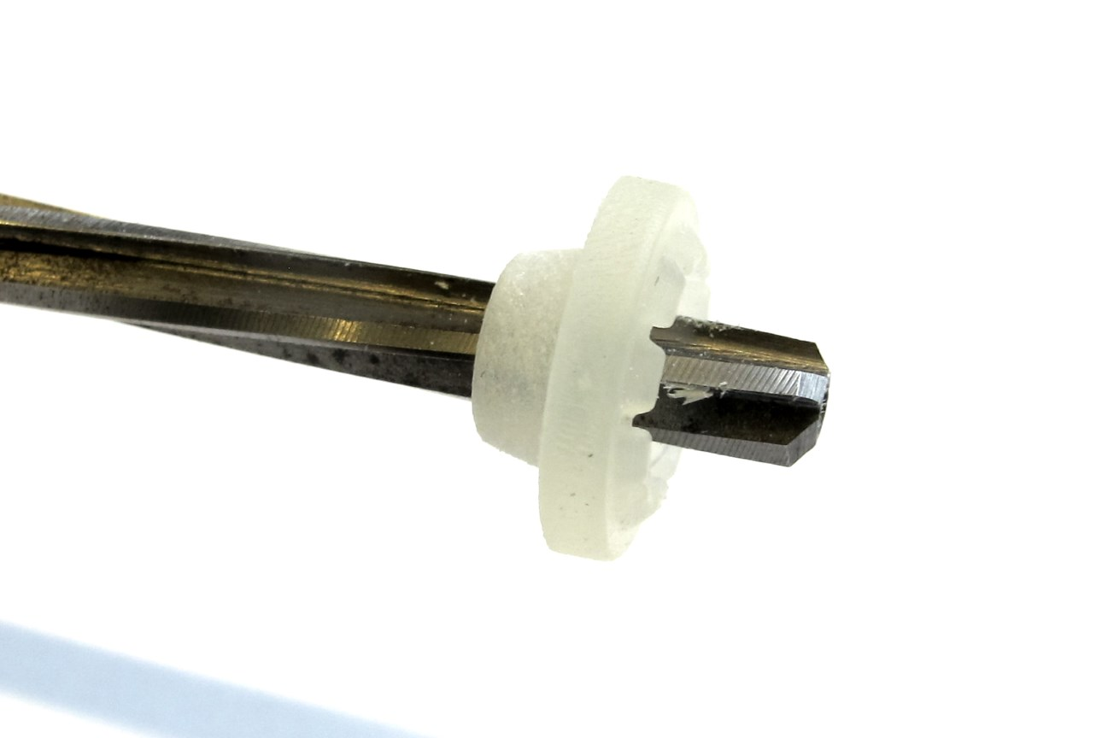  
Adjust the inner diameter of the codewheel mount with a 4mm reamer.*

*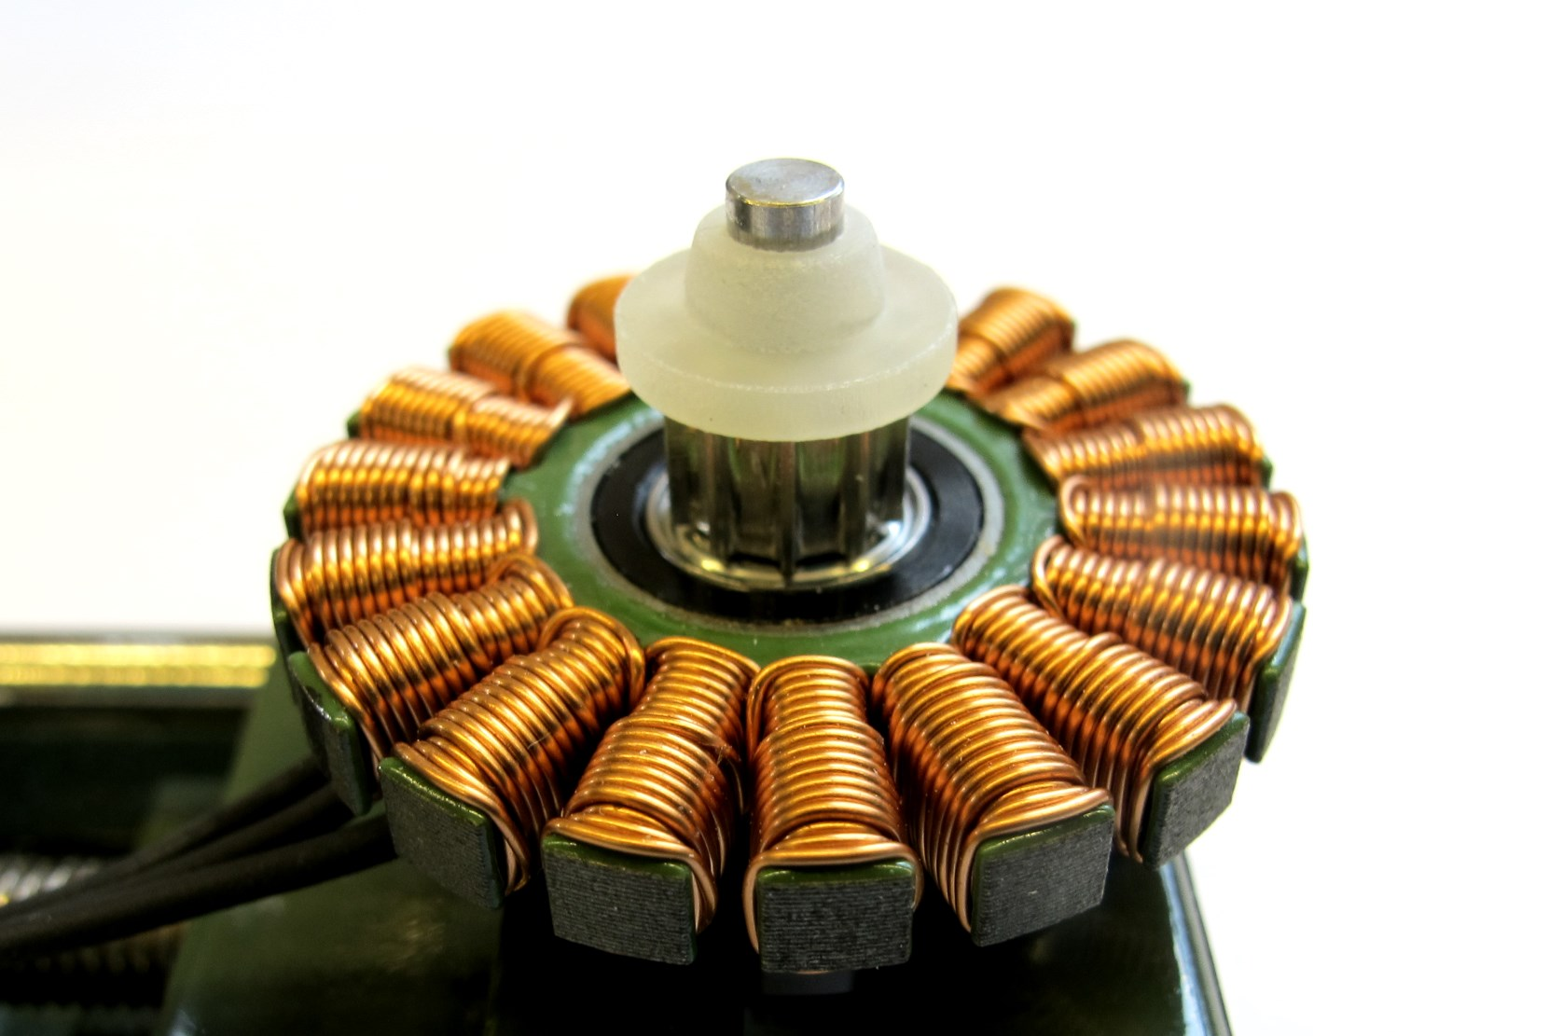  
Place the code wheel mount on the motor shaft and align the teeth of the pulley and the mount.  
Push the code wheel mount all the way down.*

*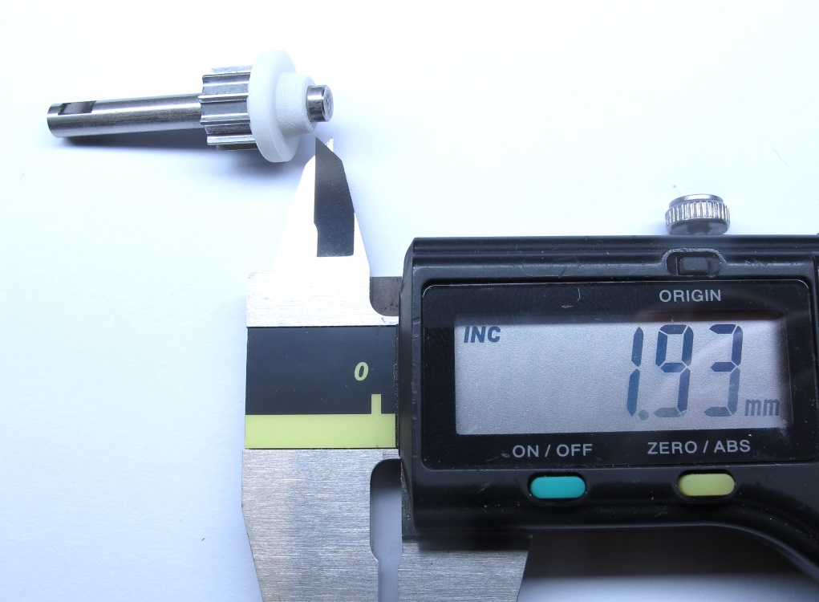  
Check the distance between the end of the motor shaft and the mount.  
The distance should be around 2mm - it's fine if it's off by 0,1 or 0,2mm.*

*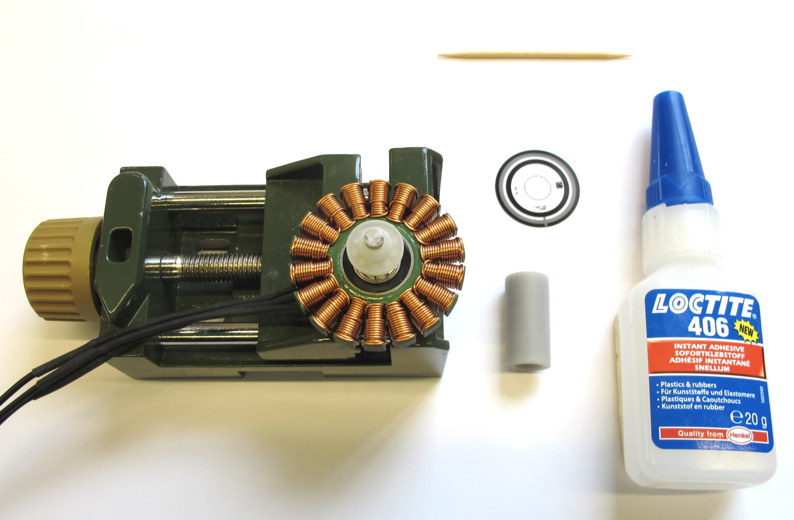  
Prepare your code wheel with the print facing upwards.  
Prepare the superglue, tooth pick, q-tipps and the bonding tool.  
Use gloves to protect your skin from the superglue.*

*  
Important: The code wheel has to be mounted in the correct orientation.  
The print on the code wheel has to be readable from the top as shown in the picture.*

*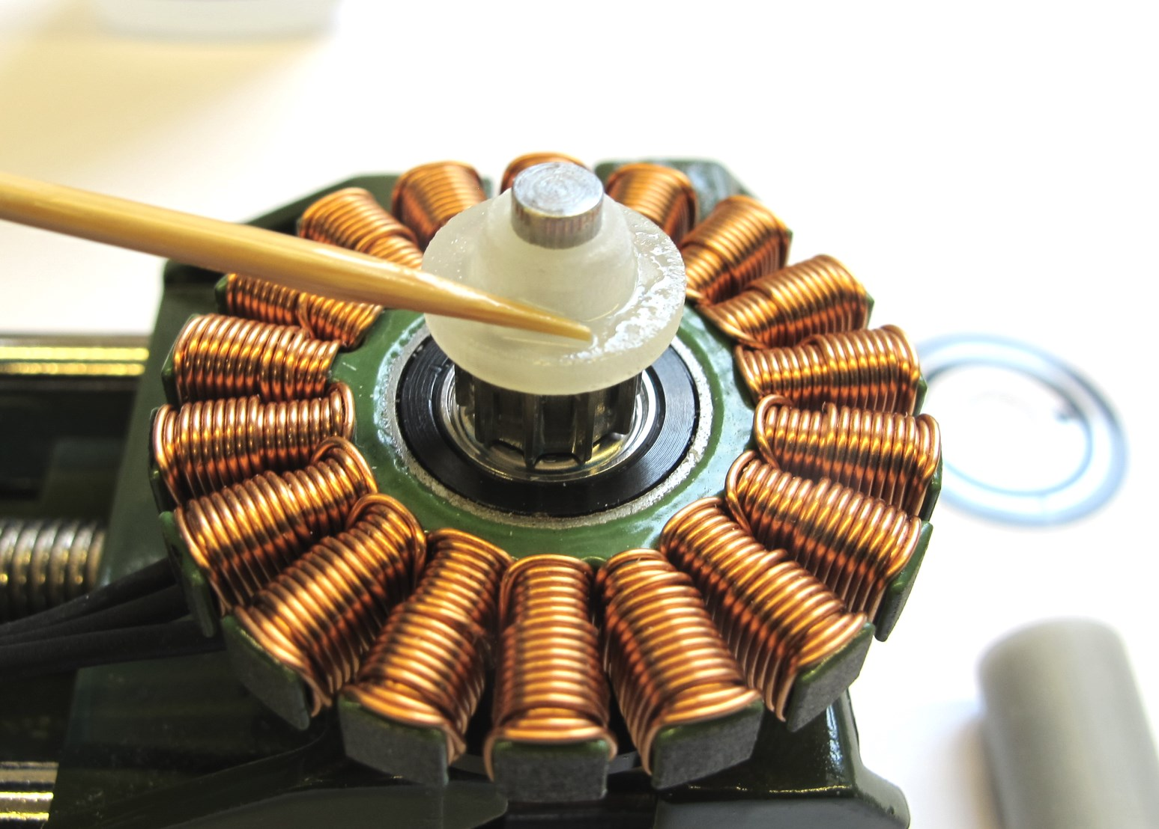  
Apply a thin layer of superglue to the code wheel mount.  
We use Loctite 406.*

*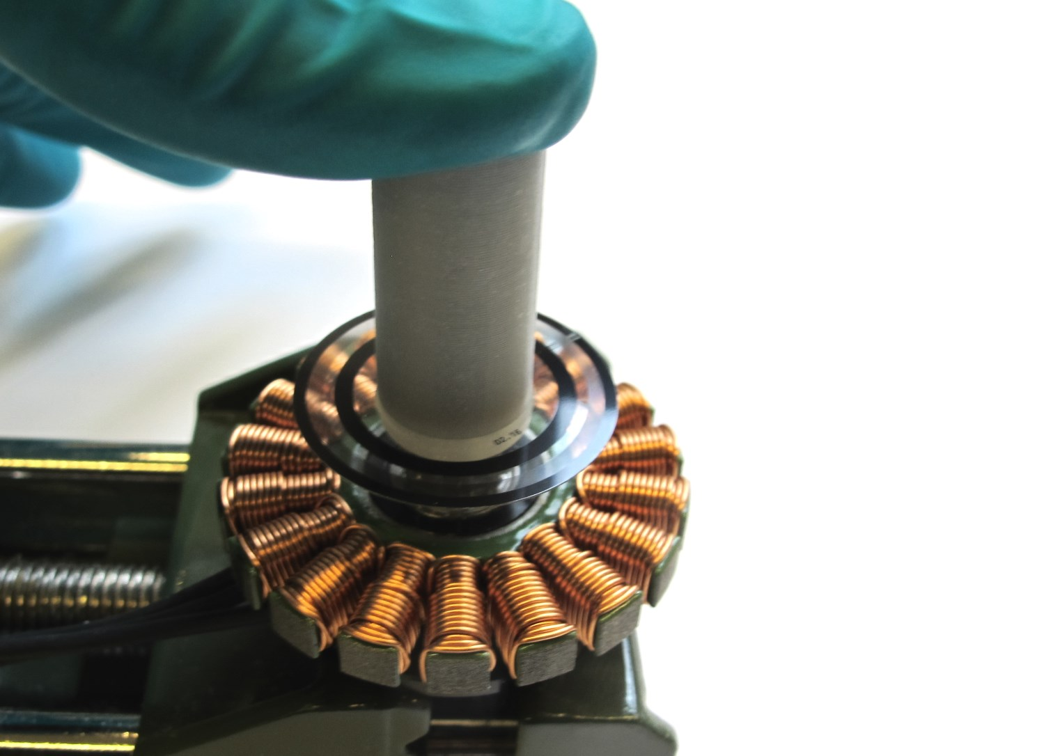  
Place the code wheel on the mount and push it all the way down using the tool.  
Hold for 30 seconds, gently remve the tool and wait a couple of minutes for the glue to cure.*

*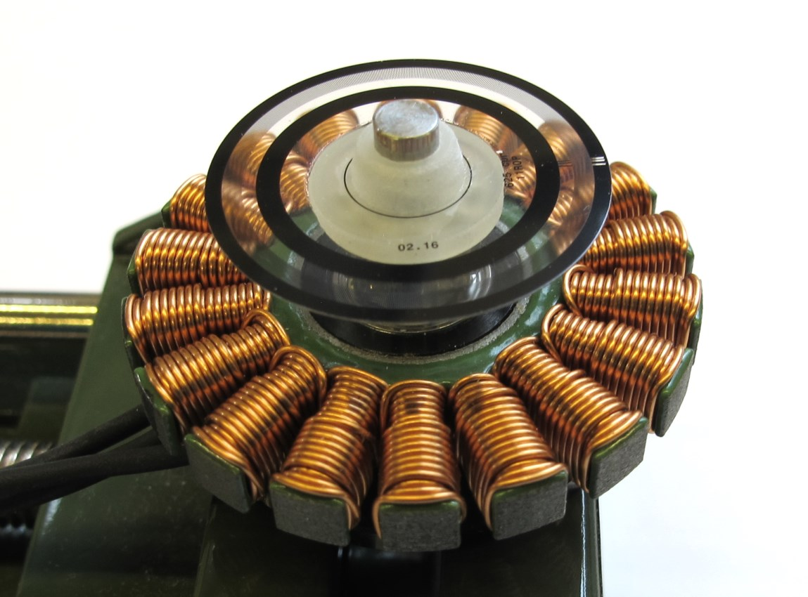  
Code wheel bonded to the code wheel mount.*

*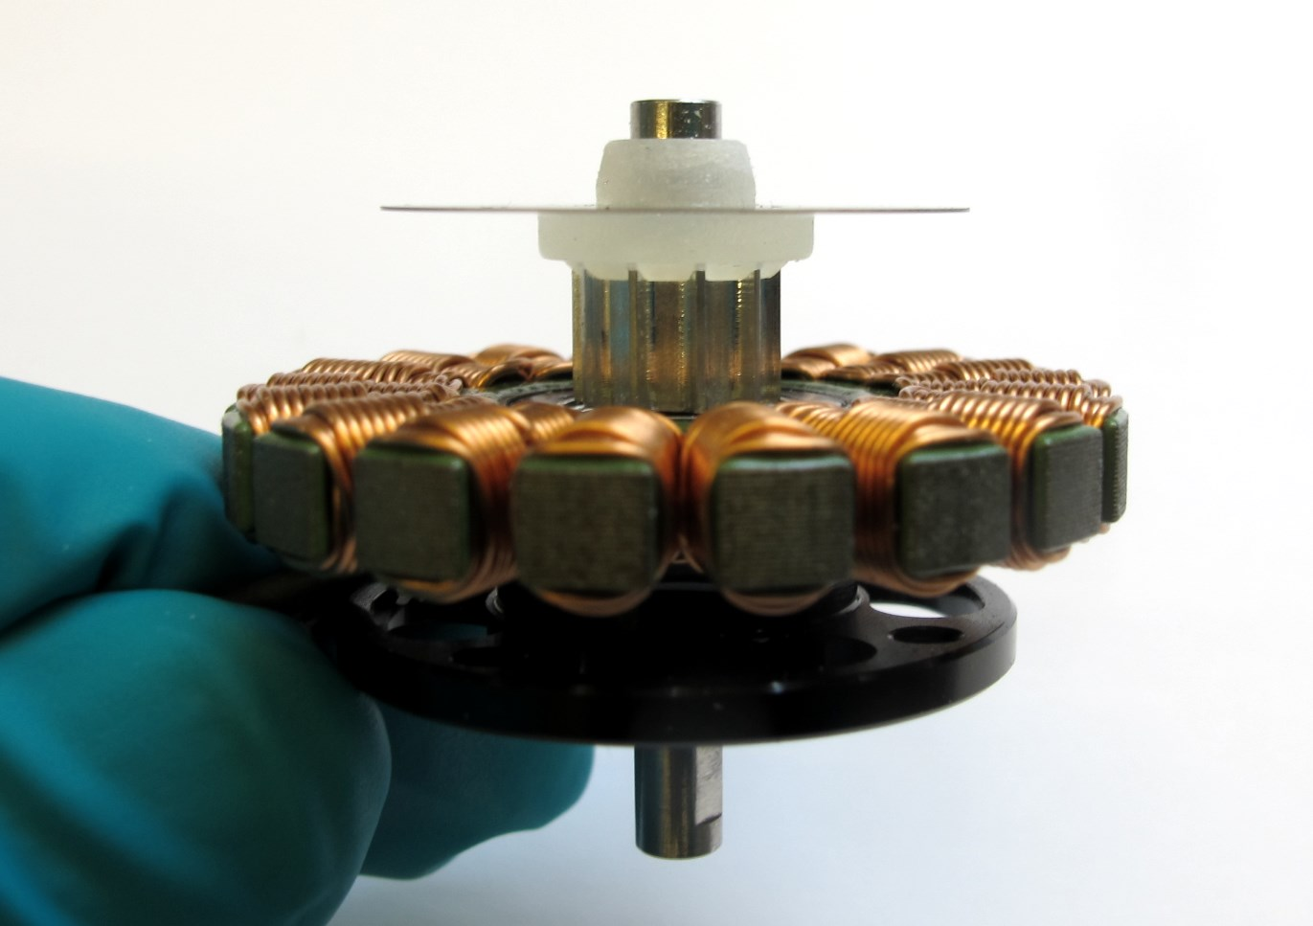  
Rotate the motor shaft and make sure that the code wheel is horizontal and doesn't wobble.  
Remove the motor shaft assembly from the stator.*

*  
The motor shaft assembly is now ready for installation.*

# **Details Motor Preparation**

**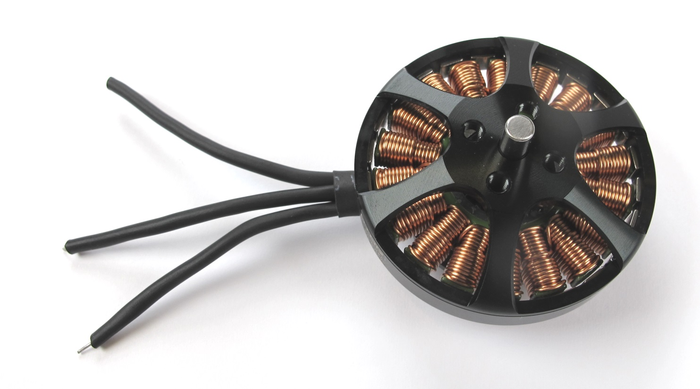***Starting Point: Antigravity 4004 300kV from T-Motor*

*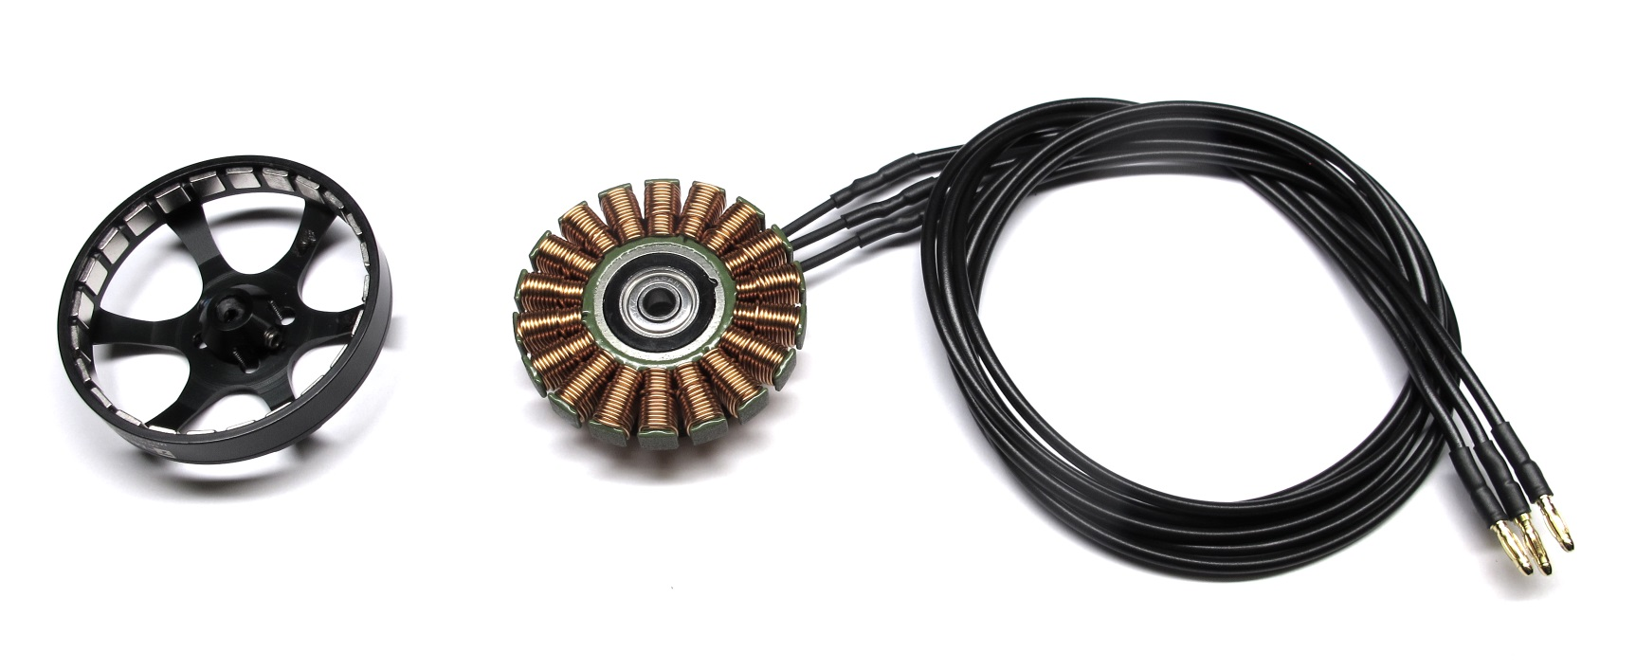  
End Result: Stator and rotor separated and prepared for installation*

## **Description**

* this page describes how to prepare the the outrunner motor for the brushless actuator modules
* stator and rotor are separated -> [Separating Rotor and Stator](https://github.com/open-dynamic-robot-initiative/open_robot_actuator_hardware/blob/master/mechanics/actuator_module_v1/details/details_motor_preparation.md#separating-rotor-and-stator)
* the motor shaft is removed from the rotor -> [Removing the Motor Shaft](https://github.com/open-dynamic-robot-initiative/open_robot_actuator_hardware/blob/master/mechanics/actuator_module_v1/details/details_motor_preparation.md#removing-the-motor-shaft)
* the bore diameter of the rotor is increased to fit the custom motor shaft -> [Increasing the Rotor Bore Diameter](https://github.com/open-dynamic-robot-initiative/open_robot_actuator_hardware/blob/master/mechanics/actuator_module_v1/details/details_motor_preparation.md#increasing-the-rotor-bore-diameter)
* the motor phase insulation is removed -> [Removing the Motor Phase Insulation](https://github.com/open-dynamic-robot-initiative/open_robot_actuator_hardware/blob/master/mechanics/actuator_module_v1/details/details_motor_preparation.md#removing-the-motor-phase-insulation)
* the motor phase wires are shortened and prepared -> [Preparing the Motor Phase Wires](https://github.com/open-dynamic-robot-initiative/open_robot_actuator_hardware/blob/master/mechanics/actuator_module_v1/details/details_motor_preparation.md#preparing-the-motor-phase-wires)
* the extension wires are soldered to the motor phase wires -> [Soldering the Extension Wires](https://github.com/open-dynamic-robot-initiative/open_robot_actuator_hardware/blob/master/mechanics/actuator_module_v1/details/details_motor_preparation.md#soldering-the-extension-wires)
* finally the motor phase connectors are soldered to the extension wires. -> [Soldering the Motor Phase Connectors](https://github.com/open-dynamic-robot-initiative/open_robot_actuator_hardware/blob/master/mechanics/actuator_module_v1/details/details_motor_preparation.md#soldering-the-motor-phase-connectors)

## **Separating Rotor and Stator**

**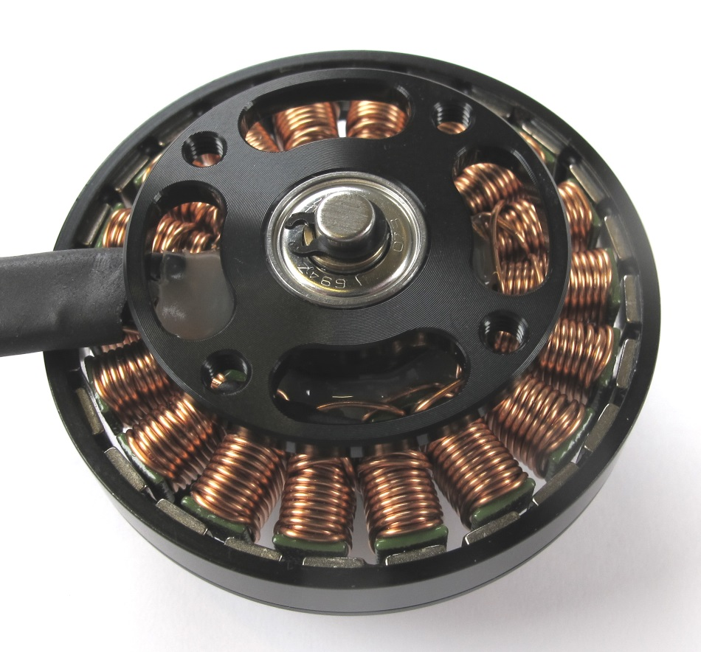***Bottom view: the retaining ring holds the motor shaft in place*

*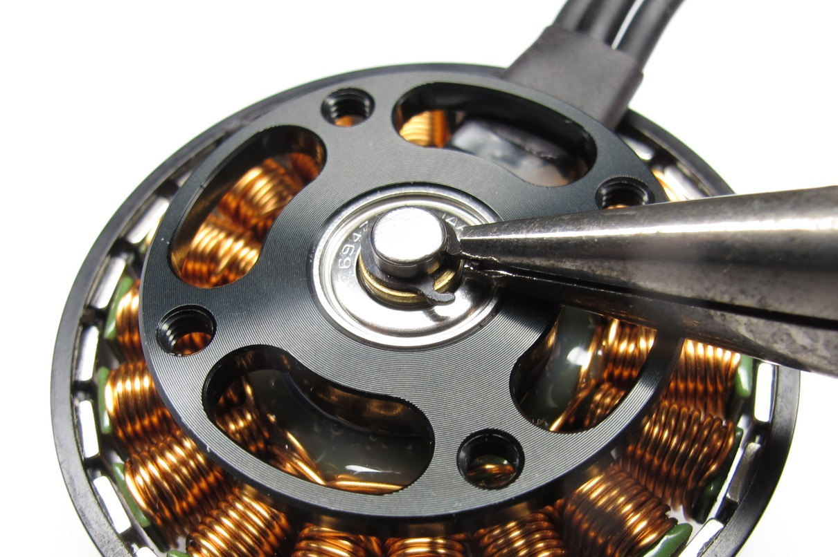  
Remove the retaining ring from the motor shaft using small pliers.  
Don't worry about damaging the retaining ring - it's no longer needed*

*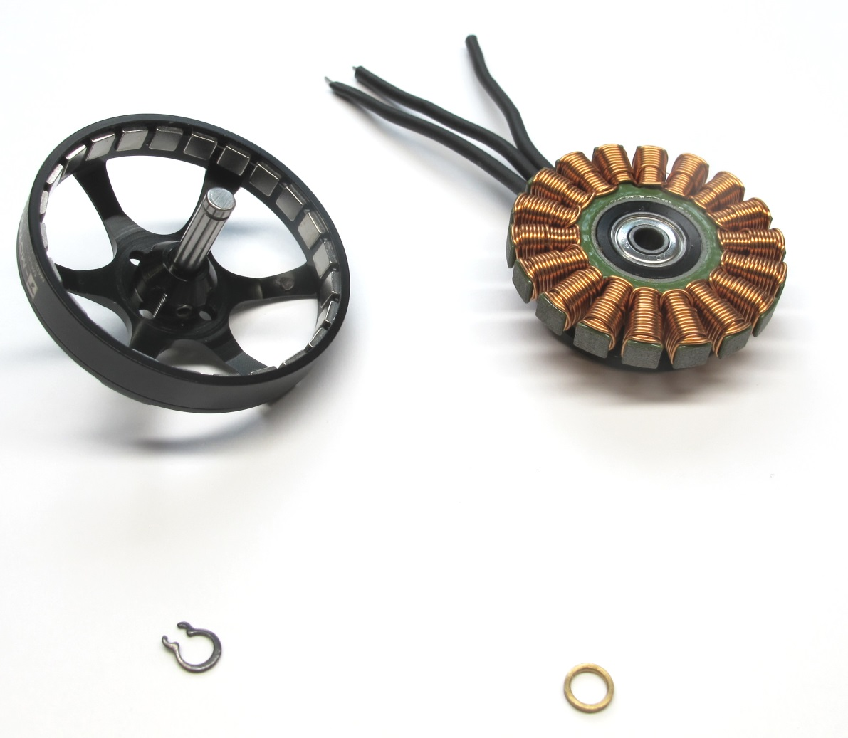  
Separate the rotor from the stator by pulling gently to overcome the magnetic forces..  
Make sure to keep the brass washer. Store the rotor on a clean surface.  
Metal particles will stick to the magnets and can cause problems later.*

## **Rotor Preparation**

### **Removing the Motor Shaft**

**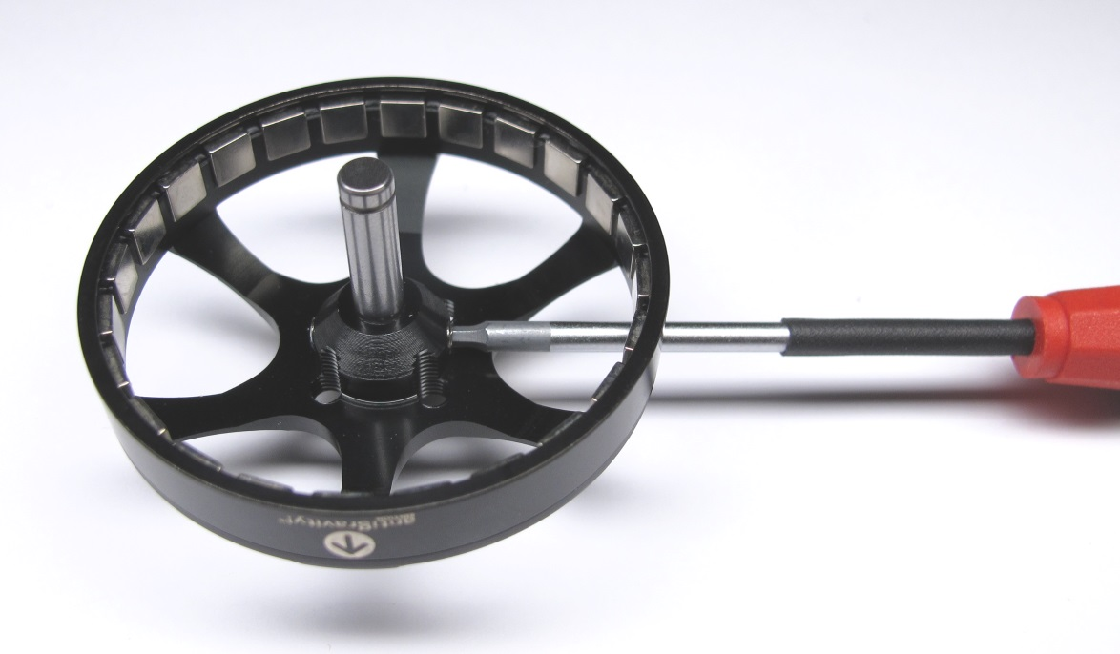***Remove the two M3 set screws on the rotor using a 1,5mm hex driver.*

*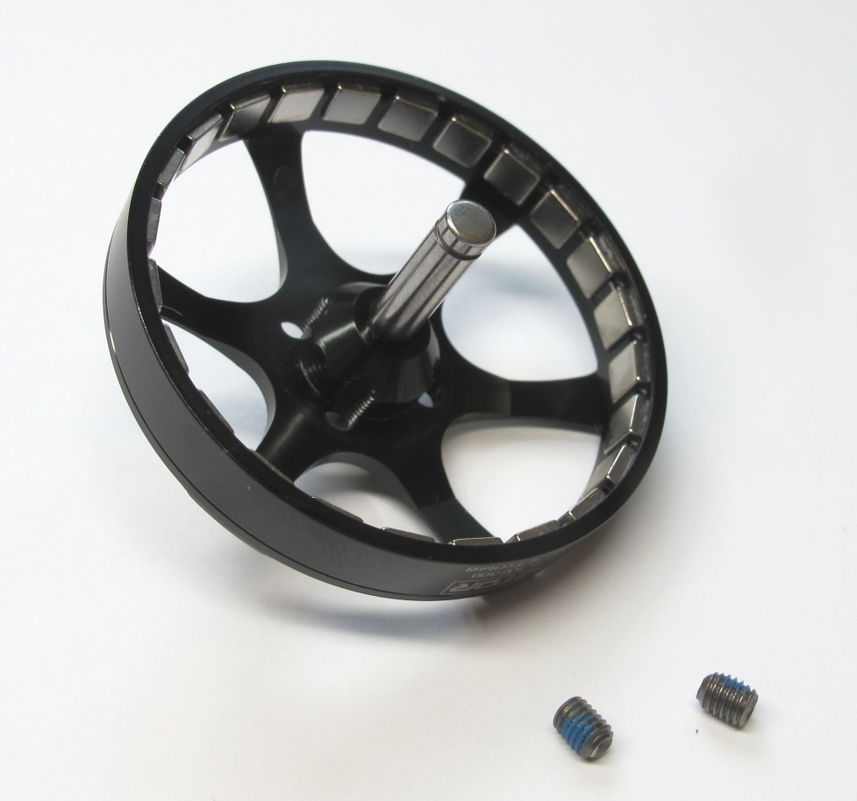  
Keep the set screws for reassembly.*

*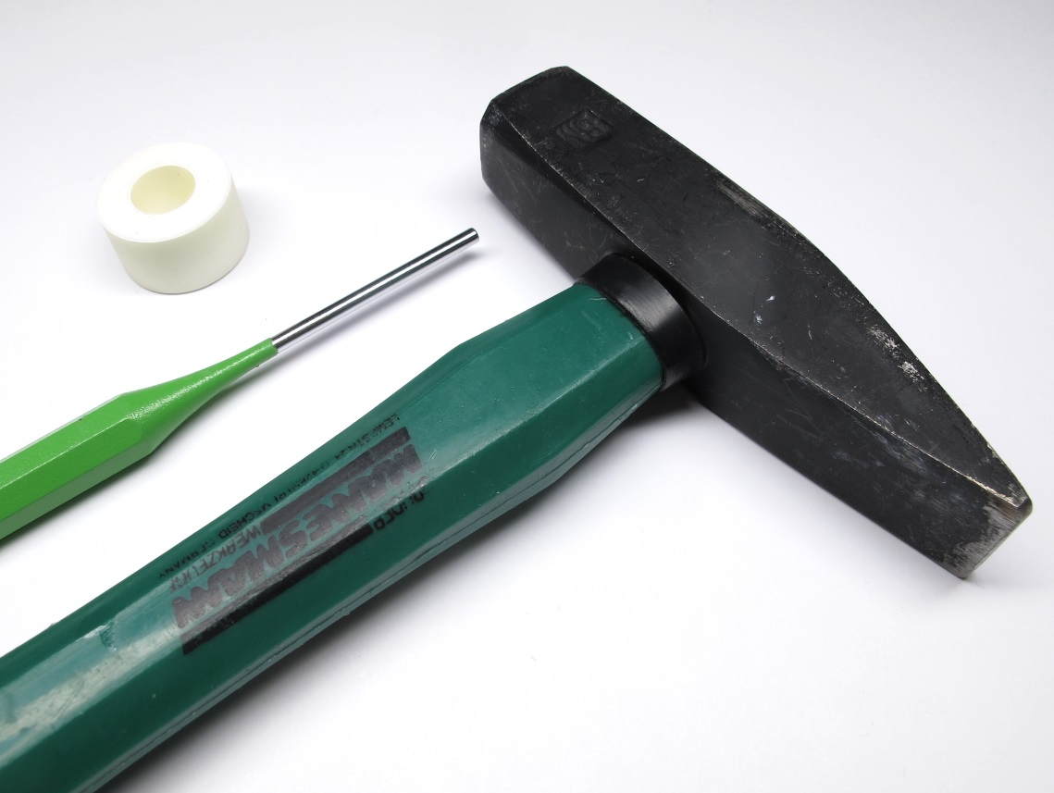  
For the next step you will need a hammer, pin driver  
and the 3d printed "motor shaft extraction tool".*[*-> STL file Motor Shaft Extraction Tool*](https://github.com/open-dynamic-robot-initiative/open_robot_actuator_hardware/blob/master/mechanics/actuator_module_v1/stl_files/tool_motor_shaft_extraction.STL)

*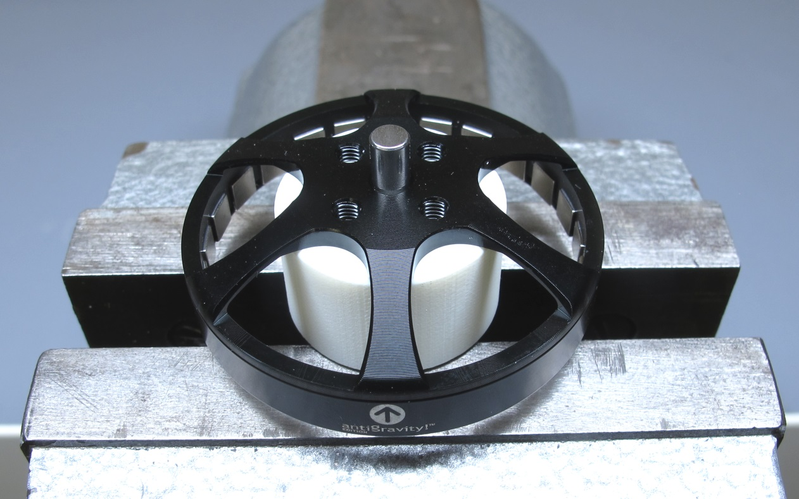  
Place the rotor on the "motor shaft extraction tool".*

*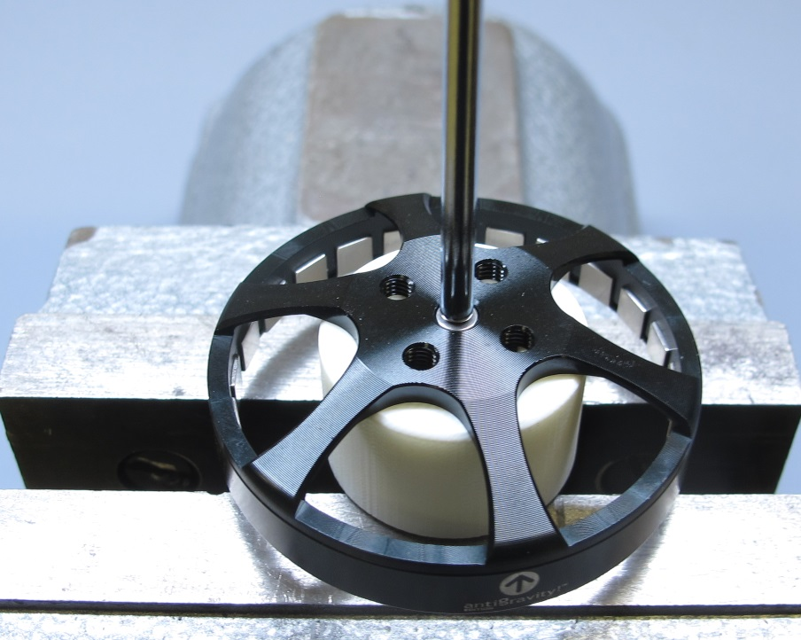  
Use the hammer and pin driver to remove the motor shaft.*

*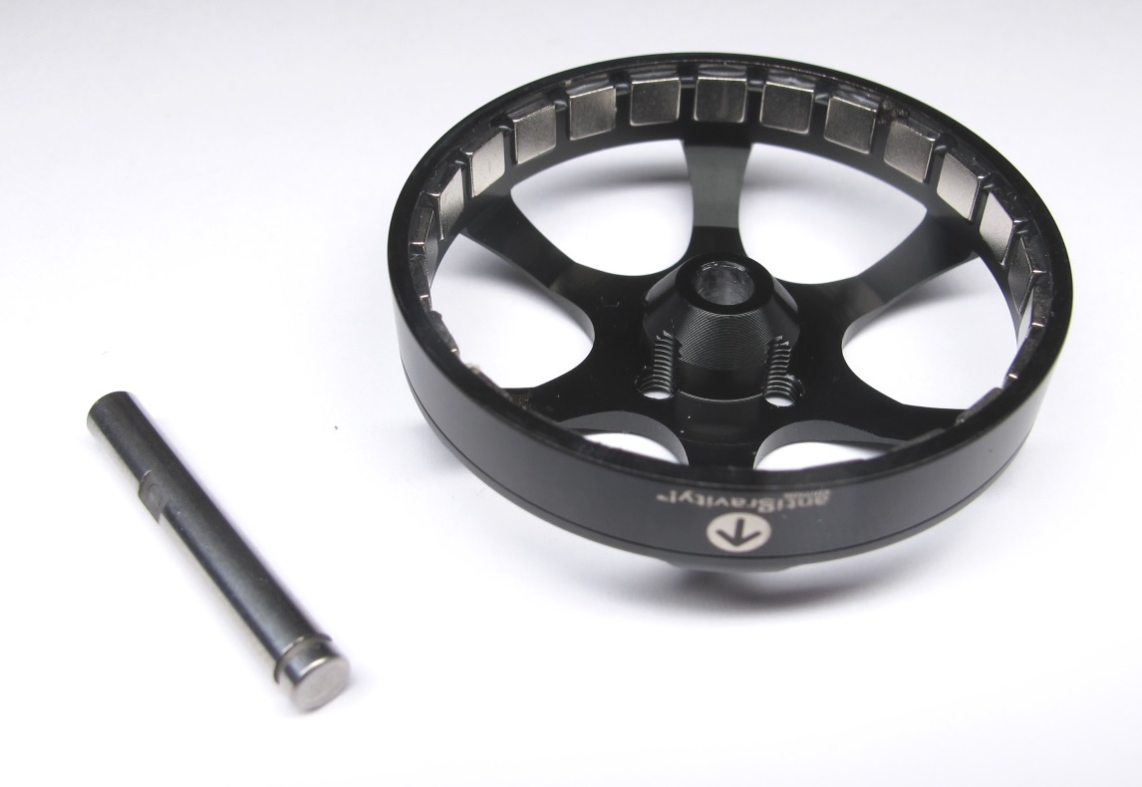  
Rotor with motor shaft removed.*

### **Increasing the Rotor Bore Diameter**

**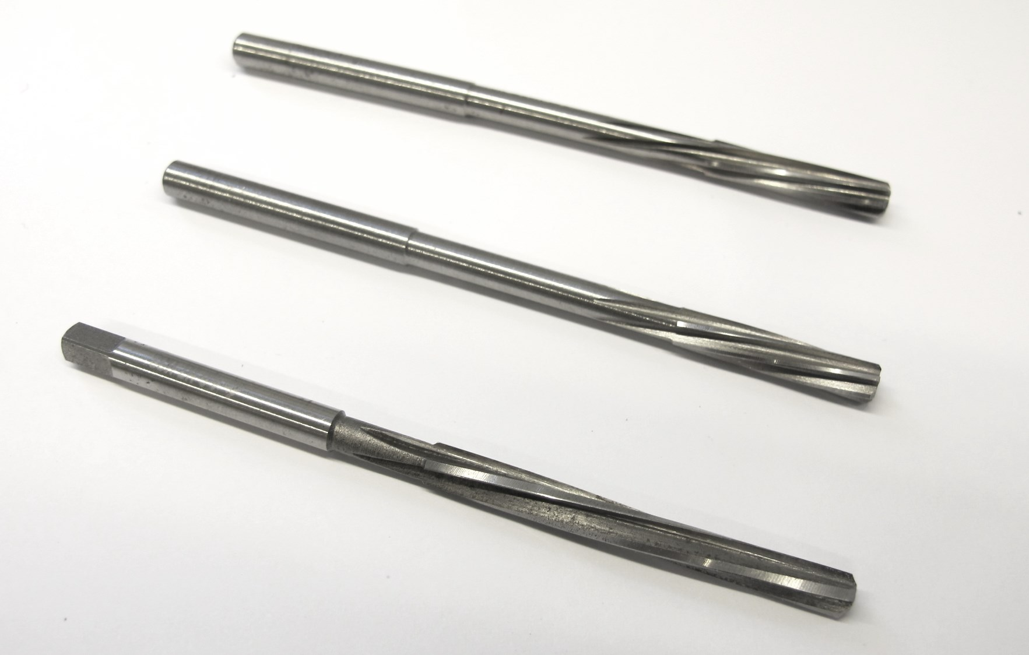***You will now need different reamer sizes to increase the bore diameter of the rotor.  
We use reamers with 3.98mm, 3.99mm and 4.00mm diameter.*

*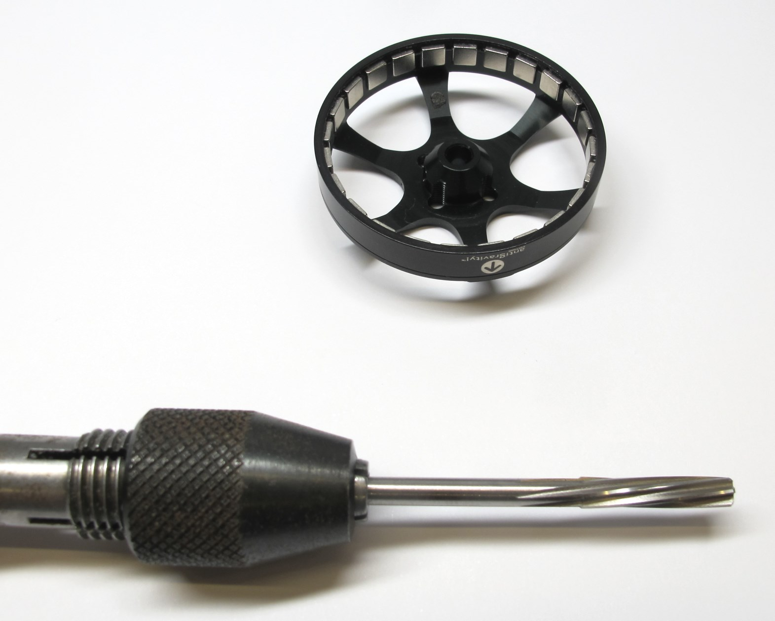  
Use a tool holder to manually increase the bore diameter.*

*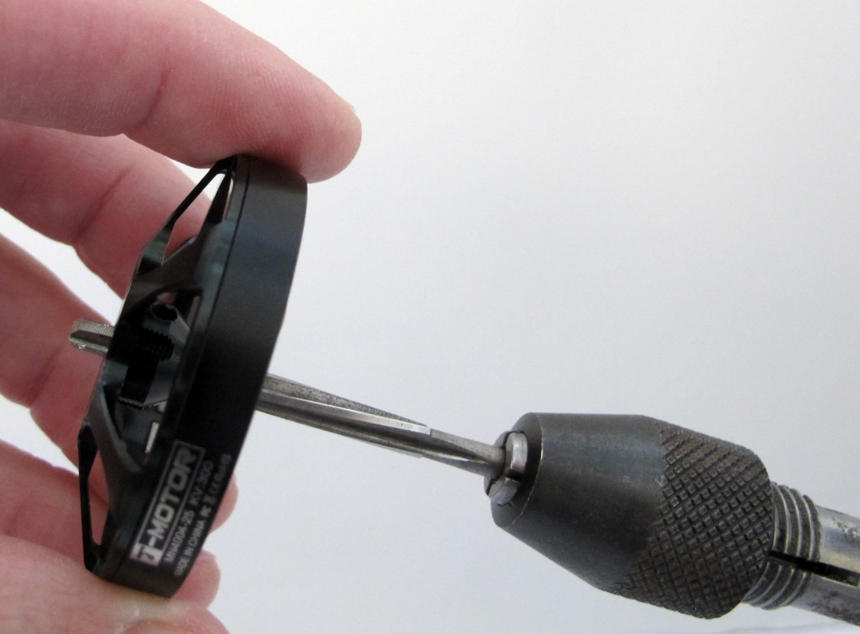  
Start with the smallest reamer - 3.98mm.  
Put some oil on the reamer.  
Carefully insert and turn the reamer a couple of times.*

*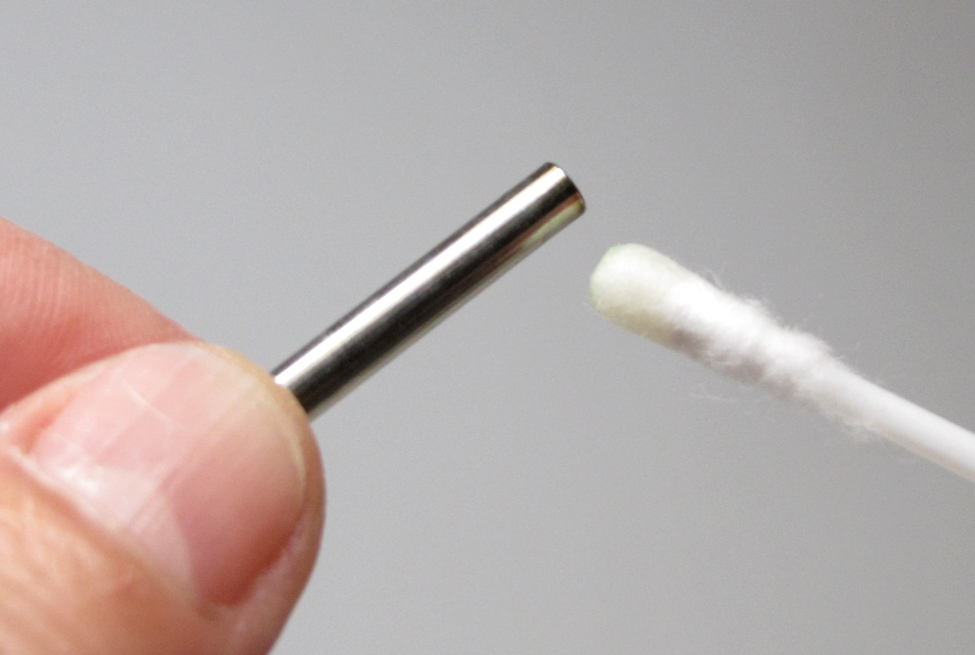  
Put a bit of oil on the custom motor shaft.*[*-> PDF Drawing Custom Motor Shaft*](https://github.com/open-dynamic-robot-initiative/open_robot_actuator_hardware/blob/master/mechanics/actuator_module_v1/drawings/motor_shaft.PDF)

*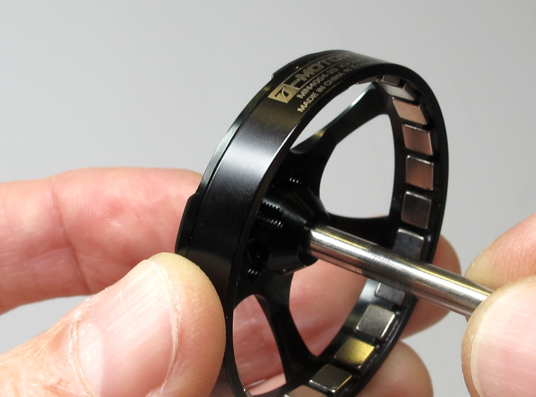  
Try to insert the custom motor shaft.  
If the reamed hole is too tight repeat the last two steps with the same reamer size.  
If the bore is still too tight use the next larger reamer size.  
Continue until the shaft can be installed and removed with moderate force.*

Important: Be careful not to increase the bore diameter too much.  
If the fit is too loose the rotor will wobble when spinning.

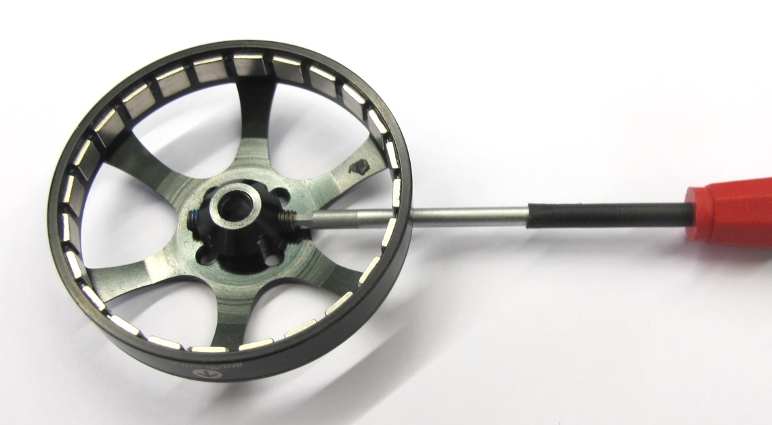  
*Install the two M3 set screws half way using a 1,5mm hex driver.*

*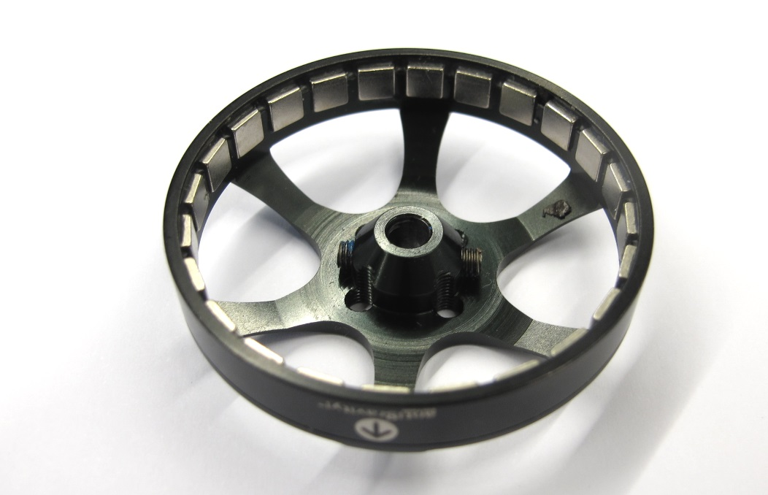  
The rotor is now ready for assembly.*

## **Stator Preparation**

### **Removing the Motor Phase Insulation**

**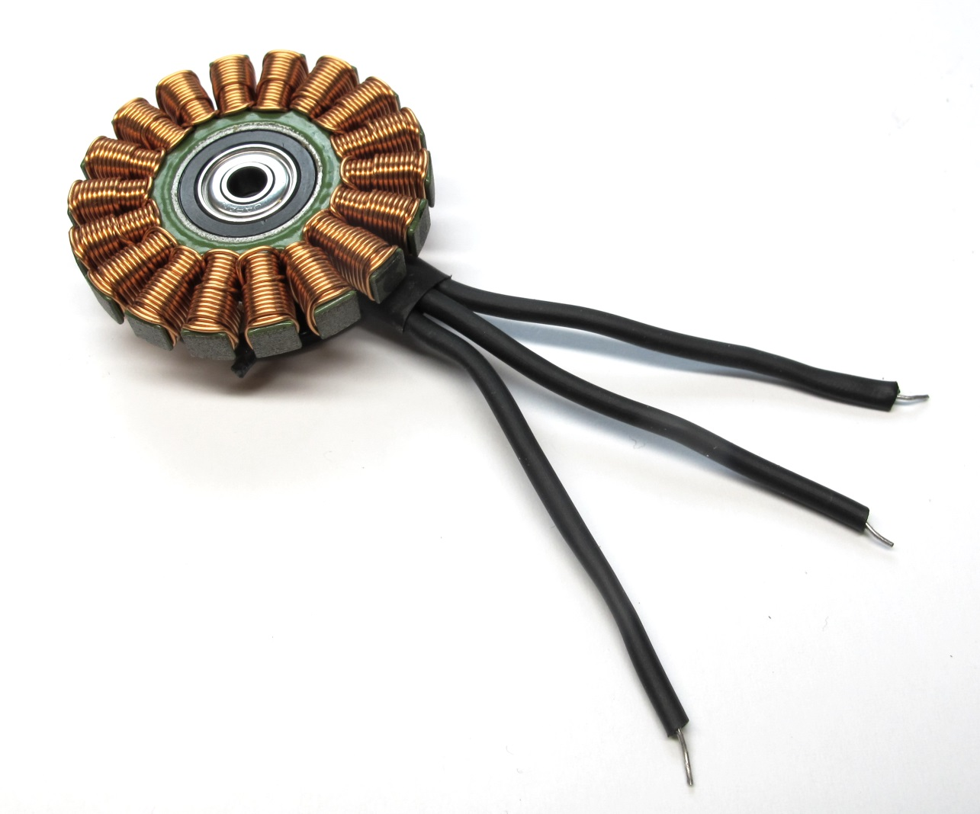***Stator with original phase wires*

*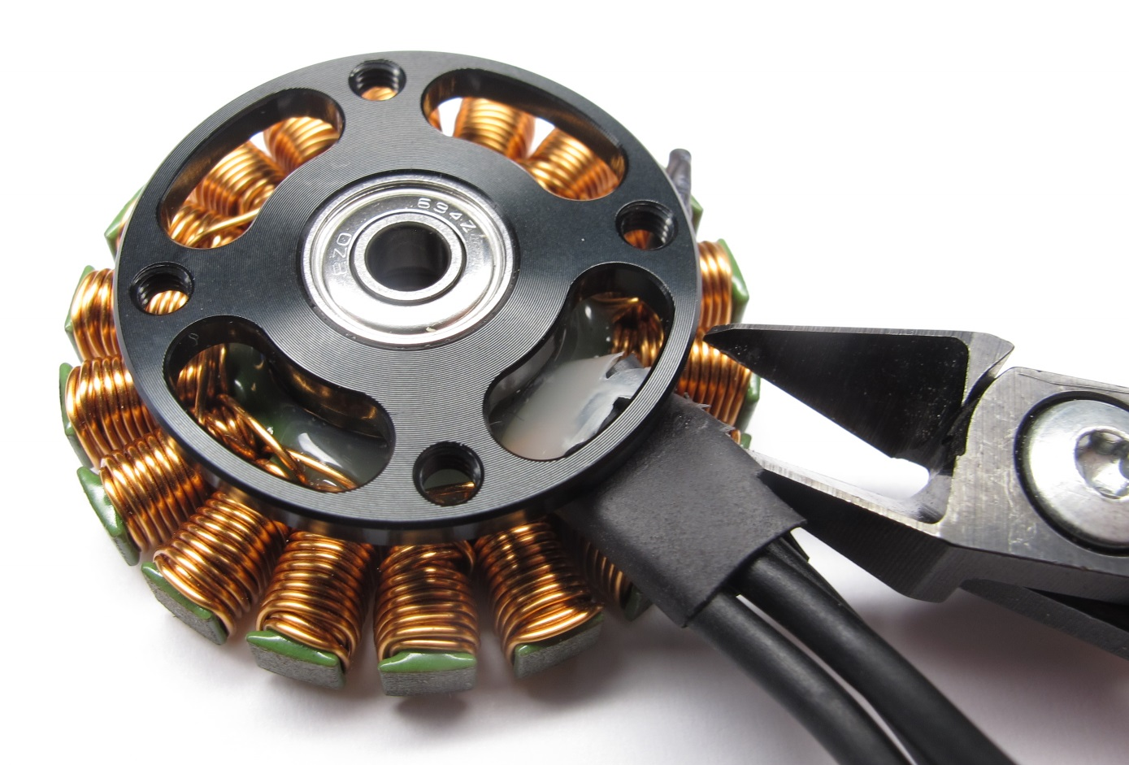  
Carefully cut and remove the large heat shrink at the base.*

*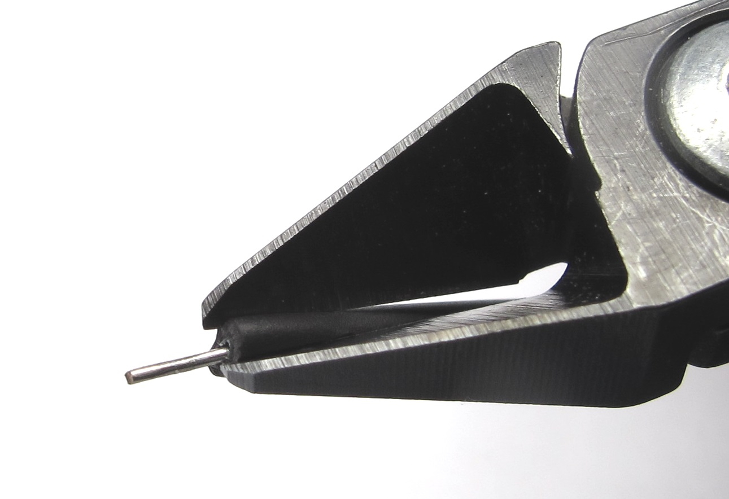  
Cut off a piece of the phase wire heat shrink under an angle.*

*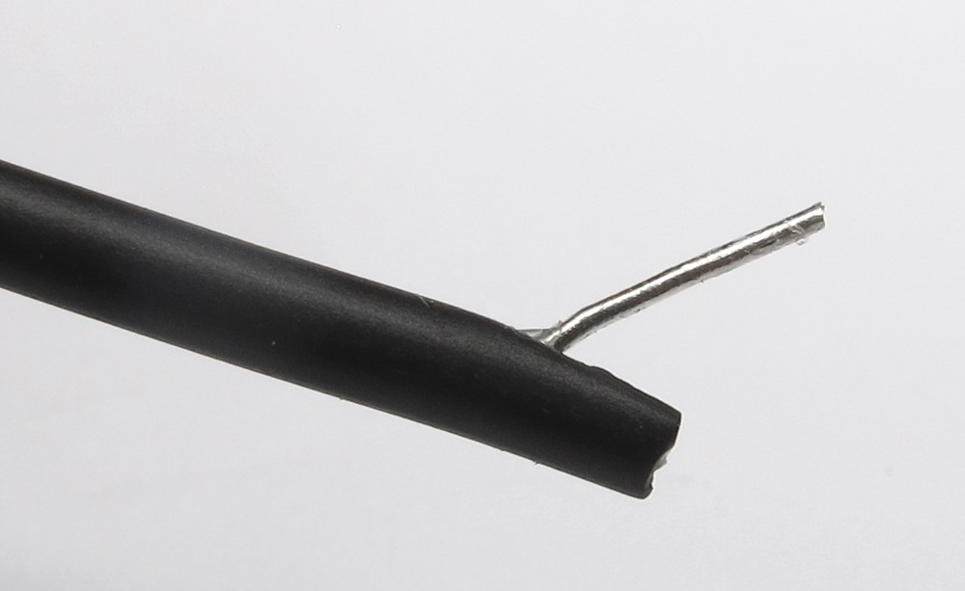  
Hold the phase wire with pliers and grab the heat shrink with your fingers.*

*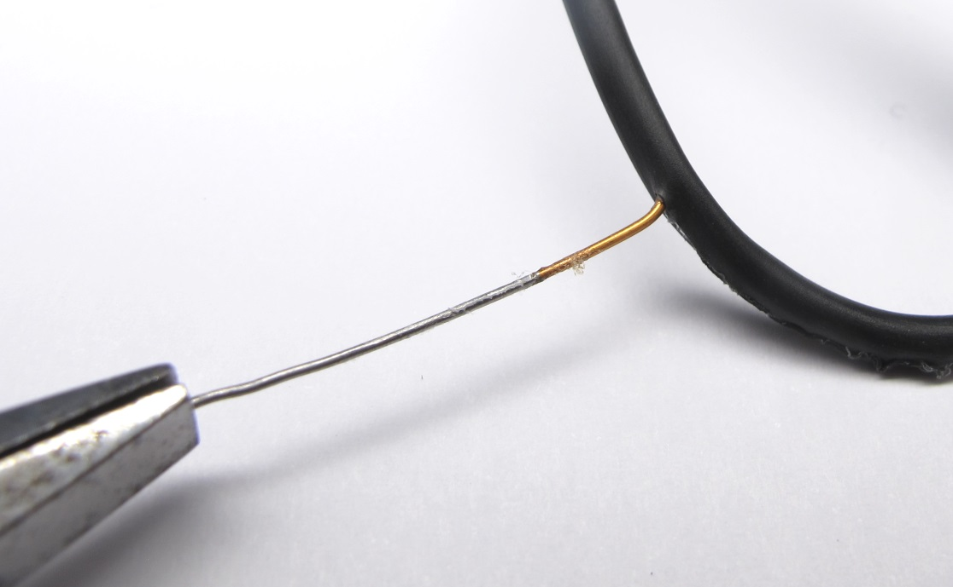  
Slowly pull on the wire while holding the heat shrink.  
The wire will cut through the heat shrink.*

*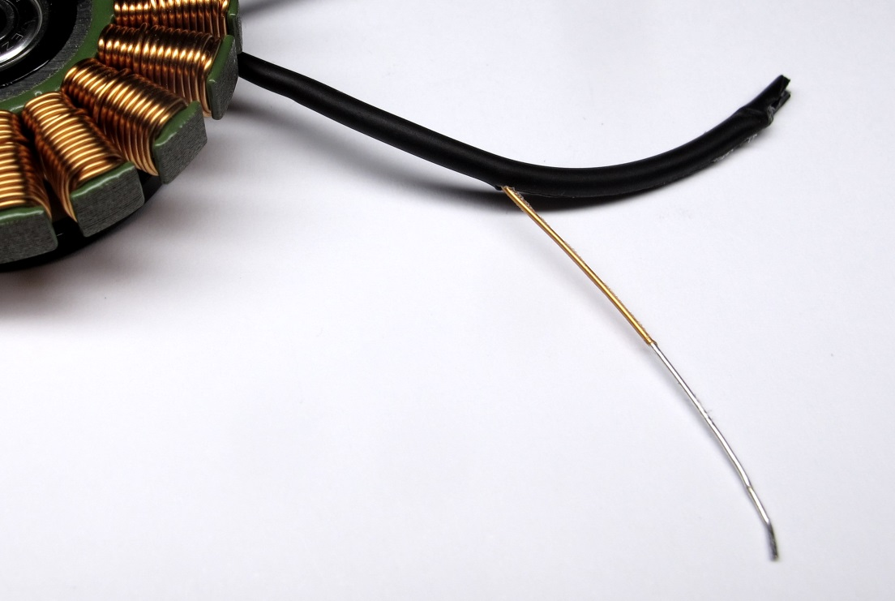  
Continue until the insulation is removed half way.*

*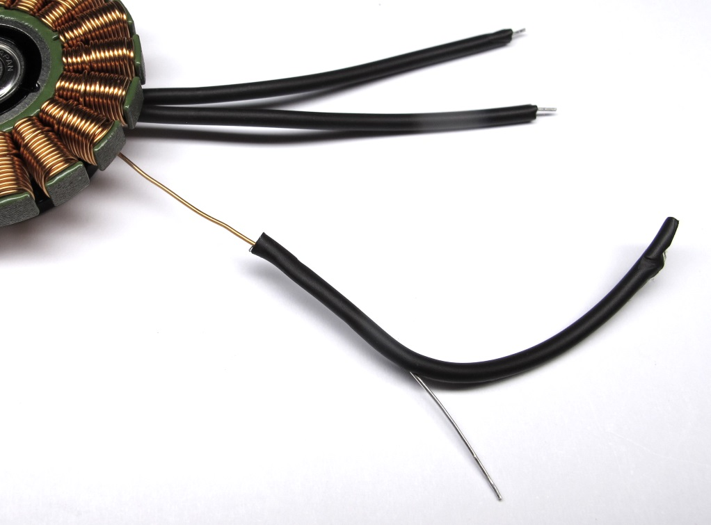  
You should now be able to carefully pull off the heat shrink from the phase wires.*

*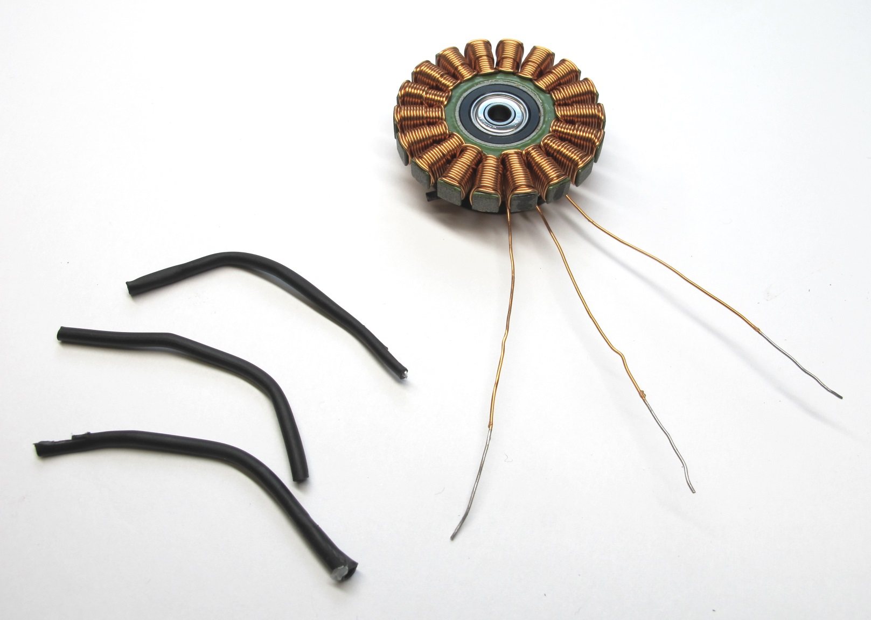  
Stator with insulation removed.*

### **Preparing the Motor Phase Wires**

**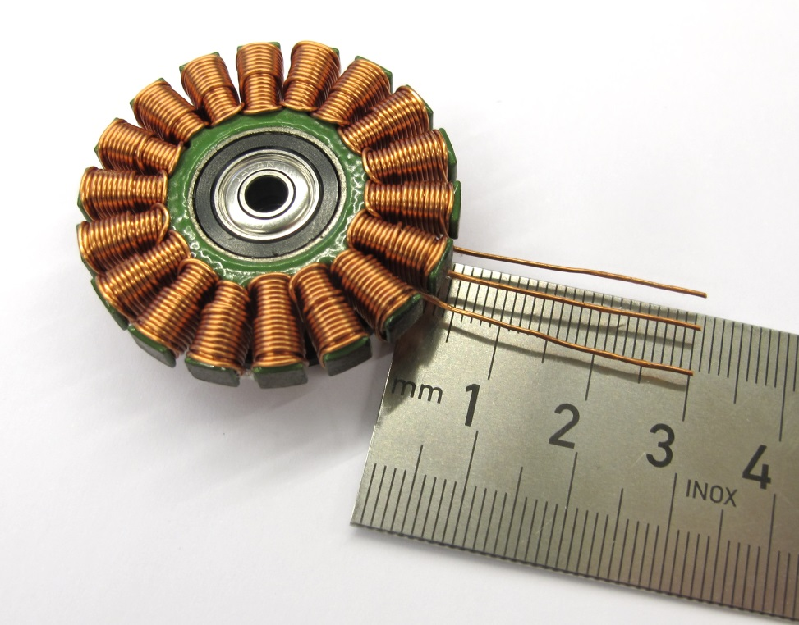***Don't shorten the motor phase wires for the Hip AA Actuator Modules - skip this step and continue with applying heat shrink to the wires.  
For the Hip FE and Upper Leg Modules we shorten the motor phase wires to about 3cm measured from the base of the stator.  
This helps to keep the solder connection inside of the shell structure.*

*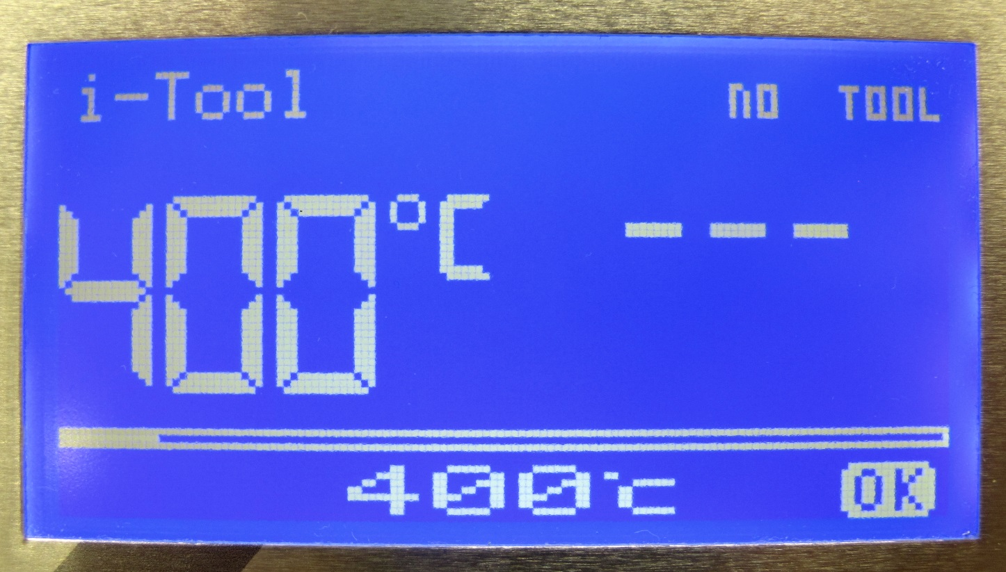  
We use a temperature controlled soldering iron to burn off the orange insulation.  
Set your soldering iron to a temperature of abour 400 degrees celcius.*

*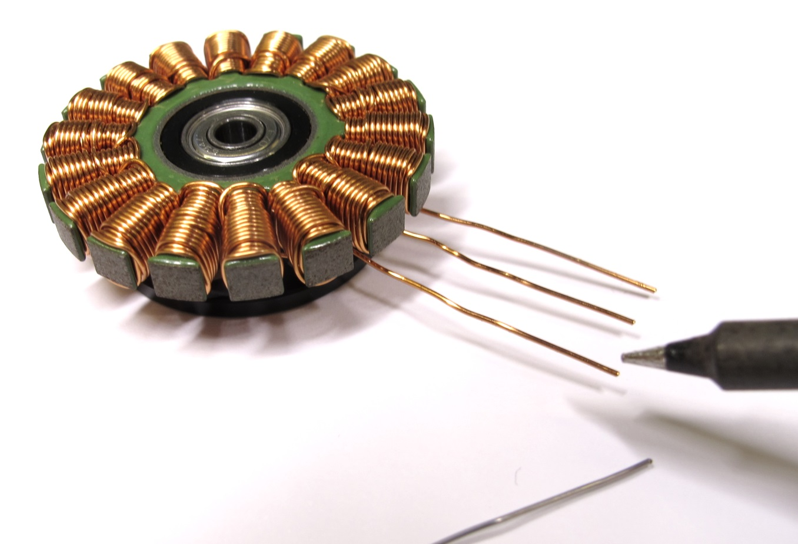  
Put solder on the tip and heat up the ends of the phase wires.  
Wait until the insulation disappears and you can see 5mm of silver wire exposed.*

*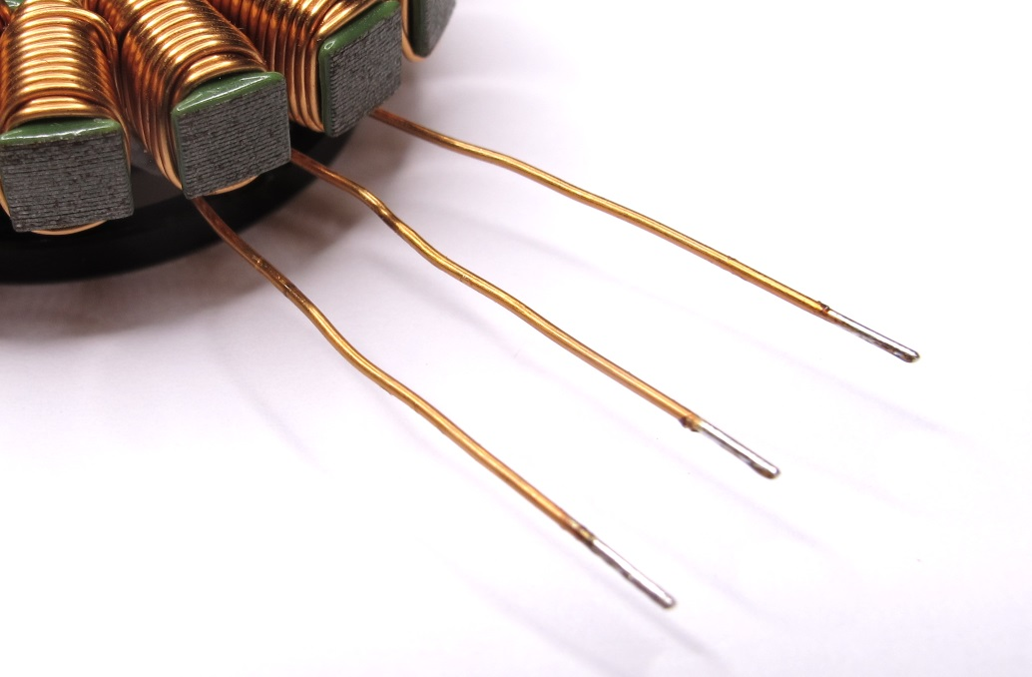  
Motor phase wires with insulation removed from the ends.*

*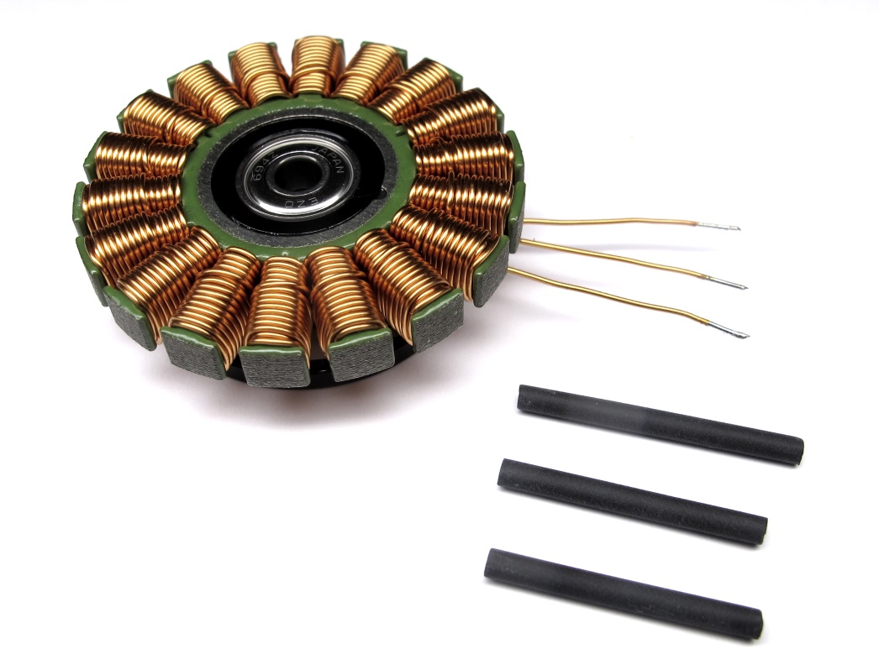  
Prepare thin heat shrink for the phase wires.*

*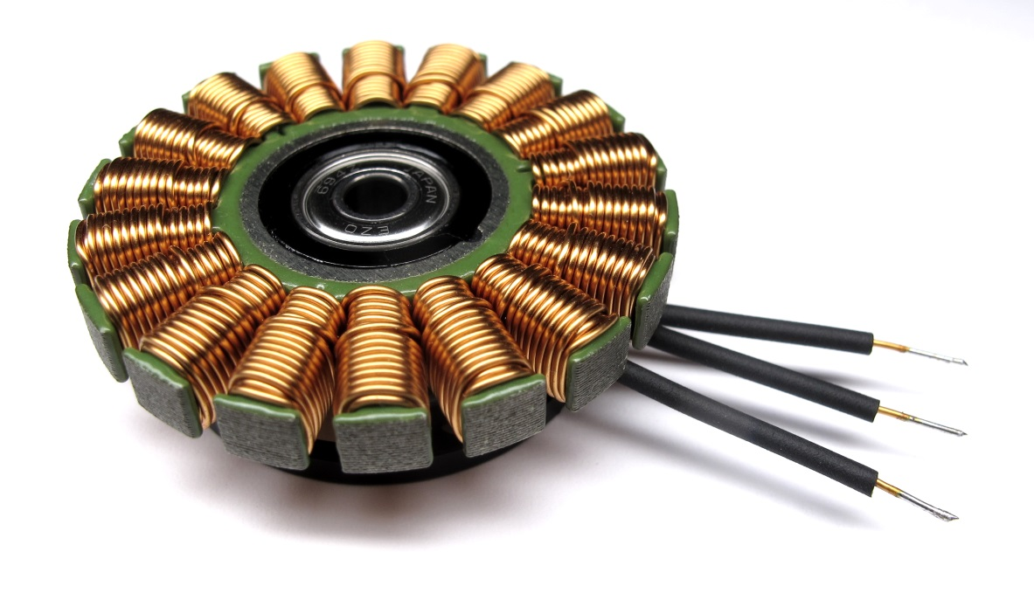  
Apply the heat shrink using a heat gun.  
You can now solder the extension wires.*

### **Soldering the Extension Wires**

**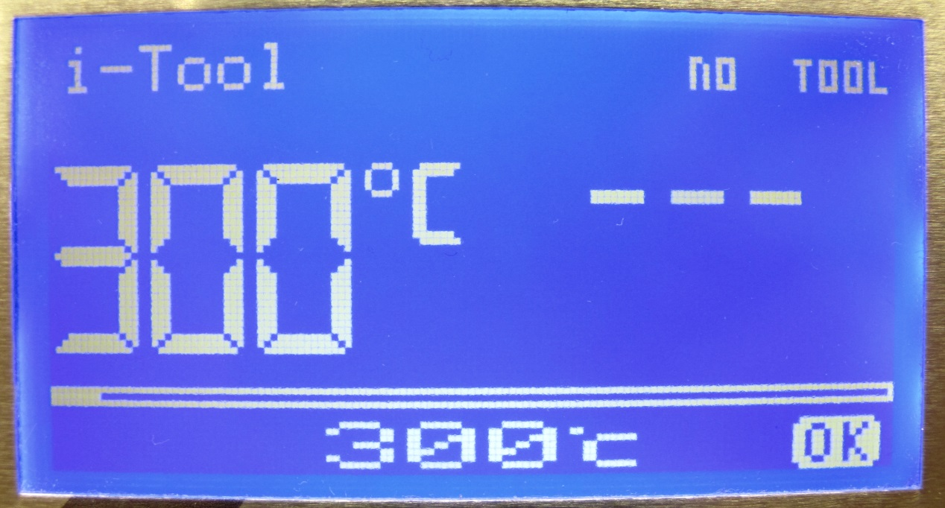***Reduce the soldering temperature to about 300 degrees celcius*

*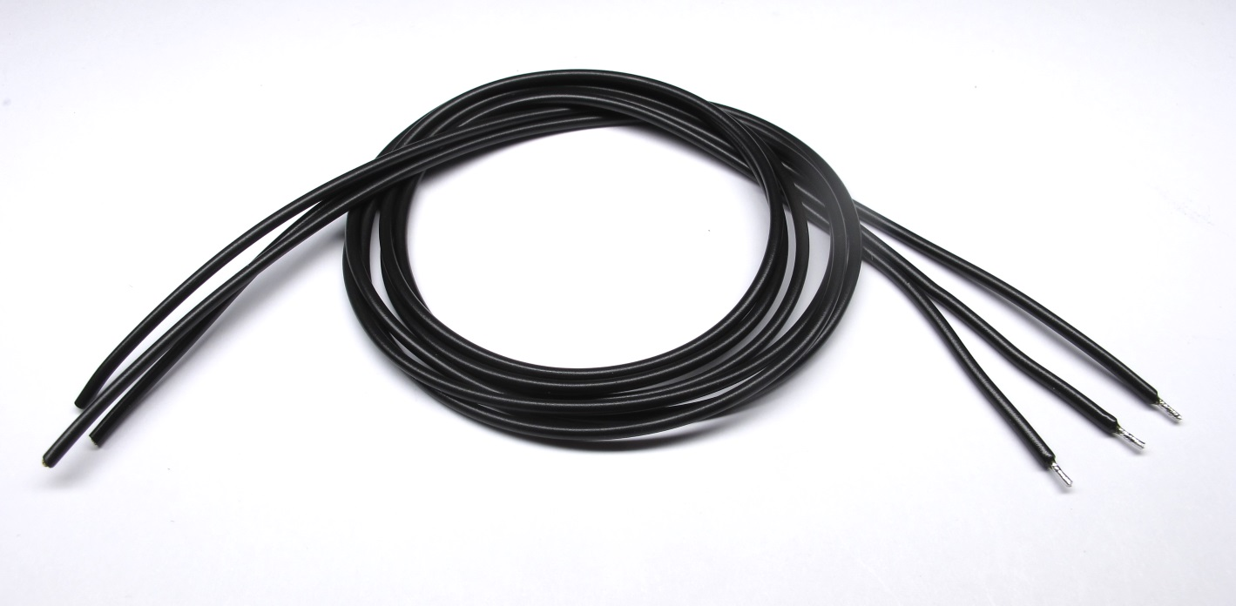  
Pepare the extension wires - make them a couple of cm longer than needed.  
We use LiY wire with a cross section of 0,5mm 2.*

*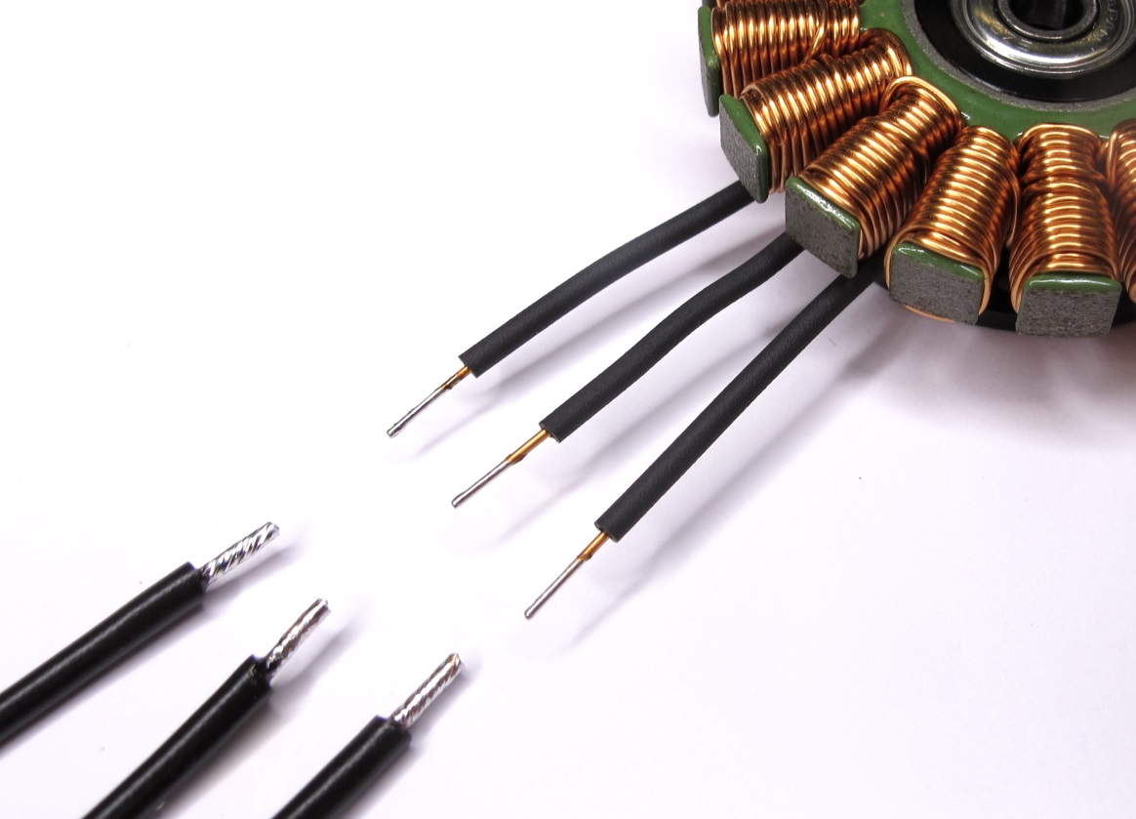  
Solder the extension wires to the phase wires.*

*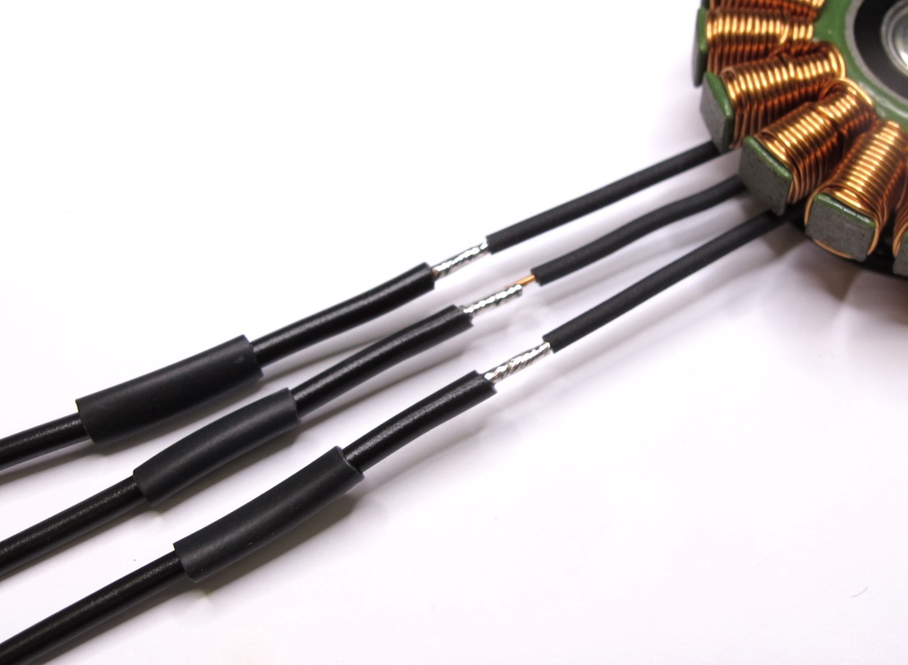  
Prepare the heat shrink for insulating the wires.  
Try to keep the heat shrink short.*

*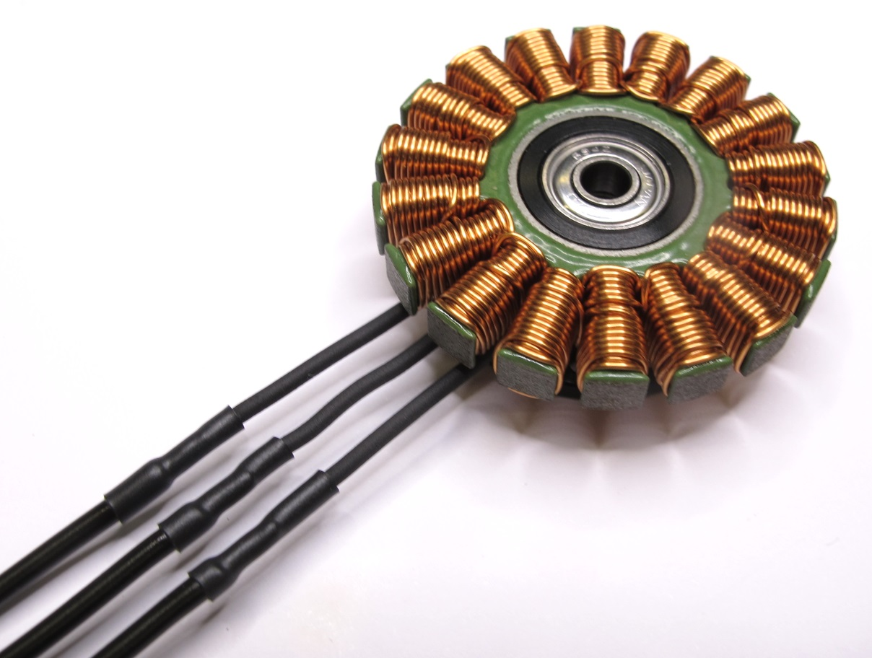  
Use a heat gun to apply the heat shrink.*

*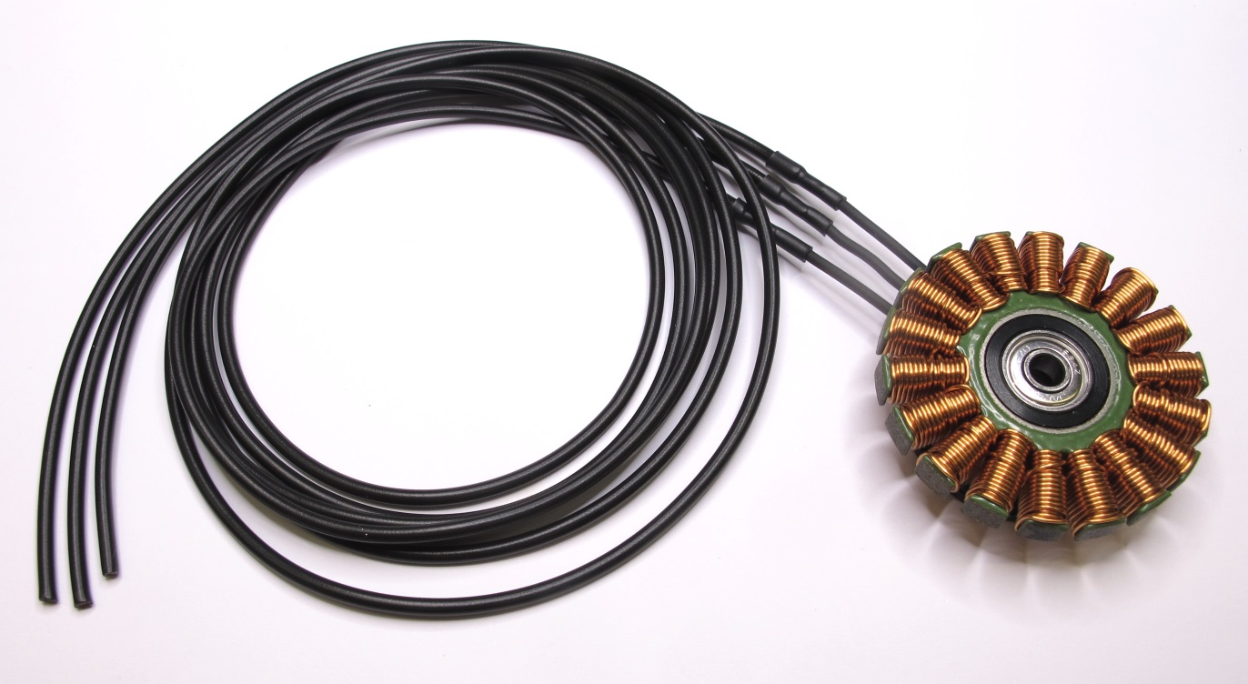  
If you are unsure about the correct wire length you can stop here.  
Follow all the other preparation steps and fully assemble the actuator module.  
You can then determine the correct wire length and solder the connectors later.*

### **Soldering the Motor Phase Connectors**

**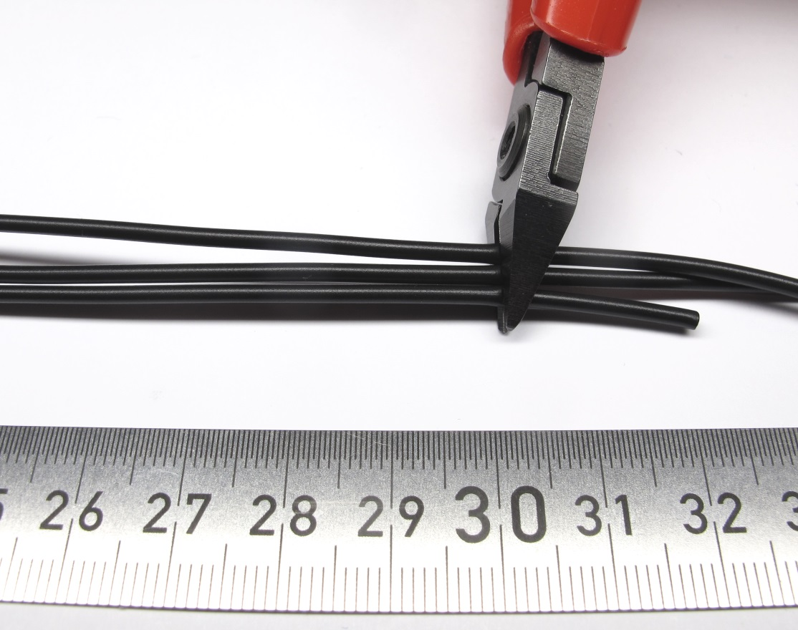***If you know the required wire length cut the wires accordingly.  
Remove a bit of the insulation, twist the strands and apply solder.*

*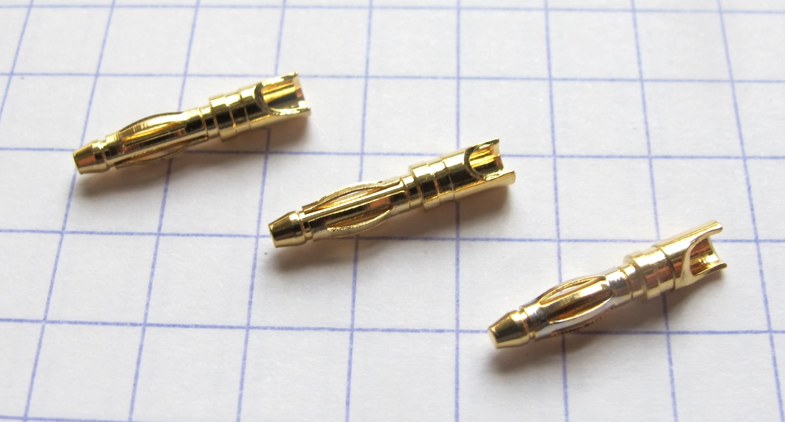  
Prepare the male motor phase connectors.  
We are using the 2mm gold connectors from REELY*

*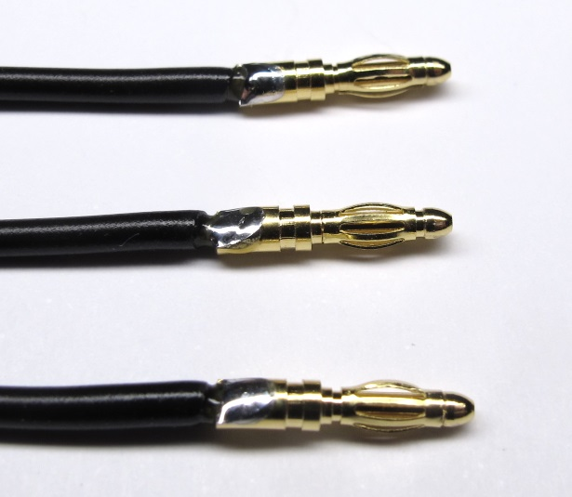  
Solder the connectors onto the phase wires.*

*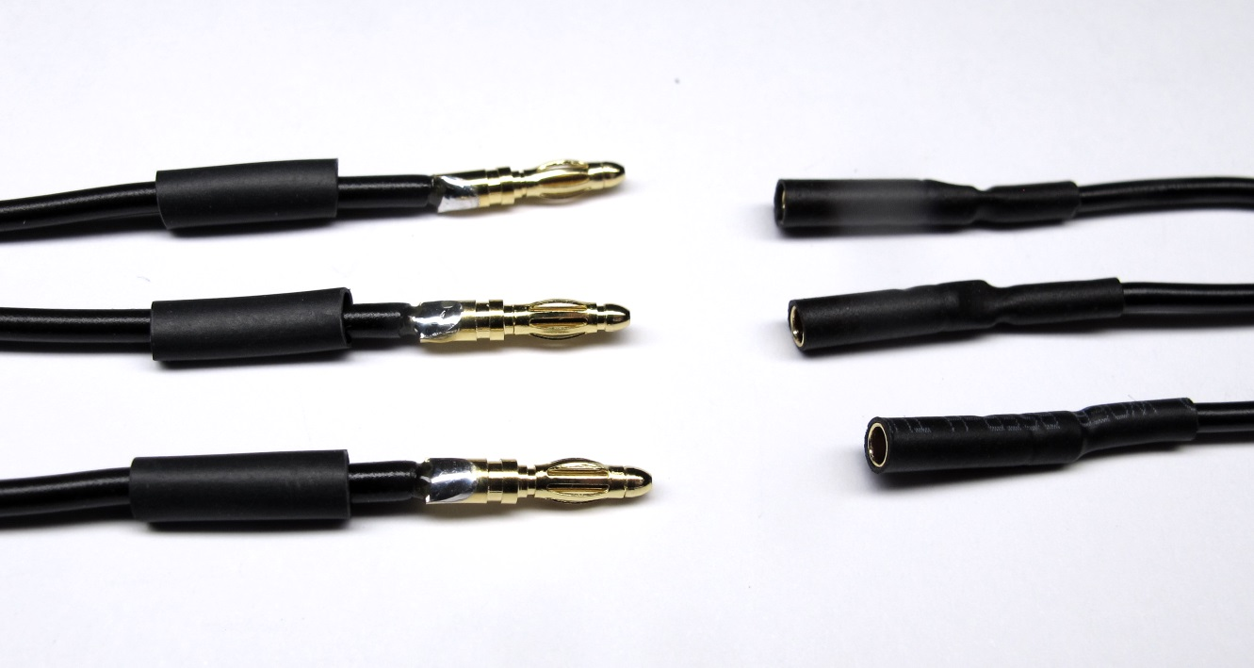  
Prepare heat shrink for the connectors.  
It makes it easier to align the heat shrink if you install the mating connectors.*

*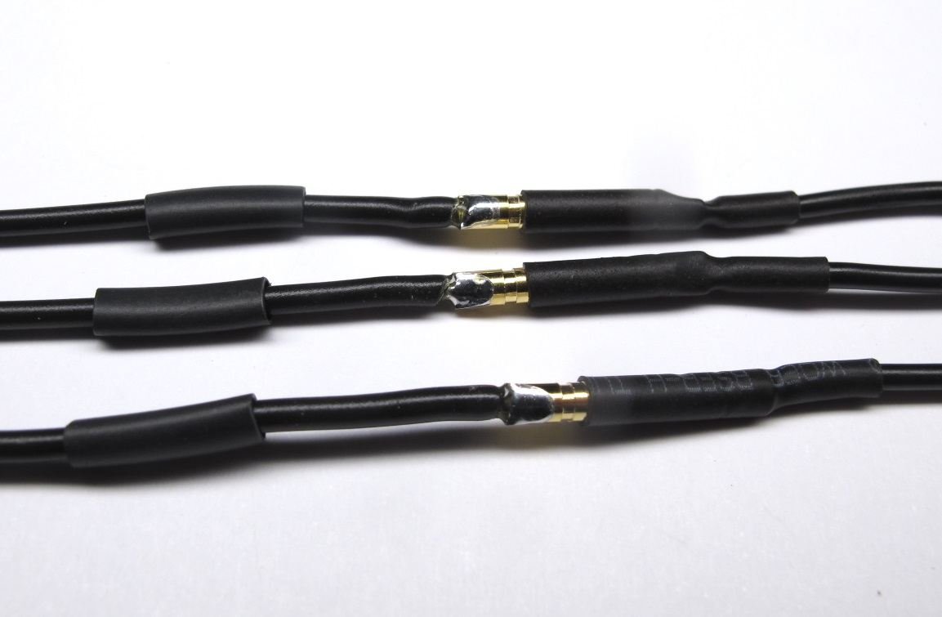  
Install the mating connectors.*

*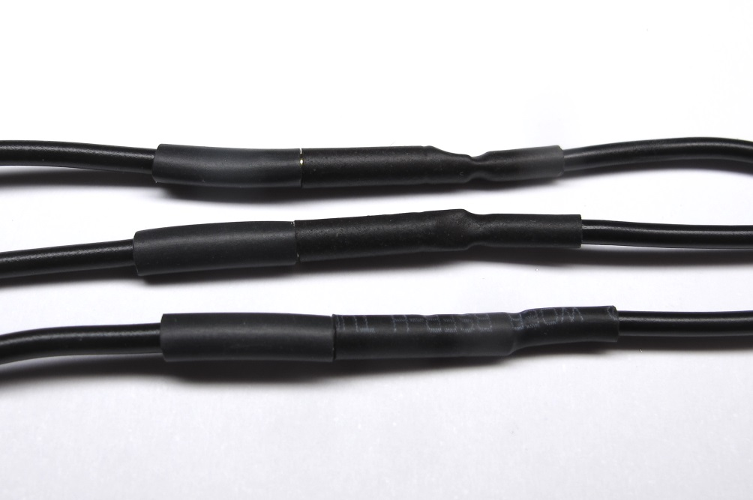  
Align the heat shrink and apply it using a heat gun.*

*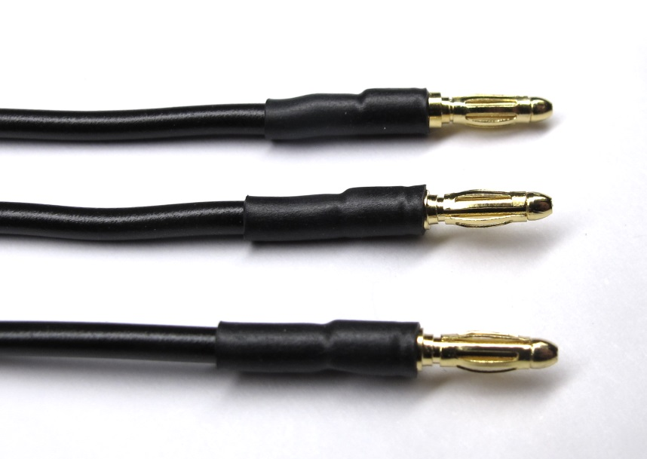  
Finished motor phase connnectors.*

*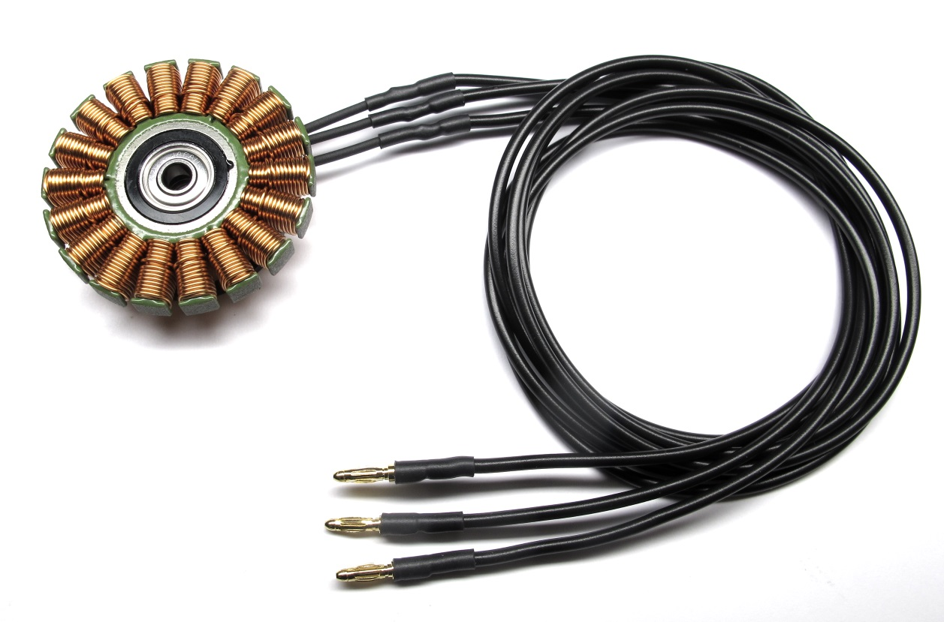  
The stator is now ready for assembly.*

Assembly

# **Details Actuator Module Assembly**

## **Description**

**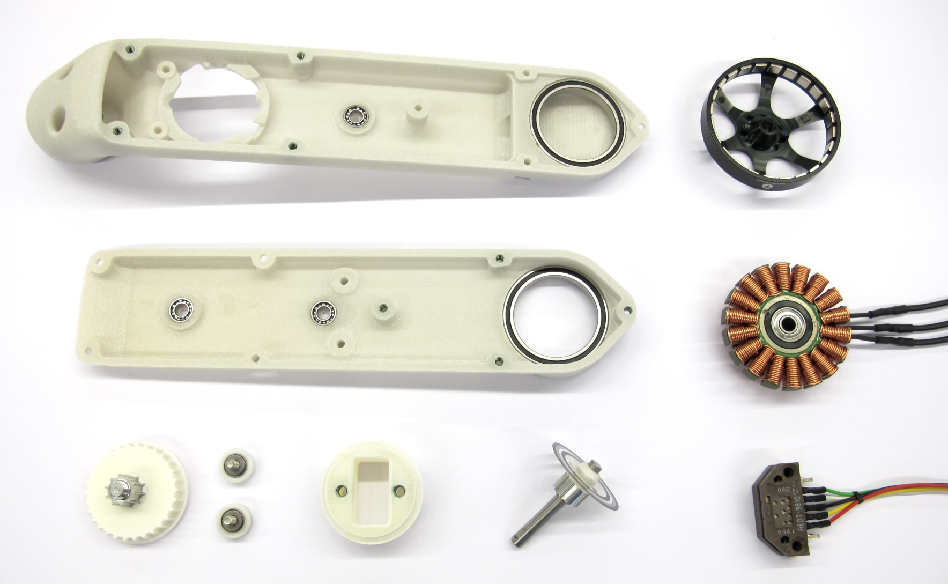***Starting Point: The six sub-assemblies that were prepared in the previous steps.*

*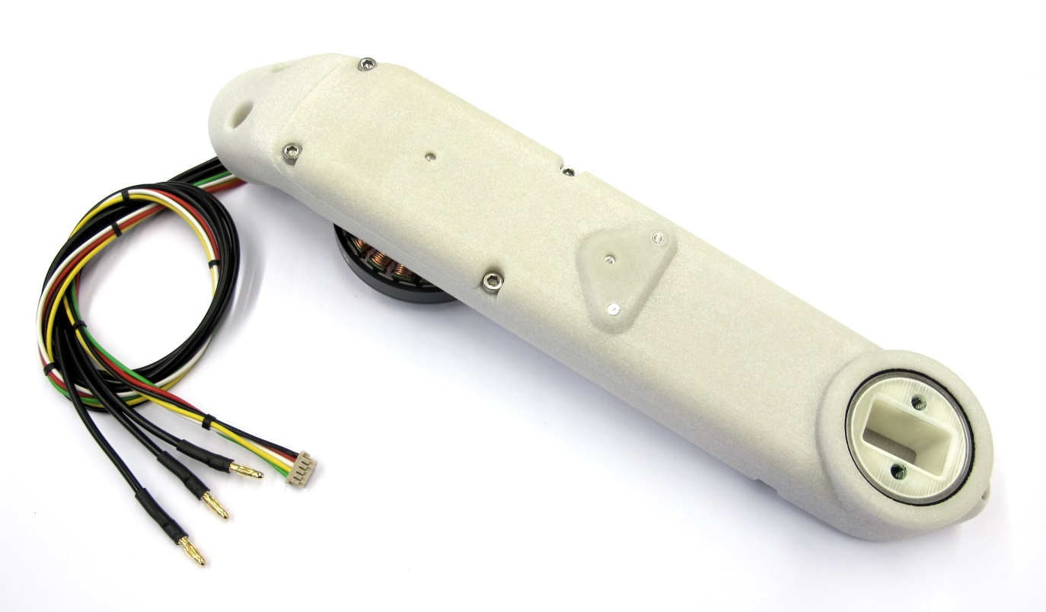  
End Result: Fully assembled actuator module.  
Weight with 30cm wires: 160g*

* this page describes how to assemble the actuator modules
* the 6 sub-assemblies that were prepared before are required for this step
* instructions on how to prepare the subassemblies can be found here: [step-by-step-instructions](https://github.com/open-dynamic-robot-initiative/open_robot_actuator_hardware/blob/master/mechanics/actuator_module_v1/details/details_actuator_module_assembly.md#step-by-step-instructions)
* in addition to the subassemblies the following components are required

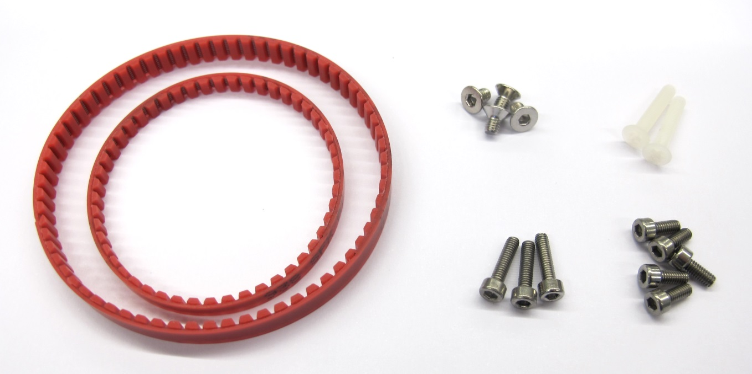  
*Aditionally required components*

* 1 x Timing Belt AT3 150mm - width 4mm
* 1 x Timing Belt AT3 201mm - width 6mm
* 4 x M3x5 Flat Head Screw for motor attachment
* 2 x M3x16 Flat Head Screw for encoder attachment
* 5 x M2,5x6 Socket Head Cap Screw and  
  3 x M2,5x8 Socket Head Cap Screw for connecting the shells

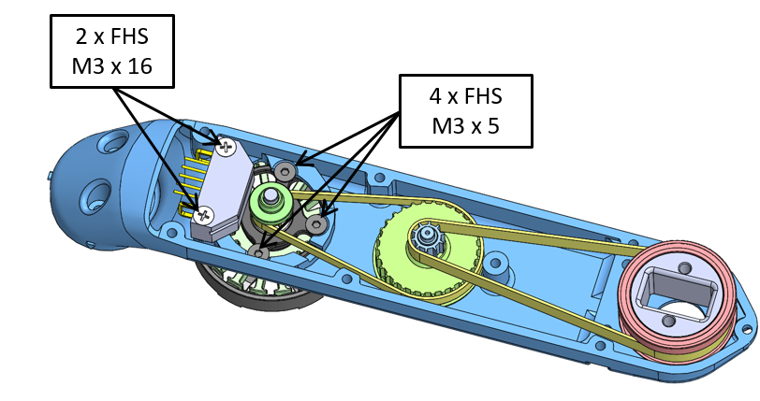  
*Fasteners for Actuator Module Assembly  
FHS = Flat Head Screw*

### **Mounting the Stator**

**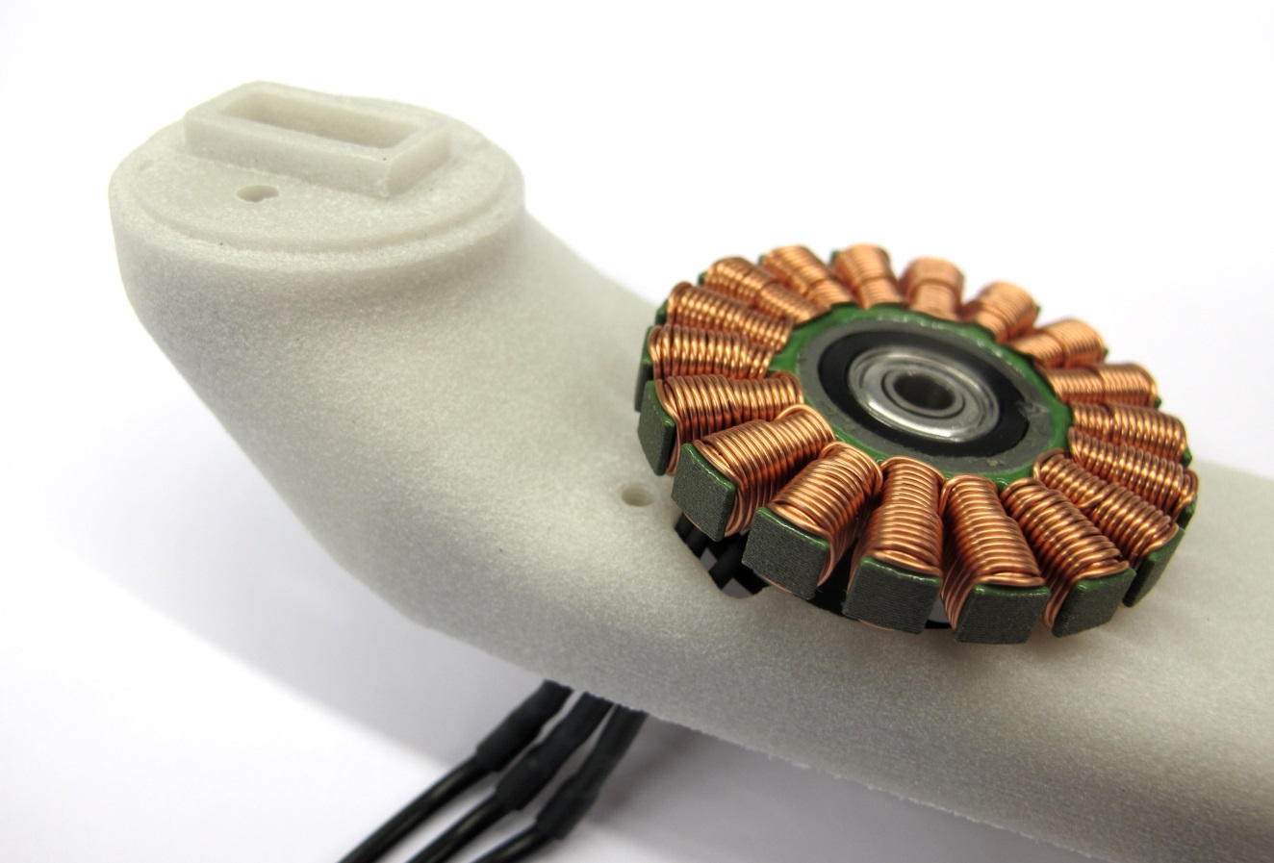***Route the motor phase wires through the opening in the shell.  
Place the stator on the mounting surface.*

*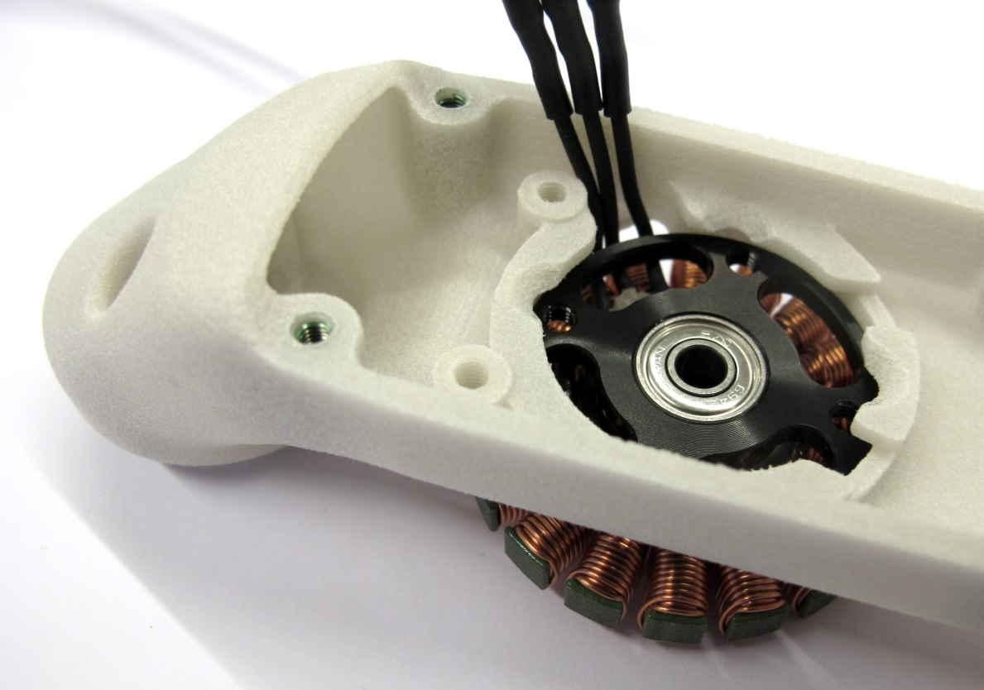  
Bend the motor phase wires up and align them with the cutout as shown in the picture.*

*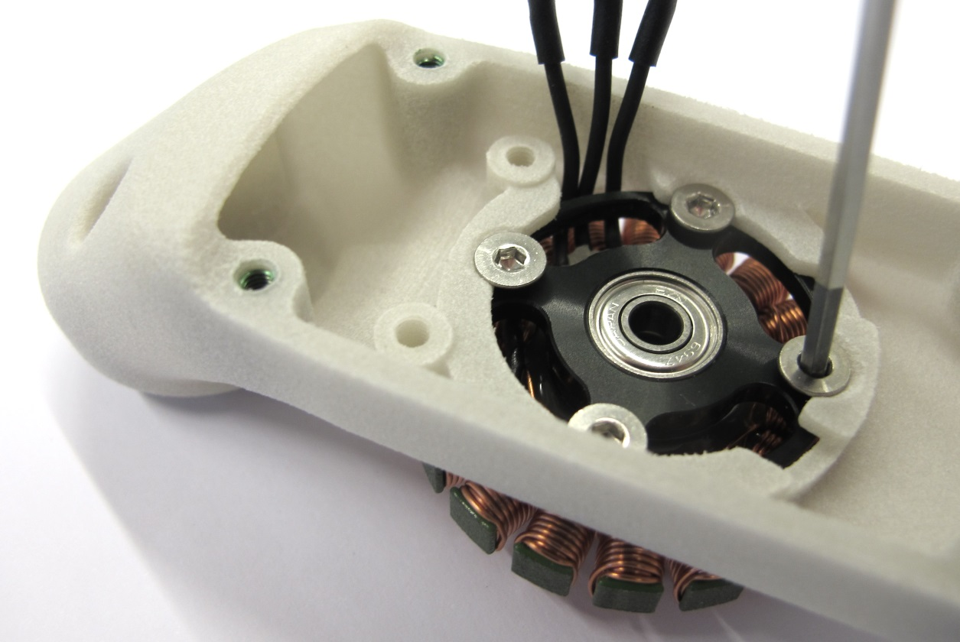  
Use a 2mm hex driver to install the four M3x5 flat head screws.  
Make sure that the stator is fully seated and doesn't move.*

*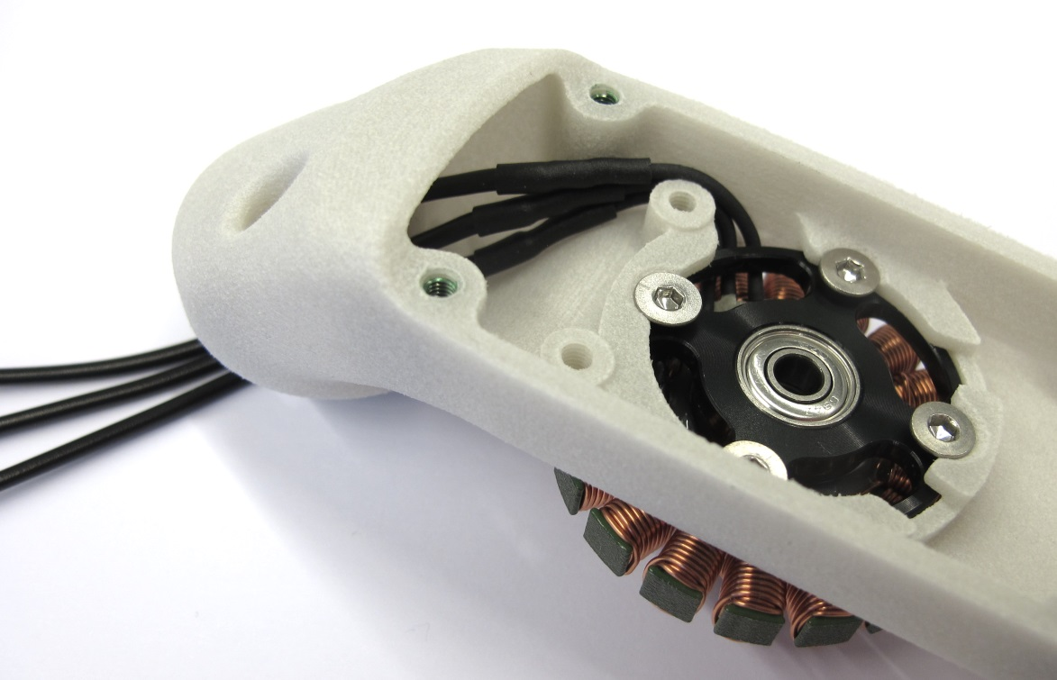  
Route the phase wires through the opening behind the encoder mount and exit through the mounting interface.*

### **Installing the Motor Shaft and Rotor**

*****For the next step you will need the motor shaft assembly.  
Handle the codewheel with care and avoid bending or scratching it during the following steps.*

*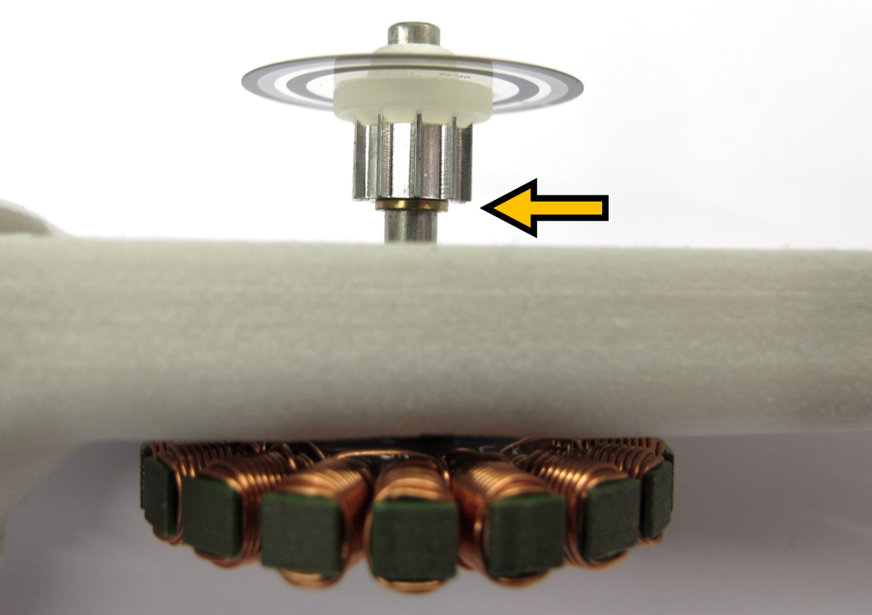  
Insert the motor shaft assembly into the stator bearing.  
Make sure that the brass spacer is installed.*

*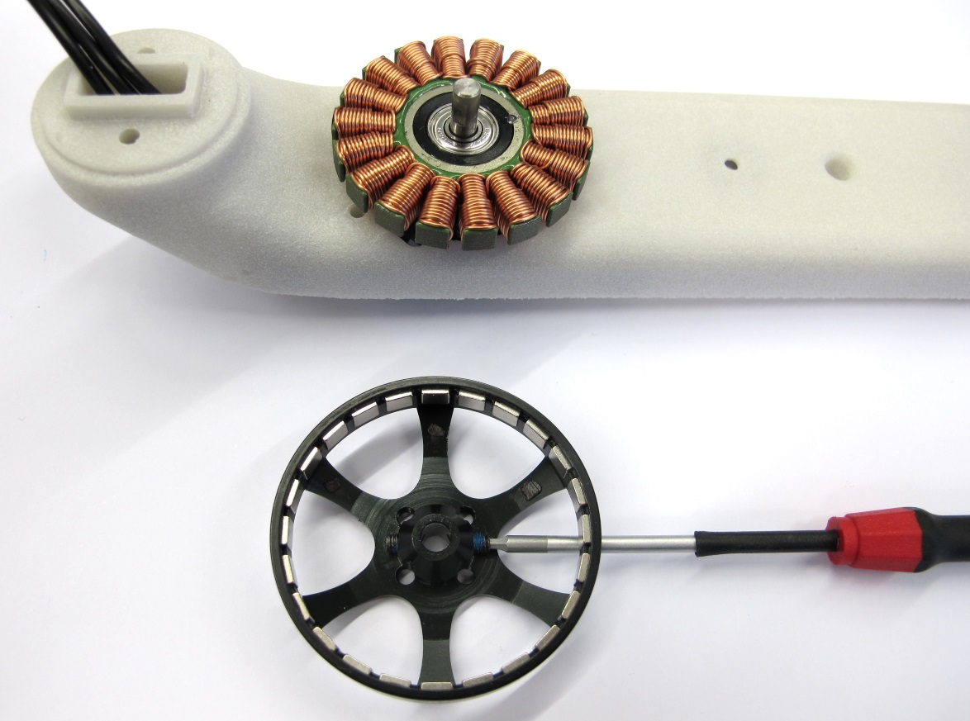  
Turn the assembly around.  
Use a 1,5mm hex driver to install the two M3 setscrews half way.*

*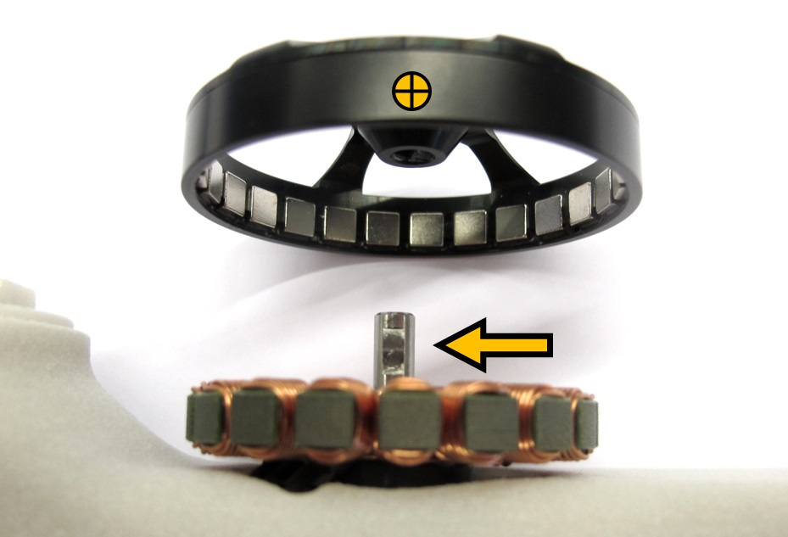  
Line up the setscrews on the rotor with the flats on the motor shaft.  
Install the rotor and push it all the way down.*

*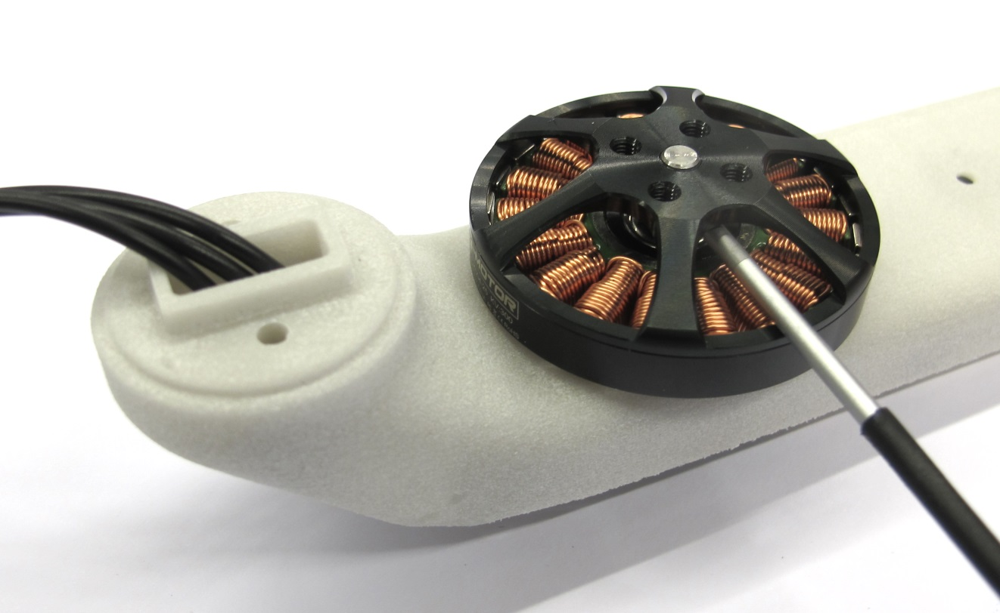  
Tighten both setscrews using a 1,5mm hex driver while pushing down on the rotor.  
Manually spinn the rotor to make sure that it runs freely.  
Pull on the rotor in the axial direction - there should be no or only minimal play.*

### **Installing the Timing Belt Transmission**

**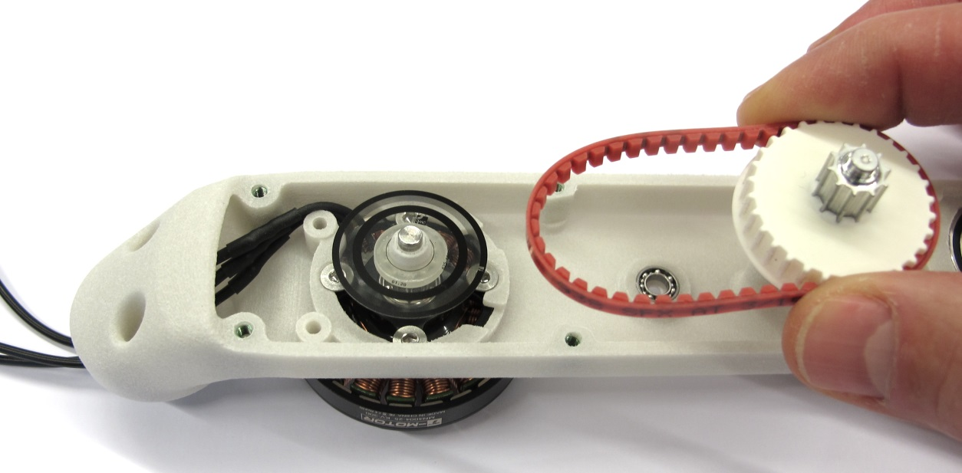***Place the 150mm timing belt on the center pulley and engage the teeth.*

*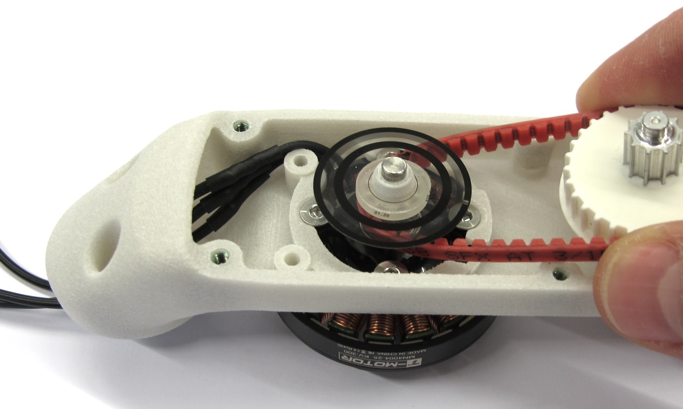  
Place the timing belt on the motor pulley and engage the teeth.*

*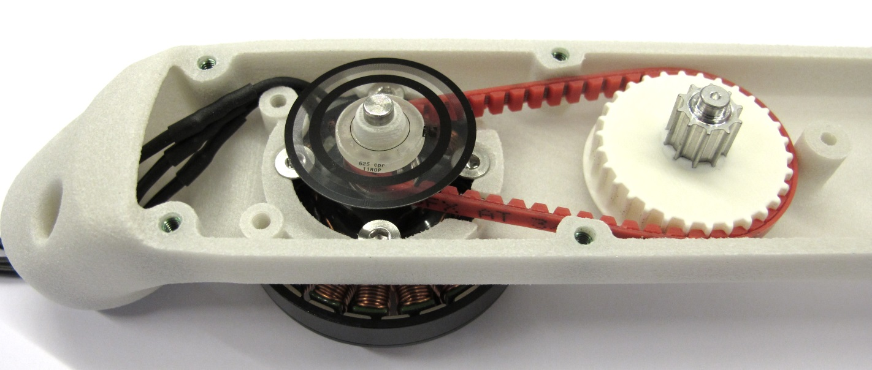  
Keep the timing belt under tension and insert the center pulley into the bearing.*

*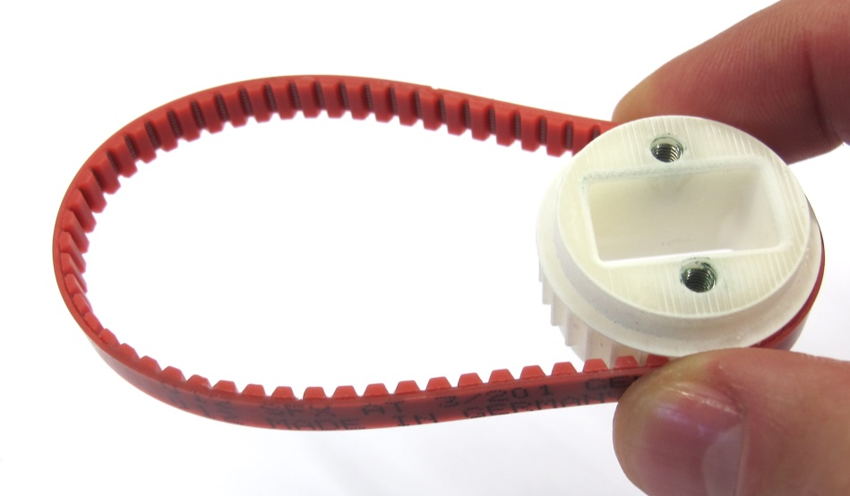  
Place the 201mm timing belt on the output pulley and engage the teeth.  
Make sure that the side with the flange is facing upwards.*

*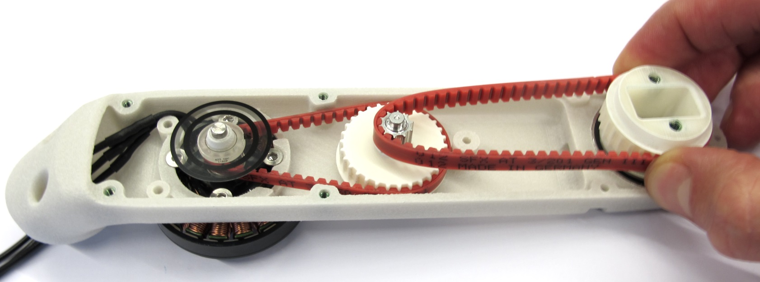  
Place the timing belt on the center pulley and engage the teeth.  
Keep the timing belt under tension and insert the output pulley into the bearing.*

*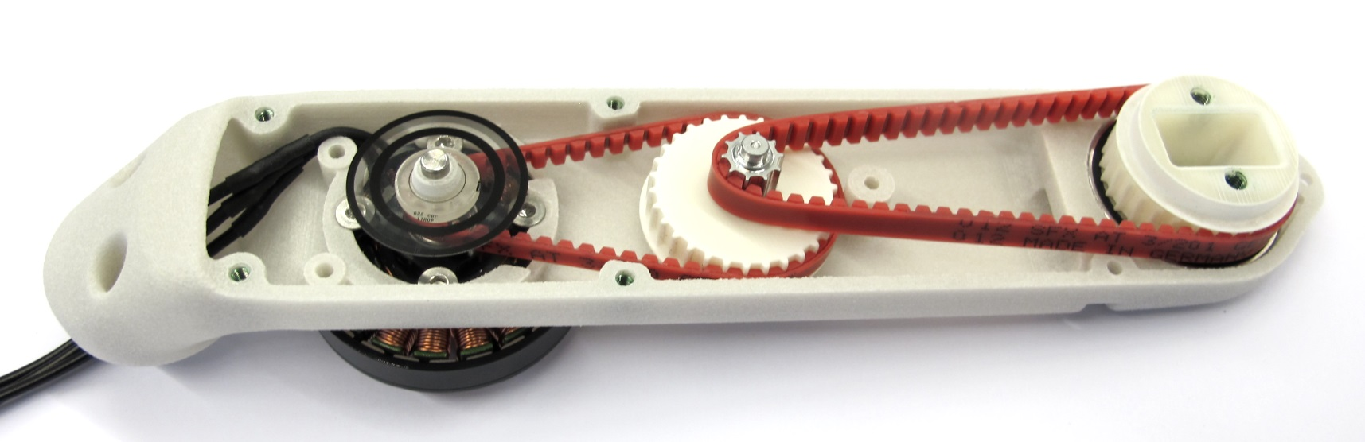  
The timing belt transmission is now completed.  
Rotate the output shaft back and forth and check if the transmission moves as expected.*

### **Installing the Encoder**

**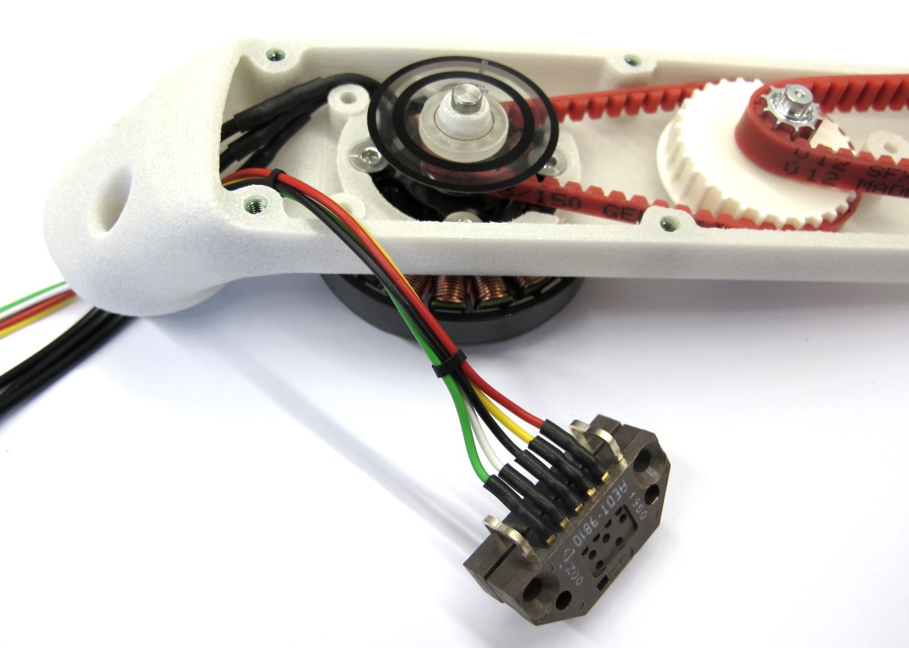***For this step you will need the encoder.  
Route the encoder wires through the opening in the interface.*

*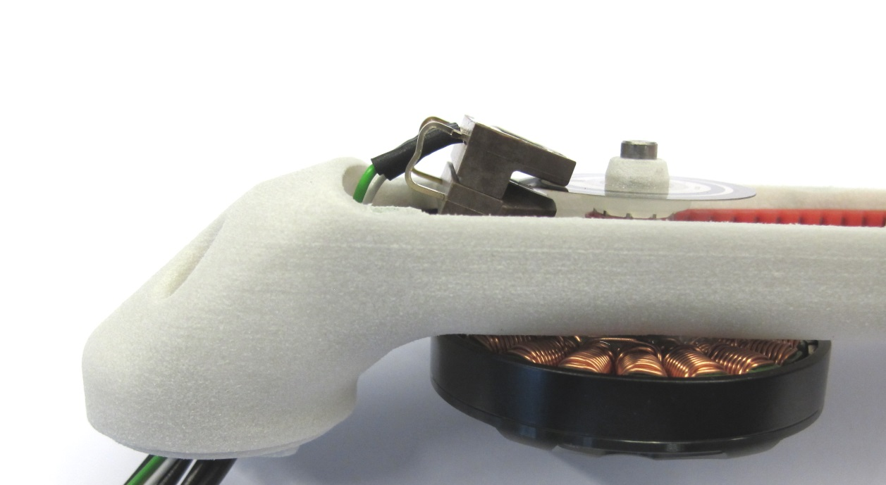  
Carefully insert the encoder under an angle such that the codewheel is located in the gap.  
We shorten and bend the encoder pins to simplify the assembly.*

*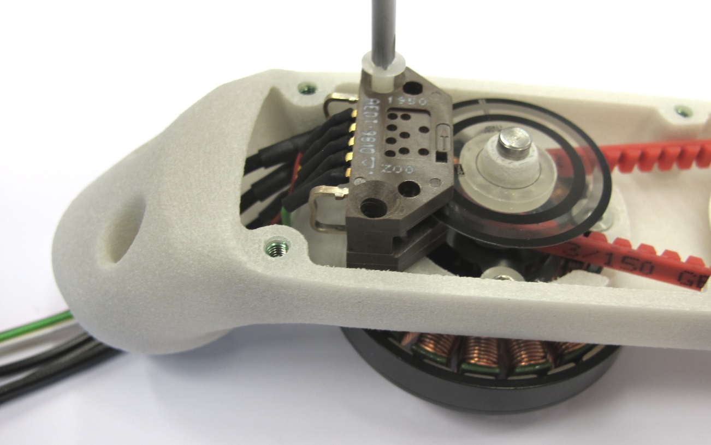  
Place the encoder on the mounting surface and install the two M3x16 screws.*

*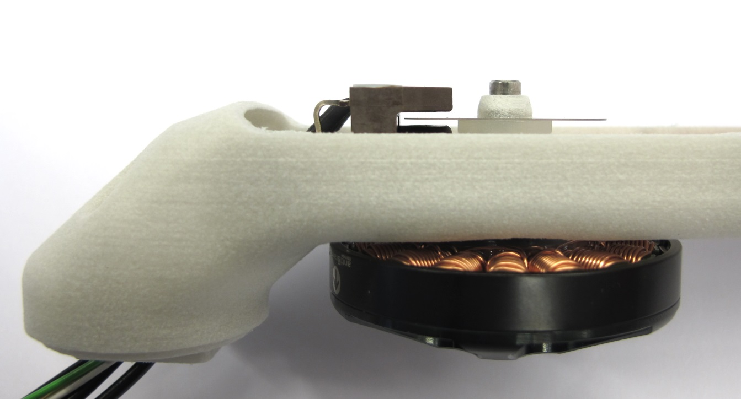  
Make sure that the codewheel is located correctly and doesn't touch the encoder.*

*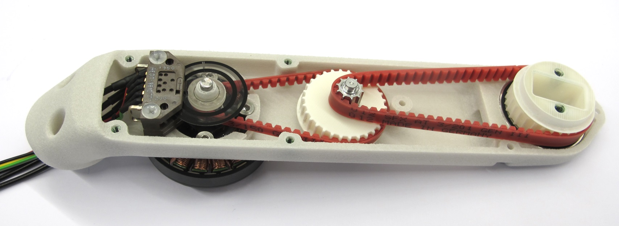  
The base of the actuator module is now completed.*

### **Installing the Timing Belt Tensioner Rollers**

**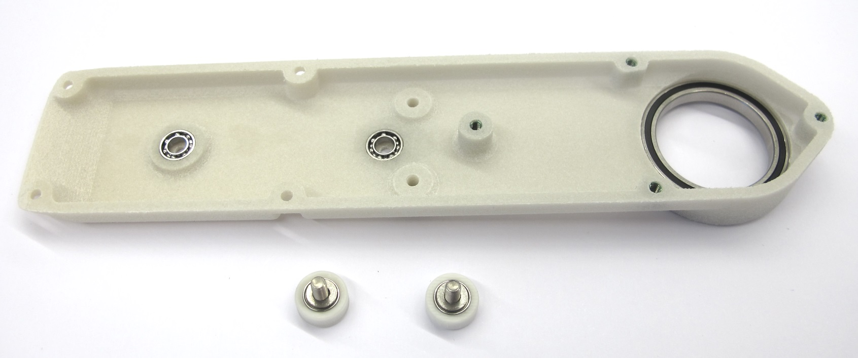***For this step you will need the shell cover and the timing belt tensioner rollers.*

*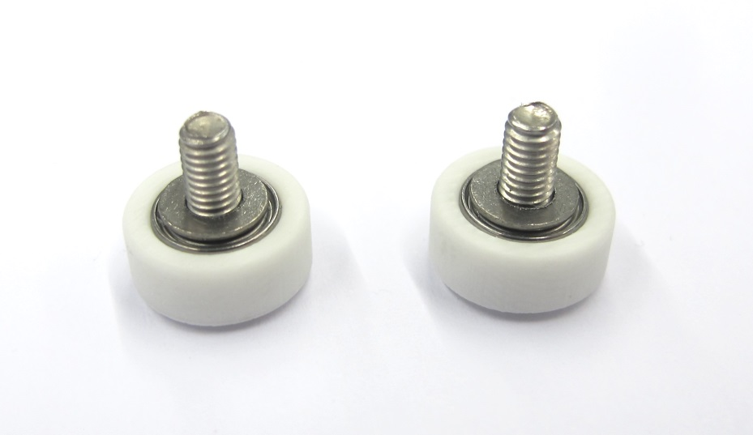  
Make sure that the washers are installed.*

*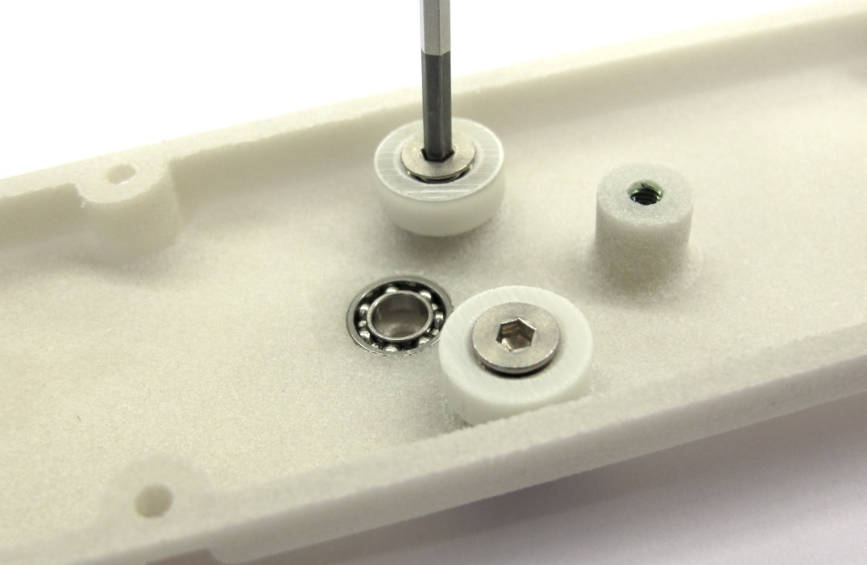  
Install the timing belt tensioner rollers using a 2mm hex driver.  
Rotate the rollers and make sure that they move freely.*

*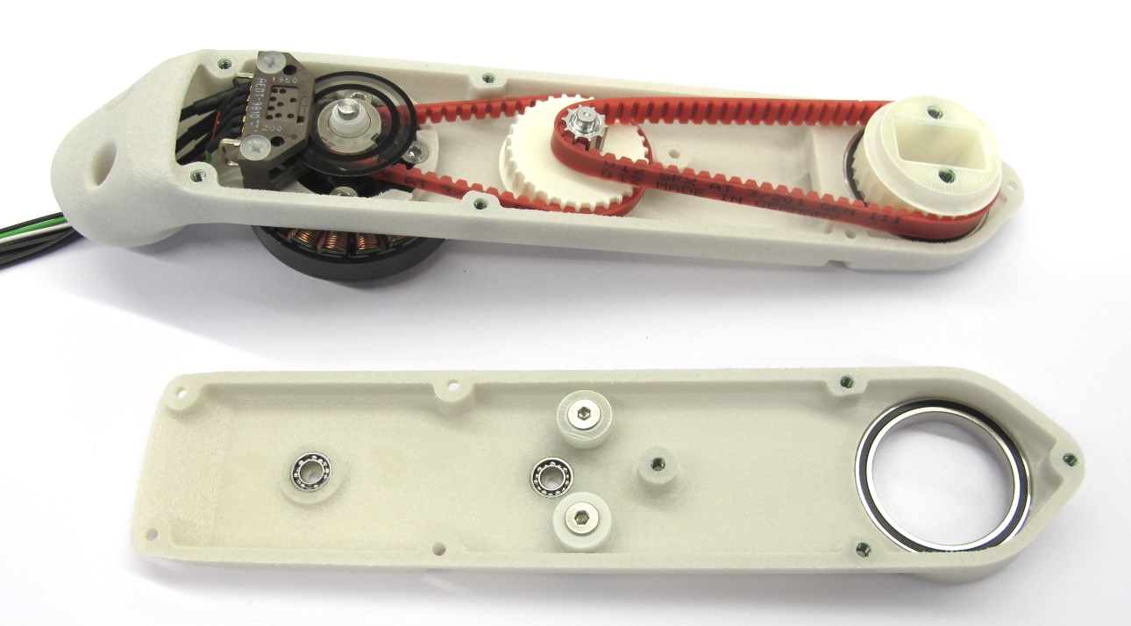  
All the components are installed - the shell can now be closed.*

### **Closing the Shell**

**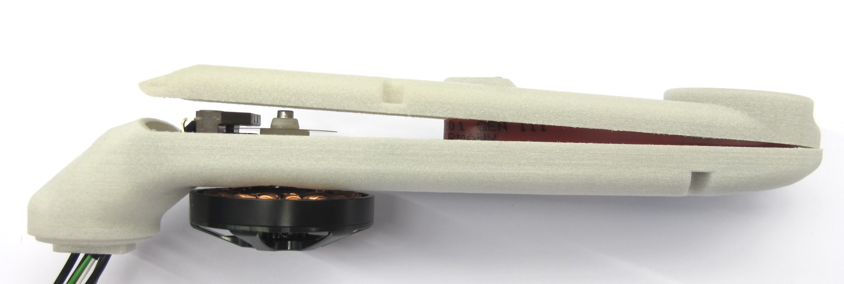***Place the shell cover on the shell base.  
Angle the cover a bit and partially install the output pulley as shown above.*

*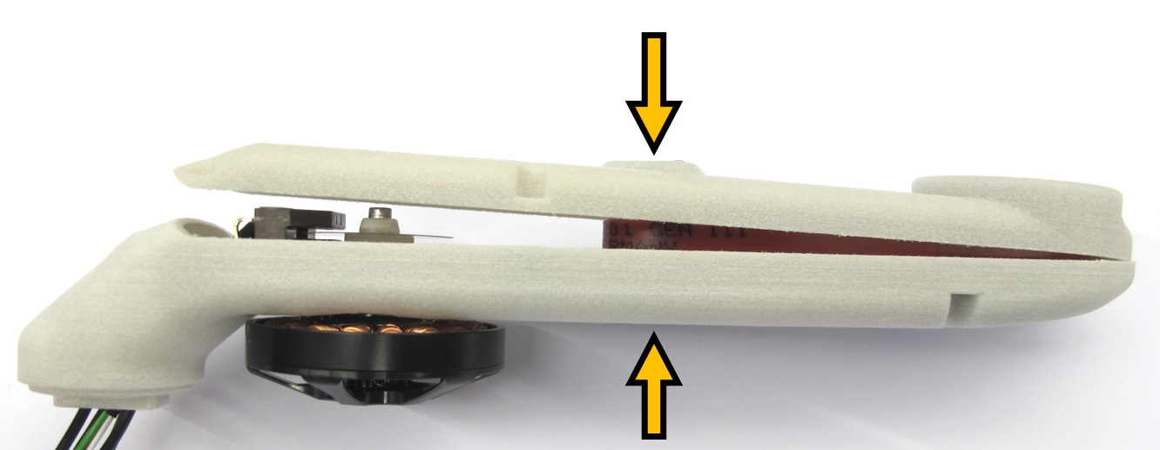  
Apply moderate pressure to the center of the assembly for all the following steps.*

*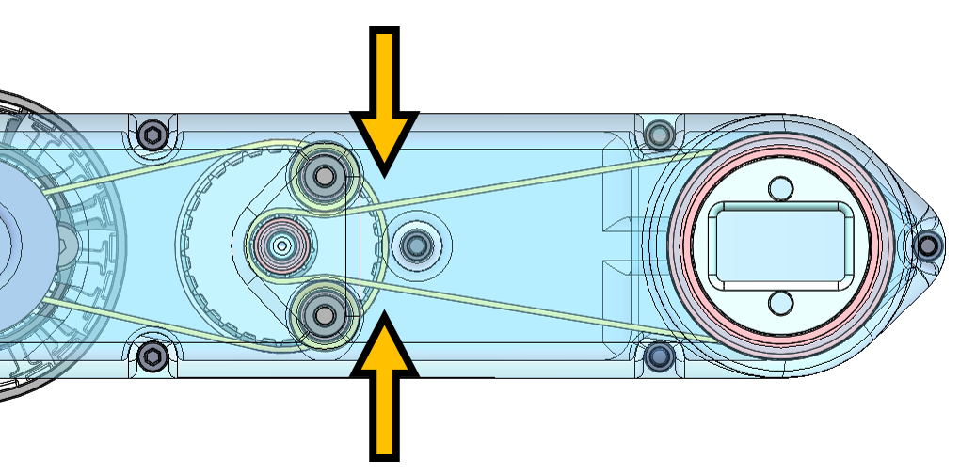  
You will now need to push the timing belt of the second stage inwards.  
That helps the timing belt to clear the tensioner rollers.*

*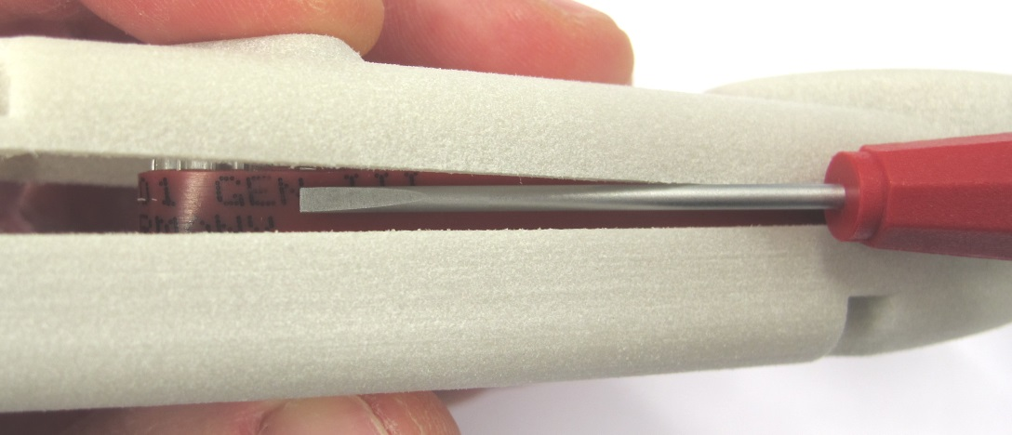  
Use a small flat head screw driver to push the timing belt inwards.  
Keep applying moderate pressure while turning the assembly around.*

*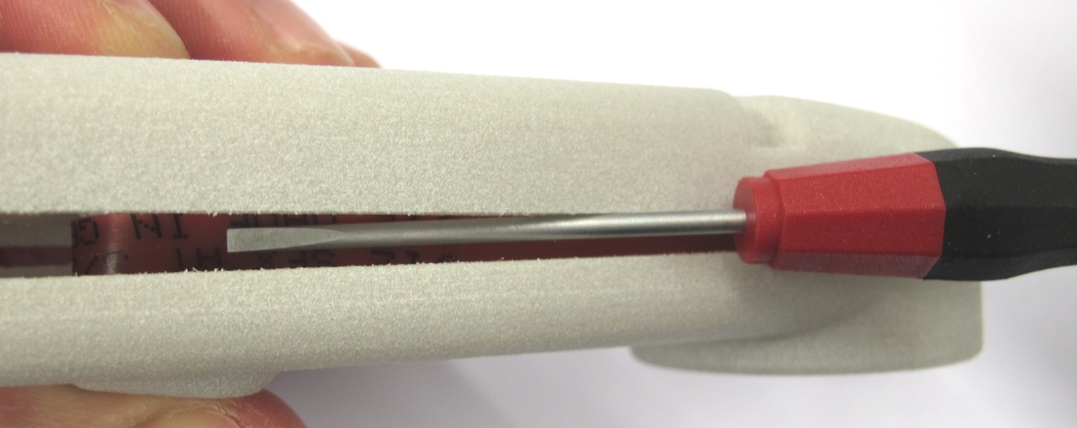  
Use a small flat head screw driver to push the timing belt inwards on the opposite side.  
The cover should move downwards a bit when the timing belt clears the roller.*

*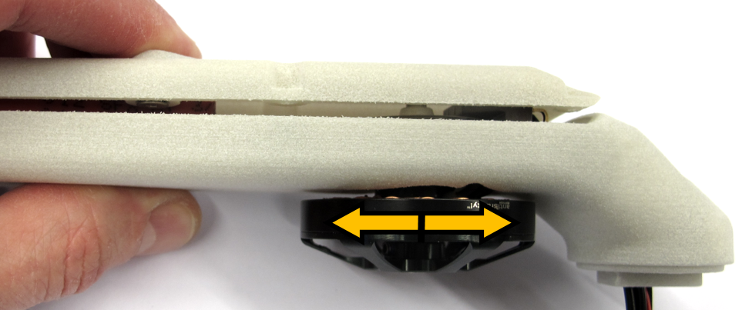  
Now the center pulley needs to find its way into the bearing on the cover.  
Grab the rotor and rotate it back and forth a couple of times while gently pushing down on the cover.*

*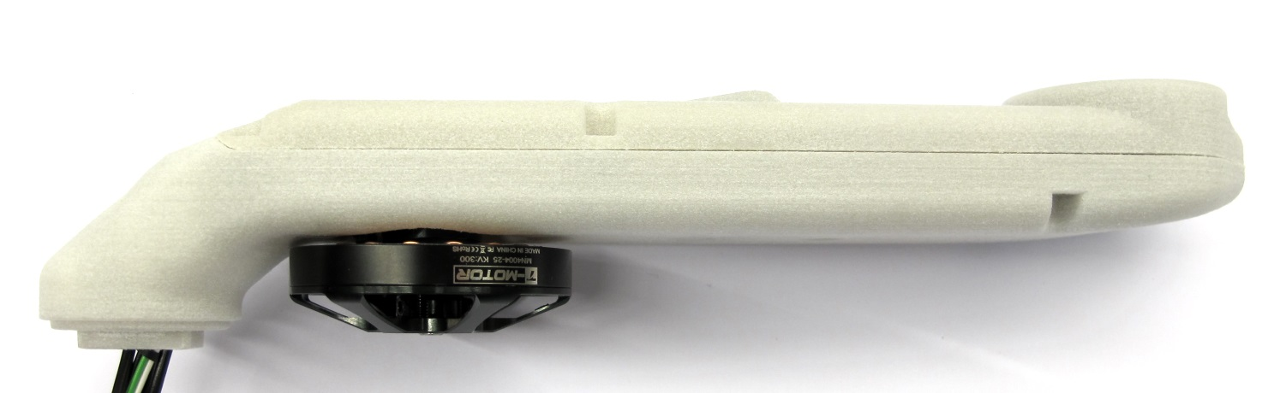  
The cover should close after a couple of turns in each direction.  
Make sure that the shell is fully closed and that the motor can be rotated.*

*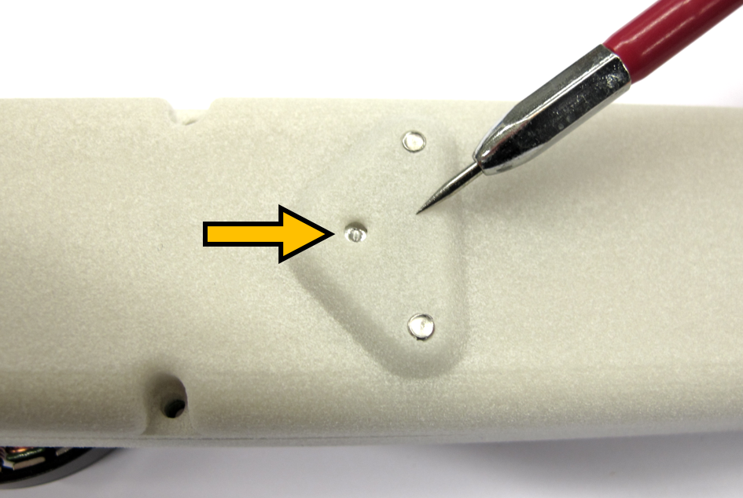  
If you have trouble closing the shell you can use a pointed tool to guide the center pulley into the bearing.  
There is a hole in the center pulley for that purpose.*

*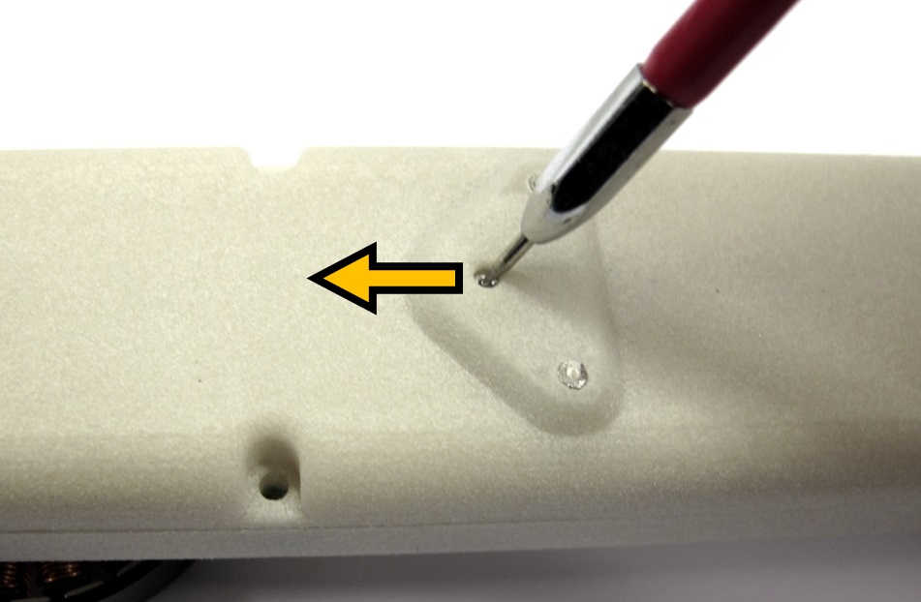  
Use a pointed tool to push the center pully into the direction of the motor.  
Turning the rotor at the same time can help.*

*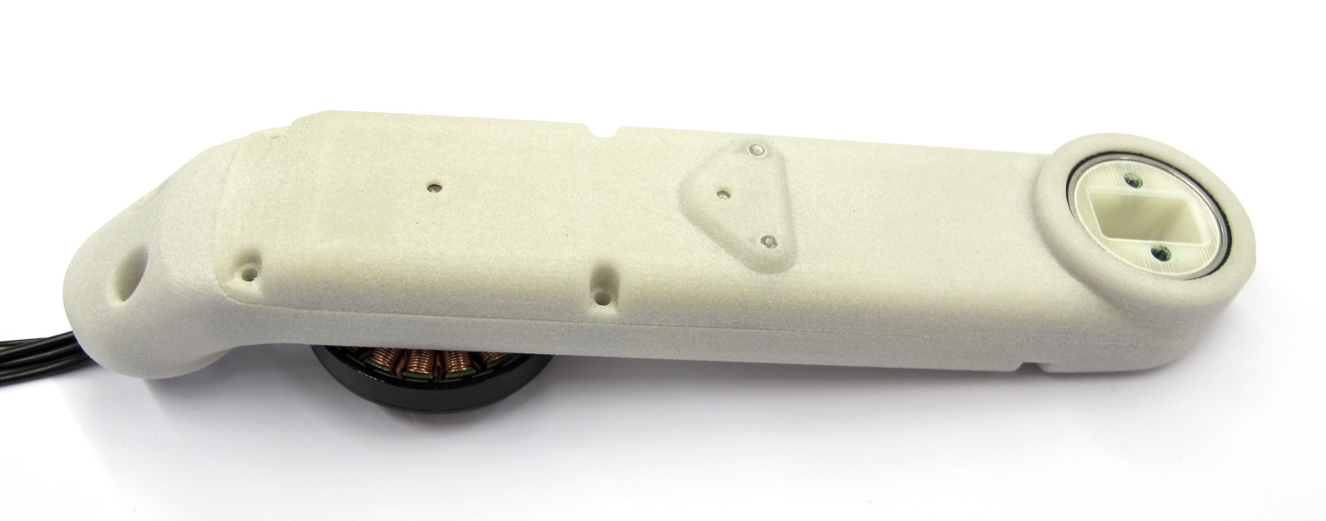  
When the shell is fully closed the fasteners can be installed.*

*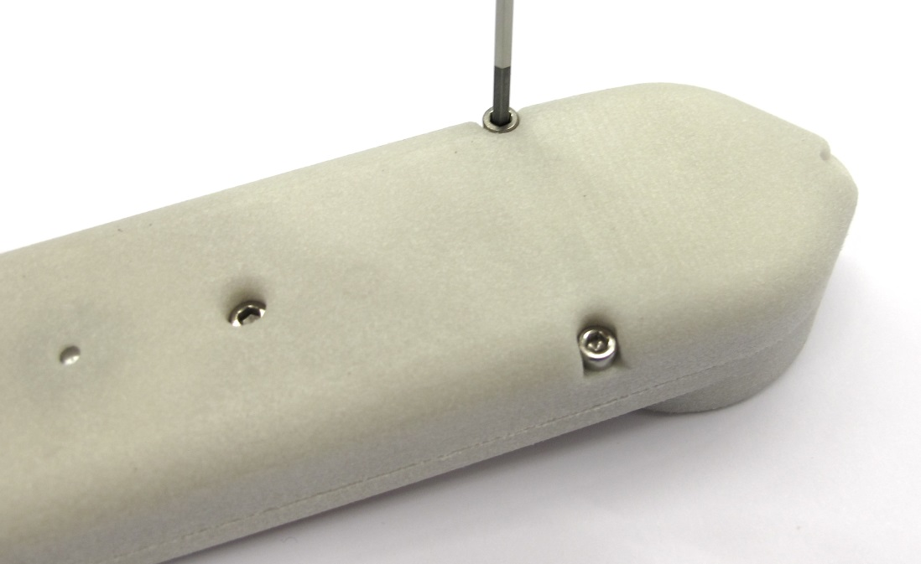  
Use a 2mm hex driver to install the eight connecting screws.  
Tighten the screws with moderate torque.  
The location of the screws is documented below.*

*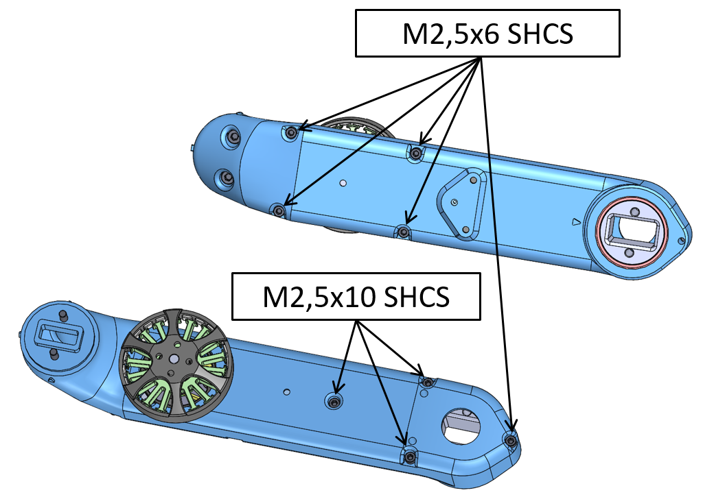  
Fasteners for connecting the Actuator Module Assembly  
SHCS = Socket Head Cap Screw*

*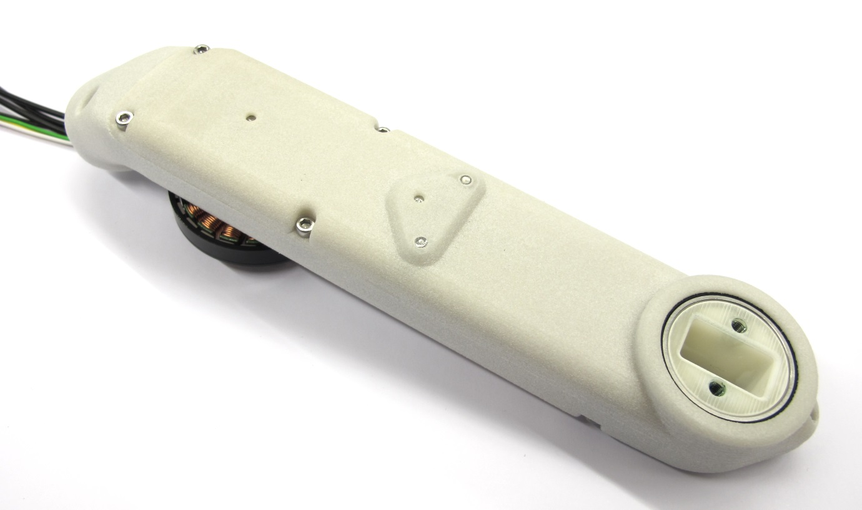  
The actuator module is now fully assembled.  
The last step is to add the motor phase and encoder connectors.*

### **Soldering the Motor Phase Connectors**

****[*Instructions Soldering the Motor Phase Connectors*](https://github.com/open-dynamic-robot-initiative/open_robot_actuator_hardware/blob/master/mechanics/actuator_module_v1/details/details_motor_preparation.md#soldering-the-motor-phase-connectors)

### **Crimping the Encoder Connector**

****[*Instructions Crimping the Encoder Connectors*](https://github.com/open-dynamic-robot-initiative/open_robot_actuator_hardware/blob/master/mechanics/actuator_module_v1/details/details_encoder_preparation.md#crimping-hirose-connector)

*  
The actuator module assembly is now completed.  
The next step is to test the module and determine the correct order of the motor phases.  
Weight of the actuator module with 30cm wires: 160g*